PROCUREMENT OF RADIOTHERAPY AND DIAGNOSTIC EQUIPMENT, BELGRADE
(PROCUREMENT NO. IOP/36-2019/RD)

CLARIFICATION NO. 5

Issued on April 17, 2020

Regarding the list of questions that the Purchaser, Public Investment Management Office Belgrade, No. 11 Nemanjina street, have received from the potential bidders, concerning the procurement procedure: Procurement of Radiotherapy and Diagnostic equipment, Belgrade no. IOP/36-2019/RD, we give you the following answers:

Question 1:

a) Point 1,3
Minimum one Photon beam energy X-6MV
- Is this requirement referring to 6 MV FFF?

b) Point 1,5
Beam Symmetry (%) ≤ 2.0 or better
- Is beam symmetry ≤ 3.0 % acceptable?

c) Point 1,21
Linear Accelerator should be fully integrated in existing Record and Verify system at IORS – ARIA ver. 15.5

- This criteria requires the collaboration of Aria manufacturer in providing a quote to any other bidder for this component.

We request that Varian shall have the obligation of providing such a quotation to any solicitor within this tender.

d) Point 2,12 and 2,13
- What is the required warranty period in total?
- Are the 3 years additional maintenance optional?

Answer 1:
- It is preferable to be an X-6 MV FFF, but an X-6MV with a flattening filter is acceptable.
A linear accelerator is provided for the administration of the patient radiotherapy by the VMAT technique. Daily workload 60-80 patient treatments per machine is planned. We require that the Dose rate be 600MU / min or higher.
- Yes, that is acceptable
Most patients will be treated with the VMAT technique. With stable beam parameters and adequate beam commissioning to the TPS, the parameter value offered is acceptable.
- All existing Linear Accelerators are integrated into the ARIA R&V system including 3 Elekta Synergy accelerators, of course this condition should not be eliminatory for other bidders. It is desirable for the end-user that the radiotherapy department use one Record&Verify system but will also accept the functional solution of the other manufacturer including their R&V system. Each provider should offer a functional solution for the implementation of VMAT therapy. Bidder is obliged to provide connectivity for its equipment (Accelerator, R&V system, TPS), Import / Export data in ECLIPSE including DICOM data conversion if needed.
- The manufacturer's warranty for the Linear Accelerator is 1 year except for vacuum components. The warranty time for vacuum components of the accelerator is 3 years.The 3-year extended warranty applies to vacuum components of the accelerator: waveguide, Klistron / magnetron, ion pumps, etc. ... applies to expensive components, primarily waveguide and Klistron/Magnetron.
Are the 3 years additional maintenance optional?
Additional maintenance is not optional. It is the obligation of the bidder.
The warranty period applies to the manufacturer. Maintenance is described in detail in paragraph 2.14. and refers to the bidder (or manufacturer and bidder) who undertakes the obligation to maintain the equipment for a specified period of 3 years. This includes preventive and corrective maintenance of all systems up to full functionality.
Question 2:
Your Tender Documents defined restrictive requirements in terms of the post-qualification criteria. Please define your business capacity requirement according to the lot items. Please also define your items as separate lots.

Answer 2:

It is not clear from the question in what way the postqualification requirement Business capacity is defined restrictively. There are no facts in the question indicating and explaining the restrictive nature of this qualification requirement. Part of the question: “Please also define your items as separate lots.“ is unclear and it is not possible to understand from this form of the question which items the bidder wishes to be defined as a separate lot.
Postqualification Requirements, (c) Business Capability is defined so that it is logically related to the subject procurement.
The Bidder have the opportunity to demonstrate the delivery of medical equipment and related service contracts successfully and substantially completed, from the beginning of the 2016, without proving or limiting the type of medical equipment, but in the value of the estimated value of the lot.

Question 3:
Your Tender Documents require ISO 20000 as evidence of bidding performances. As the subject procurement is not only the procurement of IT solutions but also of other medical equipment, construction works and other services, please harmonize the subject procurement, enable competition and remove the requirement to submit ISO 20000

Answer 3:

Compliance with the standard ISO 20000 standard is logically related to the procurement subject for Lot 2. Namely, the procurement and installation of a conference system that is the subject of this specific procurement implies compliance with the requirements of this standard. Also, within the works we have the entire IT infrastructure, which involves connecting and functioning of all the devices, which is described in detail in the Terms of Reference. This standard specifies requirements for an organization to establish, implement, maintain and continually improve a service management system (SMS). The requirements specified in this standard include the planning, design, transition, delivery and improvement of services to meet the service requirements and deliver value. In order to ensure the highest level of quality of procurement and installation of conference system and all other devices, the Contracting Authority required the bidders to have this standard as well. However, the Contracting Authority provides that the bidders may jointly fulfill this requirement of the standard, which means that this requirement may be fulfilled by members of the Joint venture, who will install this system and perform this type of installation works.
Question 4:
LOT 1
Regarding your document ""project terms of reference"", please answer the following questions:

-What can be found around the room with MRi machine due to the bringing of the MRi machine into the room, the magnetic field outside and the position of the quench tube?

-What is the structure of the walls? Reinforced concrete walls, floors, ceilings, metal sheets! What can be found underneath - floor load capacity!
-What gases should be supplied and from where (distance)?

-Does the existing transformer have sufficient capacity to connect MRi machine, chiller and air conditioner? If not, whose responsibility is it?

-Which way is the MRi machine supposed to be brought into the room (through the corridor or through the wall)? Is there already a specific plan for bringing the MRi machine into the room?

- Has a plan been put in place for installing a safety helium drainage tube (quench tube)?

Answer 4:
-The MR machine should be brought through the corridor; the picture shows the possible path of import.
-Currently, there is a single room, with RC walls and RC floor slab, which is, according to the project documentation, 40 cm thick. A RC slab is located between the floors, above this room, placed over TR profiled metal sheets (cladding).
This room can be accessed from the main basement corridor, through the main entrance to the new facility using stairs and an elevator, or via a heated passageway connecting the new facility to the Institute for Oncology and Radiology, where the brachytherapy ward is located.
-Gas supply station is on the outside of the building, about 50m distant from MR room.
- Installing a safety helium drainage tube (quench tube) is the subject of future design.
- It is the obligation of the contracting authority to provide capacity at the power transformer station for the connection of new equipment, and the obligation of the contractor is to provide all necessary equipment and installations for the connection to the same.
The prospective Bidders are invited to visit site so all necessary information for preparation of the bid could be collected.

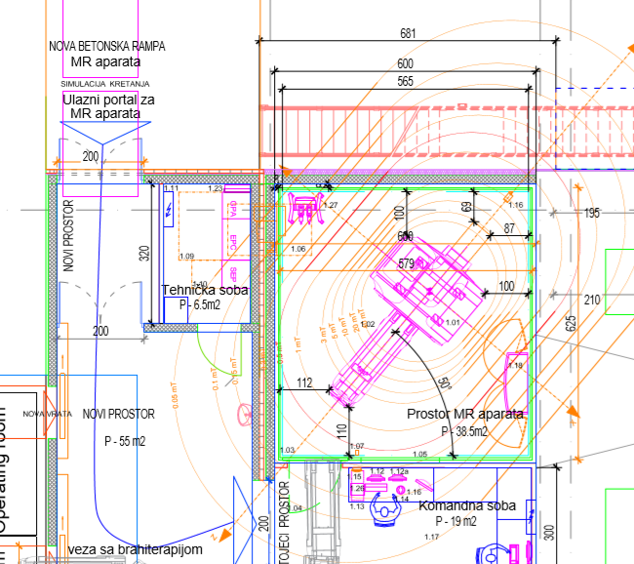

Question 5:

Please confirm that your request is to prepare a rehabilitation design of the area of concern, according to article 145 of the Law on Planning and Construction, which implies that it is necessary to prepare the following documents:

1. PIO – As-built design (Projekat postojećeg stanja)
2. IDR - Conceptual design (Idejno rešenje)
3. IDP – Preliminary design (Idejni projekat) - for issuing the Decision on approval of the execution of works according to article 145 Law on planning and construction
4. PZI - The Executive Design (Projekat za izvođenje) - for providing the Approval for the construction documents issued by the Ministry of Interior - Emergency management department (regarding the planned fire protection measures).
5. PIO - Design of as-built facilities (Projekat izvedenog objekta)

Answer 5:
Scope of documentation is defined by Terms of Reference for each lot.

Question 6:

We are contacting you as an interested Bidder for Procurement of Radiotherapy and Diagnostic equipment, Belgrade IOP/36-2019/UHI , Lot 2 – Diagnostic Equipment and kindly ask for clarification of Bidding Documents:
Question:
Would it be possible to arrange site survey for potential bidders, in order to prepare our bid quotation for item “ID 10 - Adaptation works for placement of equipment” from the document “Technical Specification with Price Schedule Lot 2 Diagnostic Equipment” as good as possible? It would help us in perceiving any special requirement regarding the placement of equipment.
Answer 6:
Site visit will be organized, see Information Site visit published on Purhaser’s web page.

Public Procurement Committee

