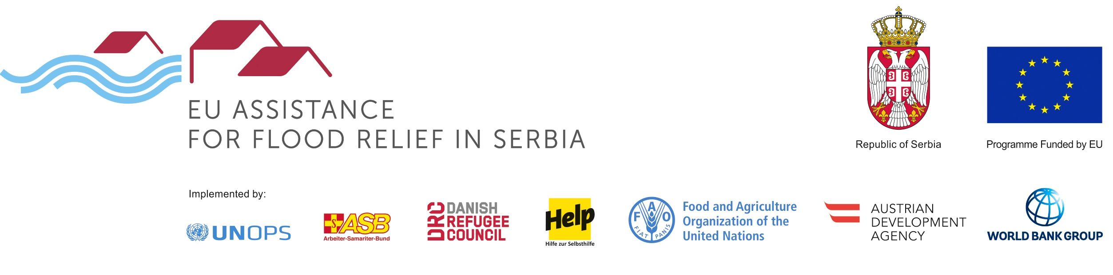

PROGRAMME: REHABILITATION OF FLOOD PROTECTION INFRASTRUCTURE
TENDER: Provision of Supervision Services within the project “Rehabilitation of Flood Protection Infrastructure” - OBRENOVAC, SURČIN AND SVILAJNAC
REFERENCE: RFPI 01 2019

The Austrian Development Agency intends to award a service contract for the supervision of works under FIDIC contract conditions in Obrenovac, Surčin and Svilajnac with financial assistance from the European Union. The open tender procedure is conducted pursuant to the provisions of the Austrian Federal Act on Public Procurement (Bundesvergabegesetz).
The official tender notice is published on https://schramm-oehler.vergabeportal.at/Detail/62377#tab2. The tender dossier can be downloaded under this link after a free registration. If you have any problems registering or downloading the tender dossier, you may also request it by e-mail at rfpi@schamm-oehler.at
Possible additional information, addenda or clarifications shall be published at the location where the tender dossier is published: https://schramm-oehler.vergabeportal.at/List
Contact Point/further information: Schramm Öhler Rechtsanwälte, e-mail: rfpi@schramm-oehler.at, tel: +43 1 409 76 09
Location of the works/projects to be supervised: Obrenovac, Surčin and Svilajnac in Serbia.
CPV codes: 71247000, 71520000, 71521000
Deadline for submission of tenders: Monday, 8 April 2019, 17:00 CET at Schramm Öhler Rechtsanwälte in Bartensteingasse 2, 1010 Vienna or via the electronic procurement platform https://schramm-oehler.vergabeportal.at/.

