PROCUREMENT DOCUMENT

Procurement of Consulting Services
Main Design, Detailed Design, Project Management, Supervision of Civil Works and Clean Room Validation for Construction of BioSense Institute Building in Novi Sad, Serbia

RFP No: IOP/10-2017/RD

Project: Public Sector Research and Development
Project component: Creation of Centres of Excellence in priority research fields
Purchaser (PIU): Public Investment Management Office
Country: Republic of Serbia

Issued on: September 2017.

PART I

Section 1. Request for Proposal Letter

Request for Proposal Letter

Consulting Services

- The Republic of Serbia (hereinafter called “Borrower”) has received financing from the European Investment Bank (the “Bank” or “EIB”) in the form of a loan toward the cost of the project Research and Development in the Public Sector. The Public Investment Management Office of the Government of the Republic of Serbia (hereinafter called “PIMO” or “Client”), an implementing agency of the Borrower, intends to apply a portion of the proceeds of this loan to eligible payments under the contract for which this Request for Proposals is issued.
- The Client now invites proposals from eligible consultants to provide the following consulting services (hereinafter called “Services”): Main Design, Detailed Design, Project Management, Works Supervision and Clean Room Validation for Construction of BioSense Institute Building in Novi Sad, Serbia. More details on the Services are provided in the Terms of Reference (Section 7). Participation in the procurement process is open to all eligible candidates.
- A firm will be selected under Quality and Cost Based Selection (QCBS) procedure and in a Simplified Technical Proposal (STP) format as described in this RFP, in accordance with the provisions of EIB Guide to Procurement (2011 edition) which can be found at the following website: www.eib.org
The RFP includes the following documents:
Section 1 – Request for Proposals Letter
Section 2 - Instructions to Consultants and Data Sheet
Section 3 - Technical Proposal (STP) - Standard Forms
Section 4 - Financial Proposal
Section 5 – Eligible Countries
Section 6 – Fraud and Corruption
Section 7 - Terms of Reference
Section 8 - Standard Form of Contract (Lump-Sum)
- Interested eligible consultants may obtain further information from Public Investment Management Office via e-mail: procurement.rd@pim.gov.rs.
- A complete set of Bidding Documents in English language shall be posted on the Purchaser’s website: http://www.obnova.gov.rs/english/public-procurement and will be available to any interested bidder.
- A Bid Security, must accompany all bids, shall be in the form of an unconditional, irrevocable and payable on first call bank guarantee issued by a bank. The amount and currency of the bid security shall be 20.000,00 EUR. For the Bidders from the Purchaser’s Country: Payable in RSD at the middle exchange rate of The National Bank of Serbia on the day invoking of the guarantee.
- Deadline for submission of the bids is: November 20th 2017 not later than 11 a.m. local time
- All bids must be delivered in closed envelopes marked with the reference „Bid for Procurement of Consulting Services Main Design, Detailed Design, Project Management, Supervision of Civil Works and Clean Room Validation for Construction of BioSense Institute Building in Novi Sad, Serbia RFP No: IOP/10-2017/RD, Kancelarija za upravljanje javnim ulaganjima”, at the address: Nemanjina street no.22-26, Belgrade, Administration for Joint Services of the Republic Bodies registry.
- Bids received after the above mentioned deadline shall be declared late, rejected and returned unopened to the bidder (upon request submitted by the bidder).
- The bid opening shall take place at the address: Svetozara Markovića street no.42, 1st Floor, Belgrade, on November 20th 2017 at 1 p.m. local time.
- Opening of the bids is public and any interested person may be present. Only authorised representatives of Bidder’s may be actively involved in the procedure of opening bids.

Section 2. Instructions to Consultants and Data Sheet

Instructions to Consultants

A. General Provisions
Definitions |  | - “Affiliate(s)” means an individual or an entity that directly or indirectly controls, is controlled by, or is under common control with the Consultant.  - “Applicable Regulations” means Procurement Regulations for IPF Borrowers of date specified in the Data Sheet  - “Applicable Law” means the laws and any other instruments having the force of law in the Client’s country, or in such other country as may be specified in the Data Sheet, as they may be issued and in force from time to time.  - “Bank” means the European Investment Bank (EIB).  - “Borrower” means the Government, Government agency or other entity that signs the loan agreement with the Bank.  - “Client” means the implementing agency that signs the Contract for the Services with the selected Consultant.  - “Consultant” means a legally-established professional consulting firm or an entity that may provide or provides the Services to the Client under the Contract.  - “Contract” means a legally binding written agreement signed between the Client and the Consultant and includes all the attached documents listed in its Clause 1 (the General Conditions of Contract (GCC), the Special Conditions of Contract (SCC), and the Appendices).  - “Data Sheet” means an integral part of the Instructions to Consultants (ITC) Section 2 that is used to reflect specific country and assignment conditions to supplement, but not to over-write, the provisions of the ITC.  - “Day” means a calendar day, unless otherwise specified as “Business Day”. A Business Day is any day that is an official working day of the Borrower. It excludes the Borrower’s official public holidays.  - “Experts” means, collectively, Key Experts, Non-Key Experts, or any other personnel of the Consultant, Sub-consultant or Joint Venture member(s).  - “Government” means the government of the Client’s country.  - “in writing” means communicated in written form (e.g. by mail, e-mail, fax, including, if specified in the Data Sheet, distributed or received through the electronic-procurement system used by the Client) with proof of receipt;  - “Joint Venture (JV)” means an association with or without a legal personality distinct from that of its members, of more than one Consultant where one member has the authority to conduct all business for and on behalf of any and all the members of the JV, and where the members of the JV are jointly and severally liable to the Client for the performance of the Contract.  - “Key Expert(s)” means an individual professional whose skills, qualifications, knowledge and experience are critical to the performance of the Services under the Contract and whose CV is taken into account in the technical evaluation of the Consultant’s proposal.  - “ITC” (this Section 2 of the RFP) means the Instructions to Consultants that provides the Consultants with all information needed to prepare their Proposals.  - “Non-Key Expert(s)” means an individual professional provided by the Consultant or its Sub-consultant and who is assigned to perform the Services or any part thereof under the Contract and whose CVs are not evaluated individually.  - “Proposal” means the Technical Proposal and the Financial Proposal of the Consultant.  - “RFP” means the Request for Proposals to be prepared by the Client for the selection of Consultants, based on the SPD - RFP.  - “SPD - RFP” means the Standard Procurement Document - Request for Proposals, which must be used by the Client as the basis for the preparation of the RFP.  - “Services” means the work to be performed by the Consultant pursuant to the Contract.  - “Sub-consultant” means an entity to whom the Consultant intends to subcontract any part of the Services while the Consultant remains responsible to the Client during the whole performance of the Contract.  - “Terms of Reference (TORs)” (this Section 7 of the RFP) means the Terms of Reference that explains the objectives, scope of work, activities, and tasks to be performed, respective responsibilities of the Client and the Consultant, and expected results and deliverables of the assignment.
Introduction |  | - The Client named in the Data Sheet intends to select a Consultant from all who have submitted their proposals, in accordance with the method of selection specified in the Data Sheet.  - Consultants are invited to submit a Technical Proposal and a Financial Proposal, or a Technical Proposal only, as specified in the Data Sheet, for consulting services required for the assignment named in the Data Sheet. The Proposal will be the basis for negotiating and ultimately signing the Contract with the selected Consultant.  - The Consultants should familiarize themselves with the local conditions and take them into account in preparing their Proposals, including attending a pre-proposal conference if one is specified in the Data Sheet. Attending any such pre-proposal conference is optional and is at the Consultants’ expense.  - The Client will timely provide, at no cost to the Consultants, the inputs, relevant project data, and reports required for the preparation of the Consultant’s Proposal as specified in the Data Sheet.
Conflict of Interest |  | - The Consultant is required to provide professional, objective, and impartial advice, at all times holding the Client’s interests paramount, strictly avoiding conflicts with other assignments or its own corporate interests, and acting without any consideration for future work.  - The Consultant has an obligation to disclose to the Client any situation of actual or potential conflict that impacts its capacity to serve the best interest of its Client. Failure to disclose such situations may lead to the disqualification of the Consultant or the termination of its Contract and/or sanctions by the Bank.  - Without limitation on the generality of the foregoing, the Consultant shall not be hired under the circumstances set forth below:
a. Conflicting Activities |  | (i) Conflict between consulting activities and procurement of goods, works or non-consulting services: a firm that has been engaged by the Client to provide goods, works, or non-consulting services for a project, or any of its Affiliates, shall be disqualified from providing consulting services resulting from or directly related to those goods, works, or non-consulting services. Conversely, a firm hired to provide consulting services for the preparation or implementation of a project, or any of its Affiliates, shall be disqualified from subsequently providing goods or works or non-consulting services resulting from or directly related to the consulting services for such preparation or implementation.
b. Conflicting Assignments |  | (ii) Conflict among consulting assignments: a Consultant (including its Experts and Sub-consultants) or any of its Affiliates shall not be hired for any assignment that, by its nature, may be in conflict with another assignment of the Consultant for the same or for another Client.
c. Conflicting Relationships |  | (iii) Relationship with the Client’s staff: a Consultant (including its Experts and Sub-consultants) that has a close business or family relationship with a professional staff of the Borrower (or of the Client, or of implementing agency, or of a recipient of a part of the Bank’s financing) who are directly or indirectly involved in any part of (i) the preparation of the Terms of Reference for the assignment, (ii) the selection process for the Contract, or (iii) the supervision of the Contract, may not be awarded a Contract, unless the conflict stemming from this relationship has been resolved in a manner acceptable to the Bank throughout the selection process and the execution of the Contract.
Unfair Competitive Advantage |  | - Fairness and transparency in the selection process require that the Consultants or their Affiliates competing for a specific assignment do not derive a competitive advantage from having provided consulting services related to the assignment in question. To that end, the Client shall indicate in the Data Sheet and make available to all eligible Consultants together with this RFP all information that would in that respect give such Consultant any unfair competitive advantage over competing Consultants.
Fraud and Corruption |  | - The Bank requires compliance with the Bank’s Policy on preventing and deterring prohibited conduct and its prevailing sanctions policies and procedures as set forth in Section 5.  - In further pursuance of this policy, Consultants shall permit and shall cause their agents (where declared or not), subcontractors, subconsultants, service providers, suppliers, and their personnel, to permit the Bank to inspect all accounts, records and other documents relating to Proposal submission and contract performance (in the case of award), and to have them audited by auditors appointed by the Bank.
Eligibility |  | - The Bank permits consultants (individuals and firms, including Joint Ventures and their individual members) from all countries to offer consulting services for Bank-financed projects.  - Furthermore, it is the Consultant’s responsibility to ensure that its Experts, joint venture members, Sub-consultants, agents (declared or not), sub-contractors, service providers, suppliers and/or their employees meet the eligibility requirements as established by the Bank in the Applicable Regulations.  - As an exception to the foregoing ITC 6.1 and ITC 6.2 above:
a. Sanctions |  | - A Consultant that has been sanctioned by the Bank, pursuant to the Bank’s Policy on preventing and deterring prohibited conduct shall be ineligible to submit proposals for, or be awarded a Bank-financed contract or benefit from a Bank-financed contract, financially or otherwise, during such period of time as the Bank shall have determined.
b. Prohibitions |  | - Firms and individuals of a country or goods manufactured in a country may be ineligible if so indicated in Section 5 (Eligible Countries) and:  (a) as a matter of law or official regulations, the Borrower’s country prohibits commercial relations with that country, provided that the Bank is satisfied that such exclusion does not preclude effective competition for the provision of Services required; or  (b) by an act of compliance with a decision of the United Nations Security Council taken under Chapter VII of the Charter of the United Nations, the Borrower’s Country prohibits any import of goods from that country or any payments to any country, person, or entity in that country.
c. Restrictions for State-Owned Enterprises |  | - State-owned enterprises or institutions in the Borrower’s country may be eligible to compete and be awarded a contract only if they can establish, in a manner acceptable to the Bank, that they: (i) are legally and financially autonomous, (ii) operate under commercial law, and (iii) are not under supervision of the Client.
d. Restrictions for Public Employees |  | - Government officials and civil servants of the Borrower’s country are not eligible to be included as Experts, individuals, or members of a team of Experts in the Consultant’s Proposal unless:  (i) the services of the government official or civil servant are of a unique and exceptional nature, or their participation is critical to project implementation; and  (ii) their hiring would not create a conflict of interest, including any conflict with employment or other laws, regulations, or policies of the Borrower.
e. Borrower Debarment |  | - A firm that is under a sanction of debarment by the Borrower from being awarded a contract is eligible to participate in this procurement, unless the Bank, at the Borrower’s request, is satisfied that the debarment; (a) relates to fraud or corruption, and (b) followed a judicial or administrative proceeding that afforded the firm adequate due process.

B. Preparation of Proposals
General Considerations |  | - In preparing the Proposal, the Consultant is expected to examine the RFP in detail. Material deficiencies in providing the information requested in the RFP may result in rejection of the Proposal.
Cost of Preparation of Proposal |  | - The Consultant shall bear all costs associated with the preparation and submission of its Proposal, and the Client shall not be responsible or liable for those costs, regardless of the conduct or outcome of the selection process. The Client is not bound to accept any proposal, and reserves the right to annul the selection process at any time prior to Contract award, without thereby incurring any liability to the Consultant.
Language |  | - The Proposal, as well as all correspondence and documents relating to the Proposal exchanged between the Consultant and the Client, shall be written in the language(s) specified in the Data Sheet.
Documents Comprising the Proposal |  | - The Proposal shall comprise the documents and forms listed in the Data Sheet.  - If specified in the Data Sheet, the Consultant shall include a statement of an undertaking of the Consultant to observe, in competing for and executing a contract, the Client country’s laws against fraud and corruption (including bribery).  - The Consultant shall furnish information on commissions, gratuities, and fees, if any, paid or to be paid to agents or any other party relating to this Proposal and, if awarded, Contract execution, as requested in the Financial Proposal submission form (Section 4).
Only One Proposal |  | - The Consultant (including the individual members of any Joint Venture) shall submit only one Proposal, either in its own name or as part of a Joint Venture in another Proposal. If a Consultant, including any Joint Venture member, submits or participates in more than one proposal, all such proposals shall be disqualified and rejected. This does not, however, preclude a Sub-consultant, or the Consultant’s staff from participating as Key Experts and Non-Key Experts in more than one Proposal when circumstances justify and if stated in the Data Sheet.
Proposal Validity |  | - The Data Sheet indicates the period during which the Consultant’s Proposal must remain valid after the Proposal submission deadline.  - During this period, the Consultant shall maintain its original Proposal without any change, including the availability of the Key Experts, the proposed rates and the total price.  - If it is established that any Key Expert nominated in the Consultant’s Proposal was not available at the time of Proposal submission or was included in the Proposal without his/her confirmation, such Proposal shall be disqualified and rejected for further evaluation, and may be subject to sanctions in accordance with ITC 5.
a. Extension of Validity Period |  | - The Client will make its best effort to complete the negotiations within the proposal’s validity period. However, should the need arise, the Client may request, in writing, all Consultants who submitted Proposals prior to the submission deadline to extend the Proposals’ validity.  - If the Consultant agrees to extend the validity of its Proposal, it shall be done without any change in the original Proposal and with the confirmation of the availability of the Key Experts, except as provided in ITC 12.7.  - The Consultant has the right to refuse to extend the validity of its Proposal in which case such Proposal will not be further evaluated.
b. Substitution of Key Experts at Validity Extension |  | - If any of the Key Experts become unavailable for the extended validity period, the Consultant shall seek to substitute another Key Expert. The Consultant shall provide a written adequate justification and evidence satisfactory to the Client together with the substitution request. In such case, a substitute Key Expert shall have equal or better qualifications and experience than those of the originally proposed Key Expert. The technical evaluation score, however, will remain to be based on the evaluation of the CV of the original Key Expert.  - If the Consultant fails to provide a substitute Key Expert with equal or better qualifications, or if the provided reasons for the replacement or justification are unacceptable to the Client, such Proposal will be rejected with the prior Bank’s no objection.
c. Sub-Contracting |  | - The Consultant shall not subcontract the whole of the Services.
Clarification and Amendment of RFP |  | - The Consultant may request a clarification of any part of the RFP during the period indicated in the Data Sheet before the Proposals’ submission deadline. Any request for clarification must be sent in writing, or by standard electronic means, to the Client’s address indicated in the Data Sheet. The Client will respond in writing, or by standard electronic means, and will send written copies of the response (including an explanation of the query but without identifying its source) to all Consultants that have been sent the tender documents. Should the Client deem it necessary to amend the RFP as a result of a clarification, it shall do so following the procedure described below:  - At any time before the proposal submission deadline, the Client may amend the RFP by issuing an amendment in writing or by standard electronic means. The amendment shall be sent to all Consultants that have been sent the tender documents and will be binding on them. The Consultants shall acknowledge receipt of all amendments in writing.  - If the amendment is substantial, the Client may extend the proposal submission deadline to give the Consultants reasonable time to take an amendment into account in their Proposals.  - The Consultant may submit a modified Proposal or a modification to any part of it at any time prior to the proposal submission deadline. No modifications to the Technical or Financial Proposal shall be accepted after the deadline.
Preparation of Proposals Specific Considerations |  | - While preparing the Proposal, the Consultant must give particular attention to the following:  - If a Consultant considers that it may enhance its expertise for the assignment by associating with other consultants in the form of a Joint Venture or as Sub-consultants, it may do so if it is so stated in the Data Sheet.  - The Client may indicate in the Data Sheet the estimated Key Experts’ time input (expressed in person-month) or the Client’s estimated total cost of the assignment, but not both. This estimate is indicative and the Proposal shall be based on the Consultant’s own estimates for the same.  - If stated in the Data Sheet, the Consultant shall include in its Proposal at least the same time input (in the same unit as indicated in the Data Sheet) of Key Experts, failing which the Financial Proposal will be adjusted for the purpose of comparison of proposals and decision for award in accordance with the procedure in the Data Sheet.  - For assignments under the Fixed-Budget selection method, the estimated Key Experts’ time input is not disclosed. Total available budget, with an indication whether it is inclusive or exclusive of taxes, is given in the Data Sheet, and the Financial Proposal shall not exceed this budget.
Technical Proposal Format and Content |  | - The Technical Proposal shall be prepared using the Standard Forms provided in Section 3 of the RFP and shall comprise the documents listed in the Data Sheet. The Technical Proposal shall not include any financial information. A Technical Proposal containing material financial information shall be declared non-responsive.  15.1.1 Consultant shall not propose alternative Key Experts. Only one CV shall be submitted for each Key Expert position. Failure to comply with this requirement will make the Proposal non-responsive.  - Depending on the nature of the assignment, the Consultant is required to submit a Full Technical Proposal (FTP), or a Simplified Technical Proposal (STP) as indicated in the Data Sheet and using the Standard Forms provided in Section 3 of the RFP.
Financial Proposal |  | - The Financial Proposal shall be prepared using the Standard Forms provided in Section 4 of the RFP. It shall list all costs associated with the assignment, including (a) remuneration for Key Experts and Non-Key Experts, (b) reimbursable expenses indicated in the Data Sheet.
a. Price Adjustment |  | - For assignments with a duration exceeding 18 months, a price adjustment provision for foreign and/or local inflation for remuneration rates applies if so stated in the Data Sheet.
b. Taxes |  | - The Consultant and its Sub-consultants and Experts are responsible for meeting all tax liabilities arising out of the Contract unless stated otherwise in the Data Sheet. Information on taxes in the Client’s country is provided in the Data Sheet.
c. Currency of Proposal |  | - The Consultant may express the price for its Services in the currency or currencies as stated in the Data Sheet. If indicated in the Data Sheet, the portion of the price representing local cost shall be stated in the national currency.
d. Currency of Payment |  | - Payment under the Contract shall be made in the currency or currencies in which the payment is requested in the Proposal.

C. Submission, Opening and Evaluation
Submission, Sealing, and Marking of Proposals | - The Consultant shall submit a signed and complete Proposal comprising the documents and forms in accordance with ITC 10 (Documents Comprising Proposal). Consultants shall mark as “CONFIDENTIAL” information in their Proposals which is confidential to their business. This may include proprietary information, trade secrets or commercial or financially sensitive information. The submission can be done by mail or by hand. If specified in the Data Sheet, the Consultant has the option of submitting its Proposals electronically.  - An authorized representative of the Consultant shall sign the original submission letters in the required format for both the Technical Proposal and, if applicable, the Financial Proposal and shall initial all pages of both. The authorization shall be in the form of a written power of attorney attached to the Technical Proposal.  - A Proposal submitted by a Joint Venture shall be signed by all members so as to be legally binding on all members, or by an authorized representative who has a written power of attorney signed by each member’s authorized representative.  - Any modifications, revisions, interlineations, erasures, or overwriting shall be valid only if they are signed or initialed by the person signing the Proposal.  - The signed Proposal shall be marked “Original”, and its copies marked “Copy” as appropriate. The number of copies is indicated in the Data Sheet. All copies shall be made from the signed original. If there are discrepancies between the original and the copies, the original shall prevail.  - The original and all the copies of the Technical Proposal shall be placed inside a sealed envelope clearly marked “Technical Proposal”, “[Name of the Assignment]“, [reference number], [name and address of the Consultant], and with a warning “Do Not Open until [insert the date and the time of the Technical Proposal submission deadline].”  - Similarly, the original Financial Proposal (if required for the applicable selection method) and its copies shall be placed inside of a separate sealed envelope clearly marked “Financial Proposal” “[Name of the Assignment]“, [reference number], [name and address of the Consultant], and with a warning “Do Not Open With The Technical Proposal.”  - The sealed envelopes containing the Technical and Financial Proposals shall be placed into one outer envelope and sealed. This outer envelope shall be addressed to the Client and bear the submission address, RFP reference number, the name of the assignment, the Consultant’s name and the address, and shall be clearly marked “Do Not Open Before [insert the time and date of the submission deadline indicated in the Data Sheet]”.  - If the envelopes and packages with the Proposal are not sealed and marked as required, the Client will assume no responsibility for the misplacement, loss, or premature opening of the Proposal.  - The Proposal or its modifications must be sent to the address indicated in the Data Sheet and received by the Client no later than the deadline indicated in the Data Sheet, or any extension to this deadline. Any Proposal or its modification received by the Client after the deadline shall be declared late and rejected, and promptly returned unopened.
Confidentiality | - From the time the Proposals are opened to the time the Contract is awarded, the Consultant should not contact the Client on any matter related to its Technical and/or Financial Proposal. Information relating to the evaluation of Proposals and award recommendations shall not be disclosed to the Consultants who submitted the Proposals or to any other party not officially concerned with the process, until the Notification of Intention to Award the Contract. Exceptions to this ITC are where the Client notifies Consultants of the results of the evaluation of the Technical Proposals.  - Any attempt by Consultants or anyone on behalf of the Consultant to influence improperly the Client in the evaluation of the Proposals or Contract award decisions may result in the rejection of its Proposal, and may be subject to the application of prevailing Bank’s sanctions procedures.  - Notwithstanding the above provisions, from the time of the Proposals’ opening to the time of Contract award publication, if a Consultant wishes to contact the Client or the Bank on any matter related to the selection process, it shall do so only in writing.
Opening of Technical Proposals | - The Client’s evaluation committee shall conduct the opening of the Technical Proposals in the presence of the Consultants’ authorized representatives who choose to attend (in person, or online if this option is offered in the Data Sheet). The opening date, time and the address are stated in the Data Sheet. The envelopes with the Financial Proposal shall remain sealed and shall be securely stored with a reputable public auditor or independent authority until they are opened in accordance with ITC 23.  - At the opening of the Technical Proposals the following shall be read out: (i) the name and the country of the Consultant or, in case of a Joint Venture, the name of the Joint Venture, the name of the lead member and the names and the countries of all members; (ii) the presence or absence of a duly sealed envelope with the Financial Proposal; (iii) any modifications to the Proposal submitted prior to proposal submission deadline; and (iv) any other information deemed appropriate or as indicated in the Data Sheet.
Proposals Evaluation | - Subject to provision of ITC 15.1, the evaluators of the Technical Proposals shall have no access to the Financial Proposals until the technical evaluation is concluded and the Bank issues its “no objection”, if applicable.  - The Consultant is not permitted to alter or modify its Proposal in any way after the proposal submission deadline except as permitted under ITC 12.7. While evaluating the Proposals, the Client will conduct the evaluation solely on the basis of the submitted Technical and Financial Proposals.
Evaluation of Technical Proposals | - The Client’s evaluation committee shall evaluate the Technical Proposals on the basis of their responsiveness to the Terms of Reference and the RFP, applying the evaluation criteria, sub-criteria, and point system specified in the Data Sheet. Each responsive Proposal will be given a technical score. A Proposal shall be rejected at this stage if it does not respond to important aspects of the RFP or if it fails to achieve the minimum technical score indicated in the Data Sheet.
Financial Proposals for QBS | 22.1 Following the ranking of the Technical Proposals, when the selection is based on quality only (QBS), the top-ranked Consultant is invited to negotiate the Contract.  22.2 If Financial Proposals were invited together with the Technical Proposals, only the Financial Proposal of the technically top-ranked Consultant is opened by the Client’s evaluation committee. All other Financial Proposals are returned unopened after the Contract negotiations are successfully concluded and the Contract is signed.
Public Opening of Financial Proposals (for QCBS, FBS, and LCS methods) | - After the technical evaluation is completed and the Bank has issued its no objection (if applicable), the Client shall notify those Consultants whose Proposals were considered non-responsive to the RFP and TOR or did not meet the minimum qualifying technical score, advising them the following:  (i) their Proposal was not responsive to the RFP and TOR or did not meet the minimum qualifying technical score;  (ii) provide information relating to the Consultant’s overall technical score, as well as scores obtained for each criterion and sub-criterion;  (iii) their Financial Proposals will be returned unopened after completing the selection process and Contract signing; and  (iv) notify them of the date, time and location of the public opening of the Financial Proposals and invite them to attend.  - The Client shall simultaneously notify in writing those Consultants whose Proposals were considered responsive to the RFP and TOR, and that have achieved the minimum qualifying technical score, advising them the following:  - their Proposal was responsive to the RFP and TOR and met the minimum qualifying technical score;  - provide information relating to the Consultant’s overall technical score, as well as scores obtained for each criterion and sub-criterion;  - their Financial Proposal will be opened at the public opening of Financial Proposals; and  - notify them of the date, time and location of the public opening and invite them for the opening of the Financial Proposals.  - The opening date should allow the Consultants sufficient time to make arrangements for attending the opening and shall be no less than seven (7) Business Days from the date of notification of the results of the technical evaluation, described in ITC 23.1 and 23.2.  - The Consultant’s attendance at the opening of the Financial Proposals (in person, or online if such option is indicated in the Data Sheet) is optional and is at the Consultant’s choice.  - The Financial Proposals shall be opened publicly by the Client’s evaluation committee in the presence of the representatives of the Consultants and anyone else who chooses to attend. Any interested party who wishes to attend this public opening should contact the client as indicated in the Data Sheet. Alternatively, a notice of the public opening of Financial Proposals may be published on the Client’s website, if available. At the opening, the names of the Consultants, and the overall technical scores, including the break-down by criterion, shall be read aloud. The Financial Proposals will then be inspected to confirm that they have remained sealed and unopened. These Financial Proposals shall be then opened, and the total prices read aloud and recorded. Copies of the record shall be sent to all Consultants who submitted Proposals and to the Bank.
Correction of Errors | 24.1 Activities and items described in the Technical Proposal but not priced in the Financial Proposal, shall be assumed to be included in the prices of other activities or items, and no corrections are made to the Financial Proposal.
a. Time-Based Contracts | 24.1.1 If a Time-Based contract form is included in the RFP, the Client’s evaluation committee will (a) correct any computational or arithmetical errors, and (b) adjust the prices if they fail to reflect all inputs included for the respective activities or items included in the Technical Proposal. In case of discrepancy between (i) a partial amount (sub-total) and the total amount, or (ii) between the amount derived by multiplication of unit price with quantity and the total price, or (iii) between words and figures, the former will prevail. In case of discrepancy between the Technical and Financial Proposals in indicating quantities of input, the Technical Proposal prevails and the Client’s evaluation committee shall correct the quantification indicated in the Financial Proposal so as to make it consistent with that indicated in the Technical Proposal, apply the relevant unit price included in the Financial Proposal to the corrected quantity, and correct the total Proposal cost.
b. Lump-Sum Contracts | 24.1.2 If a Lump-Sum contract form is included in the RFP, the Consultant is deemed to have included all prices in the Financial Proposal, so neither arithmetical corrections nor price adjustments shall be made. The total price, net of taxes understood as per ITC 25, specified in the Financial Proposal (Form FIN-1) shall be considered as the offered price. Where there is a discrepancy between the amount in words and the amount figures, the amount in words shall prevail.
Taxes | 25.1 The Client’s evaluation of the Consultant’s Financial Proposal shall exclude taxes and duties in the Client’s country in accordance with the instructions in the Data Sheet.
Conversion to Single Currency | - For the evaluation purposes, prices shall be converted to a single currency using the selling rates of exchange, source and date indicated in the Data Sheet.

Combined Quality and Cost Evaluation
- Quality and Cost-Based Selection (QCBS) | - In the case of QCBS, the total score is calculated by weighting the technical and financial scores and adding them as per the formula and instructions in the Data Sheet. The Consultant with the Most Advantageous Proposal, which is the Proposal that achieves the highest combined technical and financial scores, will be invited for negotiations.
b. Fixed-Budget Selection (FBS) | - In the case of FBS, those Proposals that exceed the budget indicated in ITC 14.1.4 of the Data Sheet shall be rejected.  - The Client will select the Consultant with the Most Advantageous Proposal, which is the highest-ranked Technical Proposal that does not exceed the budget indicated in the RFP, and invite such Consultant to negotiate the Contract.
c. Least-Cost Selection | - In the case of Least-Cost Selection (LCS), the Client will select the Consultant with the Most Advantageous Proposal, which is the Proposal with the lowest evaluated total price among those Proposals that achieved the minimum qualifying technical score, and invite such a Consultant to negotiate the Contract.

D. Negotiations and Award
Negotiations | - The negotiations will be held at the date and address indicated in the Data Sheet with the Consultant’s representative(s) who must have written power of attorney to negotiate and sign a Contract on behalf of the Consultant.  - The Client shall prepare minutes of negotiations that are signed by the Client and the Consultant’s authorized representative.
a. Availability of Key Experts | - The invited Consultant shall confirm the availability of all Key Experts included in the Proposal as a pre-requisite to the negotiations, or, if applicable, a replacement in accordance with ITC 12. Failure to confirm the Key Experts’ availability may result in the rejection of the Consultant’s Proposal and the Client proceeding to negotiate the Contract with the next-ranked Consultant.  - Notwithstanding the above, the substitution of Key Experts at the negotiations may be considered if due solely to circumstances outside the reasonable control of and not foreseeable by the Consultant, including but not limited to death or medical incapacity. In such case, the Consultant shall offer a substitute Key Expert within the period of time specified in the letter of invitation to negotiate the Contract, who shall have equivalent or better qualifications and experience than the original candidate.
b. Technical Negotiations | - The negotiations include discussions of the Terms of Reference (TORs), the proposed methodology, the Client’s inputs, the special conditions of the Contract, and finalizing the “Description of Services” part of the Contract. These discussions shall not substantially alter the original scope of services under the TOR or the terms of the contract, lest the quality of the final product, its price, or the relevance of the initial evaluation be affected.
c. Financial Negotiations | - The negotiations include the clarification of the Consultant’s tax liability in the Client’s country and how it should be reflected in the Contract.  - If the selection method included cost as a factor in the evaluation, the total price stated in the Financial Proposal for a Lump-Sum contract shall not be negotiated.  - In the case of a Time-Based contract, unit rates negotiations shall not take place, except when the offered Key Experts and Non-Key Experts’ remuneration rates are much higher than the typically charged rates by consultants in similar contracts. In such case, the Client may ask for clarifications and, if the fees are very high, ask to change the rates after consultation with the Bank.
Conclusion of Negotiations | - The negotiations are concluded with a review of the finalized draft Contract, which then shall be initialed by the Client and the Consultant’s authorized representative.  - If the negotiations fail, the Client shall inform the Consultant in writing of all pending issues and disagreements and provide a final opportunity to the Consultant to respond. If disagreement persists, the Client shall terminate the negotiations informing the Consultant of the reasons for doing so. After having obtained the Bank’s no objection, the Client will invite the next-ranked Consultant to negotiate a Contract. Once the Client commences negotiations with the next-ranked Consultant, the Client shall not reopen the earlier negotiations.
Standstill Period | - The Contract shall be awarded not earlier than the expiry of the Standstill Period. The duration of the Standstill Period is specified in the Data Sheet. Where only one Proposal is submitted, the Standstill Period shall not apply.
Notice of Intention to Award | - When a Standstill Period applies, it shall commence when the Client has transmitted to each Consultant whose financial proposal was opened, the Notification of Intention to Award the Contract to the successful Consultant. The Notification of Intention to Award shall contain, at a minimum, the following information:  - the name and address of the Consultant with whom the client successfully negotiated a contract;  - the contract price of the successful Proposal;  - the names of all Consultants that submitted Proposals;  - where the selection method requires, the price offered by each Consultant as read out and as evaluated;  - the overall technical scores and scores assigned for each criterion and sub-criterion to each Consultant;  - the final combined scores and the final ranking of the Consultants;  - a statement of the reason(s) why the recipient’s Proposal was unsuccessful, unless the combined score in (f) above already reveals the reason;  - the expiry date of the Standstill Period; and  - instructions on how to request a debriefing and/or submit a complaint during the Standstill Period.
Notification of Award | - Prior to the expiration of the Proposal Validity Period and upon expiry of the Standstill Period, specified in ITC 30.1 or any extension thereof, or upon satisfactorily addressing a complaint that has been filed within the Standstill Period, the Client shall publish the Contract Award Notice which shall contain, at a minimum, the following information:  - name and address of the Client;  - name and reference number of the contract being awarded, and the selection method used;  - names of the consultants that submitted proposals, and their proposal prices as read out at financial proposal opening, and as evaluated;  - names of all Consultants whose Proposals were rejected or were not evaluated, with the reasons therefor; and  - the name of the successful consultant, the final total contract price, the contract duration and a summary of its scope.  - The Contract Award Notice shall be published on the Client’s website with free access if available, or in at least one newspaper of national circulation in the Client’s Country, or in the official gazette. The Client shall also publish the contract award notice in UNDB online
Debriefing by the Client | - On receipt of the Client’s Notification of Intention to Award referred to in ITB 31.1, an unsuccessful Consultant has three (3) Business Days to make a written request to the Client for a debriefing. The Client shall provide a debriefing to all unsuccessful Consultants whose request is received within this deadline.  - Where a request for debriefing is received within the deadline, the Client shall provide a debriefing within five (5) Business Days, unless the Client decides, for justifiable reasons, to provide the debriefing outside this timeframe. In that case, the standstill period shall automatically be extended until five (5) Business Days after such debriefing is provided. If more than one debriefing is so delayed, the standstill period shall not end earlier than five (5) Business Days after the last debriefing takes place. The Client shall promptly inform, by the quickest means available, all Consultants of the extended standstill period  - Where a request for debriefing is received by the Client later than the three (3)-Business Day deadline, the Client should provide the debriefing as soon as practicable, and normally no later than fifteen (15) Business Days from the date of publication of Public Notice of Award of contract. Requests for debriefing received outside the three (3)-day deadline shall not lead to extension of the standstill period.  - Debriefings of unsuccessful Consultants may be done in writing or verbally. The Consultant shall bear their own costs of attending such a debriefing meeting
Award of Contract | - The Contract shall be signed promptly upon Notification of Award.  - The Consultant is expected to commence the assignment on the date and at the location specified in the Data Sheet.
Procurement Related Complaint | - The procedures for making a Procurement-related Complaint are as specified in the Data Sheet.

Section 2. Instructions to Consultants

E. Data Sheet

ITC  Reference | A. General
1 (b) | The date of the Applicable Regulations is: EIB Guide to Procurement (2011 edition)
1 (c) | Law of the Republic of Serbia
2.1 | Name of the Client: Public Investment Management Office (PIMO)  Method of selection: Quality and Cost Based Selection (QCBS)
2.2 | Financial Proposal to be submitted together with Technical Proposal:  Yes  The name of the assignment is: Main Design, Detailed Design, Project Management, Supervision of Civil Works and Clean Room Validation for Construction of BioSense Institute Building in Novi Sad, Serbia
2.3 | A pre-proposal conference will be held: No
2.4 | The Client will provide the following inputs, project data, reports, etc. to facilitate the preparation of the Proposals: Documents listed in the Terms of Reference.
B. Preparation of Proposals
9.1 | This RFP has been issued in the English language.  Proposals shall be submitted in the English language.  All correspondence exchange shall be in the English language.
10.1 | The Proposal shall comprise the following:  For SIMPLIFIED TECHNICAL PROPOSAL (STP):  1st Inner Envelope with the Technical Proposal:  - Power of Attorney to sign the Proposal  - Qualification Information Form  - TECH-1  - TECH-4  - TECH-5  - TECH-6  - TECH-7 Code of Conduct (ESHS)  The Consultant shall submit the Code of Conduct that will apply to the Consultant’s Key Experts and Non-Key Experts, to ensure compliance with good Environmental, Social, Health and Safety (ESHS) practice. The successful Consultant shall be required to implement the agreed Code of Conduct upon contract award.  AND  2nd Inner Envelope with the Financial Proposal:  (1) FIN-1  (2) FIN-2  (3) FIN-3  (4) Statement of Undertaking (if required under Data Sheet 10.2 below)  (5) Proposal Security (Bank Guarantee)
10.2 | Statement of Undertaking is required  Yes
11.1 | Participation of Sub-consultants, Key Experts and Non-Key Experts in more than one Proposal is permissible  No
12.1 | Proposals must remain valid for 120 days after the proposal submission deadline.
13.1 | Clarifications may be requested no later than 10 days prior to the submission deadline.  The contact information for requesting clarifications isElectronic mail address: procurement.rd@pim.gov.rs
14.1.1 | Consultants may associate with other Consultants: Yes
14.1.2 | Estimated total cost of the assignment: 500,000.00 EUR
15.2 | The format of the Technical Proposal to be submitted is: STP  Submission of the Technical Proposal in a wrong format may lead to the Proposal being deemed non-responsive to the RFP requirements.
16.1 | (1) a per diem allowance, including hotel, for experts for every day of absence from the home office for the purposes of the Services;  (2) cost of travel by the most appropriate means of transport and the most direct practicable route;  (3) cost of office accommodation, including overheads and back-stop support;  (4) communications costs;  (5) cost of purchase or rent or freight of any equipment required to be provided by the Consultants;  (6) cost of reports production (including printing) and delivering to the Client;  (7) other allowances where applicable and provisional or fixed sums (if any)
16.2 | A price adjustment provision applies to remuneration rates:  Yes, based exclusively on local inflation only after 18 months of contract commencement.
16.3 | Information on the Consultant’s tax obligations in the Client’s country can be found at the Ministry of Finance – Tax Authority website: www.mfin.rs.
16.4 | The Financial Proposal shall be stated in the following currencies:  EUR  The Financial Proposal should state local costs in the Client’s country currency (local currency): RSD
C. Submission, Opening and Evaluation
17.1 | The Consultants shall not have the option of submitting their Proposals electronically.
17.4 | The Consultant must submit:  (a) Technical Proposal: one (1) original and two (2) copies in hardcopy for as well as 1 (one) CD ROM;  (b) Financial Proposal: one (1) original and two (2) copies in hardcopy as well as 1 (one) CD ROM.
17.7 and 17.9 | The Proposals must be submitted no later than:  Date: November 20th 2017  Time: 11:00 Local Time  The Proposal submission address is:  Attention: Administration for Joint Services of the Republic Bodies registry  Street Address: no.22-26 Nemanjina street,  City: Belgrade  ZIP/Postal Code: 11000  Country: The Republic of Serbia
19.1 | An online option of the opening of the Technical Proposals is offered: No  The opening shall take place at:  Street Address: no. 42 Svetozara Markovića street  Floor: 1st Floor  City: Belgrade  ZIP/Postal Code: 11000  Country: The Republic of Serbia  Date: same as the submission deadline indicated in 17.7.  Time: 13:00 Local Time
19.2 | In addition, the following information will be read aloud at the opening of the Technical Proposals None
21.1 | Criteria, sub-criteria, and point system for the evaluation of the Simplified Technical Proposals are:  Points  a) Time proposed for building permit issuance from contract commencement date, in days  30 Points shall be awarded by applying the following system:  points= 30*tmin/tp,  where tmin is the minimal time proposed for this criterion, and tp is the time proposed in the given proposal.  Proposals with unreasonably short proposed time schedules shall be deemed as non-responsive.  b) Time proposed for the completion of the detailed design from the date of the submission of the request for construction permit issuance to the relevant authorities, in days  20 Points shall be awarded by applying the following system:  points= 20*tmin/tp,  where tmin is the minimal time proposed for this criterion, and tp is the time proposed in the given proposal.  Proposals with unreasonably short proposed time schedules shall be deemed as non-responsive.  c) Proposed quality of the workplan based on the definition and scheduling of activities as indicated in form TECH-5  20 Points shall be awarded by ranking all of the proposed work schedules based on the adequacy of activities and time proposed for their completion by applying the following system:  Rank 1 – 20 points  Rank 2 – 13 points  Rank 3 – 6 points  Rank 4 and above – 0 points  d) Proposed design of clean rooms based on information indicated in form TECH-4  20 Points shall be awarded by ranking all proposed solutions, by applying the following system:  Rank 1 – 20 points  Rank 2 – 13 points  Rank 3 – 6 points  Rank 4 and above – 0 points  e) Experience of Consultant in design, construction supervision and commissioning in similar facilities including turnkey contracts and / or EPCMV contracts  10 Points shall be awarded by applying the following system:  - Consultant possesses required experience: 10 points  - Consultant does not possess required experience: 0 points  Total points: 100  The minimum technical score (St) required to pass is: 75
 | Public Opening of Financial Proposals
23.4 | An online option of the opening of the Financial Proposals is offered: No
23.5 | Following the completion of the evaluation of the Technical Proposals, the Client will notify all Consultants of the location, date and time of the public opening of Financial Proposals.  Any interested party who wishes to attend this public opening should contact the Client and request to be notified of the location, date and time of the public opening of Financial Proposals. The request should be made before the deadline for submission of Proposals, stated above.  Alternatively, a notice of the public opening of Financial Proposals may be published on the Client’s website, if available.
25.1 | For the purpose of the evaluation, the Client will exclude: (a) all local identifiable indirect taxes such as sales tax, excise tax, VAT, or similar taxes levied on the contract’s invoices; and (b) all additional local indirect tax on the remuneration of services rendered by non-resident experts in the Client’s country. If a Contract is awarded, at Contract negotiations, all such taxes will be discussed, finalized (using the itemized list as a guidance but not limiting to it) and added to the Contract amount as a separate line, also indicating which taxes shall be paid by the Consultant and which taxes are withheld and paid by the Client on behalf of the Consultant.
26.1 | The single currency for the conversion of all prices expressed in various currencies into a single one is: EUR  The official source of the selling (exchange) rate is: National Bank of Serbia  The date of the exchange rate is: date indicated in 17.7
27.1 | The lowest evaluated Financial Proposal (Fm) is given the maximum financial score (Sf) of 100.  The formula for determining the financial scores (Sf) of all other Proposals is calculated as following:  Sf = 100 x Fm/ F, in which “Sf” is the financial score, “Fm” is the lowest price, and “F” the price of the proposal under consideration.  The weights given to the Technical (T) and Financial (P) Proposals are:  T = 55, and  P = 45  Proposals are ranked according to their combined technical (St) and financial (Sf) scores using the weights (T = the weight given to the Technical Proposal; P = the weight given to the Financial Proposal; T + P = 1) as following: S = St x T% + Sf x P%.
 | D. Negotiations and Award
28.1 | Expected date and address for contract negotiations:  Date: November 27th 2017.  Street Address: no. 42 Svetozara Markovića street  Floor: 1st Floor  City: Belgrade  ZIP/Postal Code: 11000  Country: The Republic of Serbia
30.1  Standstill Period | The Standstill Period is10 Business Days after the date the Client has transmitted to all Consultants that submitted Proposals, the Notification of its Intention to Award the Contract to the successful Consultant.  Note: Where a Consultant has previously received notification of exclusion from the process at an interim stage of the selection process, the Consultant will not receive a Notification of Intention to Award the Contract.
32.2 | The publication of the contract award information will be done as follows: http://www.obnova.gov.rs/english/public-procurement
34.2 | Expected date for the commencement of the Services:  Date: December 20th 2017.
35.1 | If a Consultant wishes to make a Procurement-related Complaint, the Consultant should submit its complaint.  Procedure for the appeal from Bidders:  Bidders believing that they have been harmed by an error or irregularity during the award process may file a complaint within 10 (ten) days from the date of receipt of the written notification sent by the Purchaser stating that their tender has not been successful.  Complaints (request for protection of rights) in the first instance, should be submitted to the Purchaser at the address:  Public Investment Management Office  no.22-26 Nemanjina street, Belgrade, Serbia  Republic of Serbia  The Purchaser may uphold the appeal within 5 days or, in case it does not uphold it, submit the complete documentation to the Republic Commission for Protection of Rights in Public Procurement Procedures for the purpose of deciding on the request.  The Republic Commission for Protection of Rights in Public Procurement Procedures is obliged to decide on the request for protection of rights within 20 days from the date of receipt of the complete documentation necessary for establishment of facts and decision making.  No appeal can be filed against decision of the Republic Commission.  However, an administrative dispute may be brought in the Administrative Court against the decision of the Republic Commission within 30 days from the day of receipt of the decision.  An administrative dispute may also be brought when the Republic Commission has not passed and delivered decision within the terms set forth in Article 158 of the Law on Public Purchases  In summary, a Procurement-related Complaint may challenge any of the following.

Qualification Requirements
These qualification requirements are to be met by all Consultants. If a Consultant does not meet all of the listed requirements, the Consultant will be disqualified from further proposal evaluation stages.

All Consultants shall include the following information and documents with their Proposals in order to qualify:

  - Copies of original documents defining the constitution or legal status, place of registration, and principal place of business; written power of attorney of the signatory of the Proposal to commit the Consultant;
  - A statement of overall annual turnover for relevant design and supervision services rendered in the past three financial years since January 2014, confirmed by Certified Auditor. Candidates who came into existence after this date shall submit a statement covering the period since the commencement of their activities;
  - A list of completed relevant projects in the past five years involving: (a) Main and Detailed Design for industrial / scientific / research facilities that include clean rooms; (b) construction management highlighting supervision of civil works on sites that include clean rooms;
  - A list of Key Experts which must include names, license numbers including but not limited to 310/311, 330/336, 350, 352, 353, 381, or equivalent international credentials, as well as individual experience in positions of Responsible Designer and Responsible Civil Works Supervisor as required by law in Client’s country. Subcontractors’ qualifications can be used in determining the Consultant’s compliance with this criterion only. A list of required licenses is available at http://www.ingkomora.org.rs/licence/?id=lic0001
  - Information regarding any litigation, current or during the last five years, in which the Consultant is involved, the parties concerned, and disputed amount; and
  - Any and all other evidentiary documents in support of qualification requirements.
If a proposal is submitted by a Joint Venture of two or more firms as members, such proposal must comply with the following requirements:
  - the Proposal shall include all the information listed above for each joint venture member;
  - the Proposal shall be signed so as to be legally binding for all members;
  - the Proposal shall include a copy of the agreement entered into by the joint venture members defining the division of assignments to each member and establishing that all members shall be jointly and severally liable for the execution of the Contract in accordance with the Contract terms; alternatively, a Letter of Intent to execute a joint venture agreement in the event of a successful Proposal shall be signed by all members and submitted with the Proposal, together with a copy of the proposed agreement;
  - one of the members shall be nominated as being in charge, authorized to incur liabilities, and receive instructions for and on behalf of any and all members of the joint venture; and
  - the execution of the entire Contract, including payment, shall be done exclusively with the member in charge.

To qualify for award of the Contract, Consultants must meet the following minimum qualifying criteria:
(a) The Consultant’s total turnover must exceed 5,000,000.00 EUR in the last three years (2014-2016);
(b) The Consultant’s bank account can never have been frozen nor blocked for any reason in the last five years (2011-2016);
(c) The Consultant should have a first class credit rating confirmed by a reputable global rating agency to demonstrate that there is no risk of bankruptcy during the period the project will be implemented;
(d) The Consultant should have successfully completed at least five service contracts for the design, construction, commissioning and validation of clean room facilities in the last 5 years prior to the submission of its proposal (2011-2016), at least two of which for ISO5 clean rooms or higher complexity, and at least one of which for clean rooms for application in the microelectronics field of operation;
(e) The Consultant should have successfully completed service contracts for Main Design and Detailed Design for civil works of industrial / scientific / research facilities, comprising at least 20,000 square meters of designed space, evidenced by the certificate that the civil works have been completed and executed according to the Main and Detailed design prepared by the Consultant and that the facilities have been successfully commissioned in the last three years prior to the submission deadline of this application (2014-2016);
(f) The candidate should have contracted at least one service contract for civil works supervision or its project management equivalent relating to construction of a facility containing ISO7 or ISO5 clean rooms in the last three years prior to the submission deadline of this application (2014-2016), on a construction project valued at least 4,500,000.00 EUR;
(g) The candidate should hold a valid certificate covering its relevant operations on the assignment: ISO9001:2015, ISO14001:2015 and OHSAS 18001:2007.
If a proposal is submitted by a Joint Venture of two or more firms as members, every member of a Joint Venture must comply with the minimum qualification criteria listed in points (a), (b), (c) and (g) in order for the Joint Venture to qualify. A consistent history of litigation or arbitration awards against the any member of a Joint Venture may also result in disqualification of the Joint Venture.
The figures for each of the individual members of a Joint Venture cannot be added together to determine the Consultant’s compliance with any one minimum qualifying criteria stated in points (d), (e) and (f). Failure to comply with this requirement will result in disqualification of the Joint Venture from proposal evaluation stages.
Subcontractors’ qualifications, experience and resources will not be taken into account in determining the Consultant’s compliance with the qualifying criteria, unless specifically stated in the points above.

Qualification Information Form

1. Individual Consultants or Individual Members of Joint Ventures | 1.1 Constitution or legal status of Consultant: [attach copy]  Place of registration: [insert]  Principal place of business: [insert]  Power of attorney of signatory of Proposal: [attach]  1.2 Total annual volume of Services performed in five years, in EUR: [insert]  1.3 Services performed as Consultant on the provision of Services of a similar nature and volume over the period indicated in qualification requirements. The values should be indicated in the same currency used for Item 1.2 above. Also list details of Services under way or committed, including expected completion date.

Project name and country | Name of employer and contact person | Type of Services provided and year of completion | Value of contract
(a)

(b)

 |  | 1.4 Qualifications, individual licenses as legally required and experience of key personnel proposed for design, administration, supervision and execution of the Contract. Attach biographical data and copies of valid licenses, or links to publicly available registries of licensed experts for verification purposes.
 | Position |  | Name |  | License Number | Years of experience (general) | Years of experience in proposed position
(a)

(b)

1.5 Financial reports for the last five years: balance sheets, profit and loss statements, auditors’ reports, etc. List below and attach copies.
1.6 Information regarding any litigation, current or within the last five years, in which the Consultant is or has been involved.
Other party(ies) |  | Cause of dispute | Details of litigation award |  | Amount involved
(a)

(b)

2. Joint Ventures | 2.1 Attach the power of attorney of the signatory(ies) of the Proposal authorizing signature of the Proposal on behalf of the joint venture.  2.2 Attach the Agreement among all members of the joint venture (and which is legally binding on all members), which shows that  (a) all members shall be jointly and severally liable for the execution of the Contract in accordance with the Contract terms;  (b) one of the members will be nominated as being in charge, authorized to incur liabilities, and receive instructions for and on behalf of any and all members of the joint venture; and  (c) the execution of the entire Contract, including payment, shall be done exclusively with the member in charge.
3. Additional Requirements | 3.1 Consultants should provide any additional information required in free tabular form as stated in the qualification requirements.
Form of Proposal Security
(Bank Guarantee)

[The bank shall fill in this Bank Guarantee Form in accordance with the instructions indicated.]

[Guarantor letterhead or SWIFT identifier code]
Beneficiary: [Client to insert its name and address]
RFP No.: [Client to insert reference number for the Request for Proposals]
Date: [Insert date of issue]
PROPOSAL GUARANTEE No.: [Insert guarantee reference number]
Guarantor: [Insert name and address of place of issue, unless indicated in the letterhead]
We have been informed that ______ [insert name of the Consultant, which in the case of a joint venture shall be the name of the joint venture (whether legally constituted or prospective) or the names of all members thereof] (hereinafter called "the Consultant") has submitted or will submit to the Beneficiary its Proposal (hereinafter called "the Proposal") for the execution of Main Design, Detailed Design, Project Management, Supervision of Civil Works and Clean Room Validation for Construction of BioSense Institute Building in Novi Sad, Serbia under Request for Proposal No. __________ _ (“the RFP”).
Furthermore, we understand that, according to the Beneficiary’s conditions, Proposals must be supported by a Proposal guarantee.
At the request of the Consultant, we, as Guarantor, hereby irrevocably undertake to pay the Beneficiary any sum or sums not exceeding 10% of the offered contract price as listed in the Consultant’s Proposal upon receipt by us of the Beneficiary’s complying demand, supported by the Beneficiary’s statement, whether in the demand itself or a separate signed document accompanying or identifying the demand, stating that either the Consultant:
(a) has withdrawn its Proposal during the period of Proposal validity set forth in the Consultant’s Proposal (“the Proposal Validity Period”), or any extension thereto provided by the Consultant; or
(b) having been notified of the acceptance of its Proposal by the Beneficiary during the Proposal Validity Period or any extension thereto provided by the Consultant, (i) has failed to sign the contract agreement, or (ii) has failed to furnish the performance security, in accordance with the Instructions to Consultants (“ITC”) of the Beneficiary’s procurement document.
This guarantee will expire: (a) if the Consultant is the successful Consultant, upon our receipt of copies of the Contract agreement signed by the Consultant and the performance security issued to the Beneficiary in relation to such Contract agreement; or (b) if the Applicant is not the successful Consultant, upon the earlier of (i) our receipt of a copy of the Beneficiary’s notification to the Consultant of the results of the procurement process; or (ii) twenty-eight days after the end of the Proposal Validity Period.
Consequently, any demand for payment under this guarantee must be received by us at the office indicated above on or before that date.
This guarantee is subject to the Uniform Rules for Demand Guarantees (URDG) 2010 Revision, ICC Publication No. 758.

_____________________________
[Signature(s)]

Note: All italicized text is for use in preparing this form and shall be deleted from the final product.

Section 3. Technical Proposal – Standard Forms
{Notes to Consultant shown in brackets { } throughout Section 3 provide guidance to the Consultant to prepare the Technical Proposal; they should not appear on the Proposals to be submitted.}

Checklist of Required Forms
Required for FTP or STP |  | FORM | DESCRIPTION | Page Limit
FTP | STP
 |  | TECH-1 | Technical Proposal Submission Form.
If applicable |  | TECH-1 Attachment | If the Proposal is submitted by a joint venture, attach a letter of intent or a copy of an existing agreement.
If applicable |  | Power of Attorney | No pre-set format/form. In the case of a Joint Venture, several are required: a power of attorney for the authorized representative of each JV member, and a power of attorney for the representative of the lead member to represent all JV members
 |  | TECH-2 | Consultant’s Organization and Experience.
 |  | TECH-2A | A. Consultant’s Organization
 |  | TECH-2B | B. Consultant’s Experience
 |  | TECH-3 | Comments or Suggestions on the Terms of Reference and on Counterpart Staff and Facilities to be provided by the Client.
 |  | TECH-3A | A. On the Terms of Reference
 |  | TECH-3B | B. On the Counterpart Staff and Facilities
 |  | TECH-4 | Description of the Approach, Methodology, and Work Plan for Performing the Assignment, including a detailed description of the proposed clean room design
 |  | TECH-5 | Work Schedule and Planning for Deliverables
 |  | TECH-6 | Team Composition, Key Experts Inputs, and attached Curriculum Vitae (CV)
 |  | TECH-7 | Code of Conduct (ESHS)

All pages of the original Technical and Financial Proposal shall be initialed by the same authorized representative of the Consultant who signs the Proposal.

Form TECH-1

Technical Proposal Submission Form

{Location, Date}

To: [Name and address of Client]

Dear Sirs:

We, the undersigned, offer to provide the consulting services for Main Design, Detailed Design, Project Management, Supervision of Civil Works and Clean Room Validation for Construction of BioSense Institute Building in Novi Sad, Serbia in accordance with your Request for Proposals (RFP) dated [Insert Date] and our Proposal. We are hereby submitting our Proposal, which includes this Technical Proposal and a Financial Proposal sealed in a separate envelope.

{If the Consultant is a joint venture, insert the following: We are submitting our Proposal a joint venture with: {Insert a list with full name and the legal address of each member, and indicate the lead member}. We have attached a copy {insert: “of our letter of intent to form a joint venture” or, if a JV is already formed, “of the JV agreement”} signed by every participating member, which details the likely legal structure of and the confirmation of joint and severable liability of the members of the said joint venture.

{OR

If the Consultant’s Proposal includes Sub-consultants, insert the following: We are submitting our Proposal with the following firms as Sub-consultants: {Insert a list with full name and address of each Sub-consultant.}

We hereby declare that:

(a) All the information and statements made in this Proposal are true and we accept that any misinterpretation or misrepresentation contained in this Proposal may lead to our disqualification by the Client and/or may be sanctioned by the Bank.

(b) Our Proposal shall be valid and remain binding upon us for the period of time specified in the Data Sheet, ITC 12.1.

(c) We have no conflict of interest in accordance with ITC 3.

(d) We meet the eligibility requirements as stated in ITC 6, and we confirm our understanding of our obligation to abide by the Bank’s Policy on preventing and deterring prohibited conduct in regard to Fraud and Corruption as per ITC 5.

(e) We, along with any of our sub-consultants, subcontractors, suppliers, or service providers for any part of the contract, are not subject to, and not controlled by any entity or individual that is subject to, a temporary suspension or a debarment imposed by the Bank. Further, we are not ineligible under the Client’s country laws or official regulations;

(f) In competing for (and, if the award is made to us, in executing) the Contract, we undertake to observe the laws against fraud and corruption, including bribery, in force in the country of the Client.

(g) Except as stated in the Data Sheet, ITC 12.7, we undertake to negotiate a Contract on the basis of the proposed Key Experts. We accept that the substitution of Key Experts for reasons other than those stated in ITC 12 and ITC 28.4 may lead to the termination of Contract negotiations.

(h) Our Proposal is binding upon us and subject to any modifications resulting from the Contract negotiations.

We undertake, if our Proposal is accepted and the Contract is signed, to initiate the Services related to the assignment no later than the date indicated in ITC 34.2 of the Data Sheet and to provide any and all Performance and / or Advance Payment Securities as stipulated in the RFP.

We hereby also inform you that our proposal {please indicate: requires / does not require} an advance payment be made if we are awarded the contract.

We understand that the Client is not bound to accept any Proposal that the Client receives.

We remain,

Yours sincerely,

_________________________________________________________________
Signature (of Consultant’s authorized representative) {In full and initials}:
Full name: {insert full name of authorized representative}
Title: {insert title/position of authorized representative}
Name of Consultant (company’s name or JV’s name):
Capacity: {insert the person’s capacity to sign for the Consultant}
Address: {insert the authorized representative’s address}
Phone/fax: {insert the authorized representative’s phone and fax number, if applicable}
Email: {insert the authorized representative’s email address}

{For a joint venture, either all members shall sign or only the lead member, in which case the power of attorney to sign on behalf of all members shall be attached}

Form TECH-4 (for Simplified Technical Proposal Only)

Description of Approach, Methodology, and Work Plan for Performing the Assignment

Form TECH-4: a description of the approach, methodology, and work plan for performing the assignment, including a detailed description of the proposed methodology and staffing for training, if the Terms of Reference specify training as a specific component of the assignment.

{Suggested structure of your Technical Proposal}
a) Technical Approach, Methodology, and Organization of the Consultant’s team. {Please explain your understanding of the objectives of the assignment as outlined in the Terms of Reference (TOR), the technical approach, and the methodology you would adopt for implementing the tasks including the Environmental, Social, Health and Safety (ESHS) aspects] to deliver the expected output(s); the degree of detail of such output; and describe the structure and composition of your team. In particular, please include a detailed description of the proposed clean room design which will include, but not be limited to, the concept of ISO5/ISO7 class Clean rooms in the defined building area (proposed concept layout, concept of HVAC including description of its energy efficiency, detailed specifications of materials used for building clean rooms, personal & material flow, etc.), concept of gowning procedures, concept of cleaning procedures, estimation of Clean room running costs and description and proposal for validation procedures. Please do not repeat/copy the TORs in here.}
b) Work Plan and Staffing. {Please outline the plan for the implementation of the main activities/tasks of the assignment, their content and duration, phasing and interrelations, milestones (including interim approvals by the Client), and tentative delivery dates of the reports and documents. The proposed work plan should be consistent with the technical approach and methodology, showing understanding of the TOR and ability to translate them into a feasible working plan and work schedule showing the assigned tasks for each expert and understanding of the legal requirements in the Client’s country and the Client requirements for the services to be rendered under this assignment. A list of the final documents (including reports) to be delivered as final output(s) should be included here. The work plan should be consistent with the Work Schedule Form.}
c) Comments (on the TOR and on counterpart staff and facilities)
{Your suggestions should be concise and to the point, and incorporated in your Proposal. Please also include comments, if any, on counterpart staff and facilities to be provided by the Client. For example, administrative support, office space, local transportation, equipment, data, background reports, etc.}

Form TECH-5 (for FTP and STP)

Work Schedule and planning for deliverables

N° | Deliverables ¹ (D-..) | Months
 |  | 1 | 2 | 3 | 4 | 5 | 6 | 7 | 8 | 9 | ..... | n | TOTAL
D-1 | MAIN DESIGN
 | {must include Inception Report}
 | {must include Building Permit Project}
 | …
D-2 | DETAILED DESIGN
 | {must include Project for Construction}
 | …
D-3 | PROJECT MANAGEMENT
 | …
D-4 | SUPERVISION OF CIVIL WORKS AND CLEAN ROOMS CONSTRUCTION
 | …
D-5 | RESEARCH EQUIPMENT INSTALLATION AND INTEGRATION SUPERVISION
 | …
D-6 | CLEAN ROOM VALIDATION
 | …
D-7 | COMMISSIONING ASSISTANCE
 | …
D-8 | WARRANTY PERIOD ASSISTANCE
… | …
… | …
… | …

1 List the deliverables with the breakdown for activities required to produce them and other benchmarks such as the Client’s approvals, authorities’ approvals, licenses and permits. For phased assignments, indicate the activities, delivery of reports, and benchmarks separately for each phase. Include any and all phases required for proposal evaluation in line with listed limits.
2 Duration of activities shall be indicated in a form of a bar chart.
3. Include a legend, if necessary, to help read the chart.

Form TECH-6 (for FTP and STP)

Team Composition, Assignment, and Key Experts’ inputs

N° | Name | Expert’s input (in person/month) per each Deliverable (listed in TECH-5) |  |  |  |  |  |  |  |  |  |  |  |  | Total time-input  (in Months)
 |  | Position |  | D-1 |  | D-2 |  | D-3 | ........ |  | D-... |  |  |  | Home | Field | Total
KEY EXPERTS
K-1 | {e.g., Mr. Abbbb} | [Team Leader] Role, Licence | [Home] | [2 month] |  | [1.0] |  | [1.0]
 |  |  | [Field] | [0.5 m] |  | [2.5] |  | [0]
K-2
K-3
n
 |  |  |  |  |  |  |  |  |  |  | Subtotal
NON-KEY EXPERTS
N-1 |  |  | [Home]
 |  |  | [Field]
N-2
n
 |  |  |  |  |  |  |  |  |  |  | Subtotal
 |  |  |  |  |  |  |  |  |  |  | Total

1 For Key Experts, the input should be indicated individually for the same positions as required under the Data Sheet ITC21.1.
2 Months are counted from the start of the assignment/mobilization. One (1) month equals twenty two (22) working (billable) days. One working (billable) day shall be not less than eight (8) working (billable) hours.
3 “Home” means work in the office in the expert’s country of residence. “Field” work means work carried out in the Client’s country or any other country outside the expert’s country of residence.

Full time input
Part time input

Form TECH-6
(Continued)

CURRICULUM VITAE (CV)

Position Title and No. | {e.g., K-1, TEAM LEADER}
Name of Expert: | {Insert full name}
Date of Birth: | {day/month/year}
Country of Citizenship/Residence

Education: {List college/university or other specialized education, giving names of educational institutions, dates attended, degree(s)/diploma(s) obtained}
________________________________________________________________________

Employment record relevant to the assignment: {Starting with present position, list in reverse order. Please provide dates, name of employing organization, titles of positions held, types of activities performed and location of the assignment, and contact information of previous clients and employing organization(s) who can be contacted for references. Past employment that is not relevant to the assignment does not need to be included.}

Period | Employing organization and your title/position. Contact information for references | Country | Summary of activities performed relevant to the Assignment
[e.g., May 2005-present] | [e.g., Ministry of ……, advisor/consultant to…  For references: Tel…………/e-mail……; Mr. Hbbbbb, deputy minister]

Membership in Professional Associations and Publications: ______________________________________________________________________

Language Skills (indicate only languages in which you can work): ______________
______________________________________________________________________

Adequacy for the Assignment:

Detailed Tasks Assigned on Consultant’s Team of Experts: | Reference to Prior Work/Assignments that Best Illustrates Capability to Handle the Assigned Tasks
{List all deliverables/tasks as in TECH- 5 in which the Expert will be involved)

Expert’s contact information: (e-mail …………………., phone……………)

Certification:
I, the undersigned, certify that to the best of my knowledge and belief, this CV correctly describes myself, my qualifications, and my experience, and I am available, as and when necessary, to undertake the assignment in case of an award. I understand that any misstatement or misrepresentation described herein may lead to my disqualification or dismissal by the Client, and/or sanctions by the Bank.

{day/month/year}

Name of Expert Signature Date

{day/month/year}

Name of authorized Signature Date
Representative of the Consultant
(the same who signs the Proposal)

Form TECH-7

Code of Conduct
Environmental, Social, Health and Safety (ESHS)

The Consultant shall submit the Code of Conduct that will apply to the Consultant’s Key Experts and Non-Key Experts, to ensure compliance with good Environmental, Social, Health and Safety (ESHS) practice as may be more fully described in the following: .
- [the Terms of Reference described in Section 7];
- [Environmental and Social Impact Assessment (ESIA)];
- [Environmental and Social Management Plan (ESMP)];
- [Consent Conditions (regulatory authority conditions attached to any permits or approvals for the project)]; and
- [specify any other relevant document/s]

Section 4. Financial Proposal - Standard Forms
{Notes to Consultant shown in brackets { } provide guidance to the Consultant to prepare the Financial Proposals; they should not appear on the Financial Proposals to be submitted.}

Financial Proposal Standard Forms shall be used for the preparation of the Financial Proposal according to the instructions provided in Section 2.

FIN-1 Financial Proposal Submission Form

FIN-2 Summary of Costs

FIN-3 Breakdown of Costs

Form FIN-1
Financial Proposal Submission Form

{Location, Date}

To: [Name and address of Client]

Dear Sirs:

We, the undersigned, offer to provide the consulting services for Main Design, Detailed Design, Project Management, Supervision of Civil Works and Clean Room Validation for Construction of BioSense Institute Building in Novi Sad, Serbia in accordance with your Request for Proposal dated [Insert Date] and our Technical Proposal.

Our attached Financial Proposal is for the amount of {Indicate the corresponding to the amount(s) currency(ies)} {Insert amount(s) in words and figures}, excluding of all indirect local taxes in accordance with ITC 25.1 in the Data Sheet. The estimated amount of local indirect taxes is {Insert currency} {Insert amount in words and figures} which shall be confirmed or adjusted, if needed, during negotiations. {Please note that all amounts shall be the same as in Form FIN-2}.

Our Financial Proposal shall be valid and remain binding upon us, subject to the modifications resulting from Contract negotiations, for the period of time specified in the Data Sheet, ITC 12.1.

Commissions and gratuities paid or to be paid by us to an agent or any third party relating to preparation or submission of this Proposal and Contract execution, paid if we are awarded the Contract, are listed below:

Name and Address Amount and Purpose of Commission
of Agents Currency or Gratuity

{If no payments are made or promised, add the following statement: “No commissions or gratuities have been or are to be paid by us to agents or any third party relating to this Proposal and Contract execution.”}

We understand you are not bound to accept any Proposal you receive.

We remain,

Yours sincerely,

_________________________________________________________________
Signature (of Consultant’s authorized representative) {In full and initials}:
Full name: {insert full name of authorized representative}
Title: {insert title/position of authorized representative}
Name of Consultant (company’s name or JV’s name):
Capacity: {insert the person’s capacity to sign for the Consultant}
Address: {insert the authorized representative’s address}
Phone/fax: {insert the authorized representative’s phone and fax number, if applicable}
Email: {insert the authorized representative’s email address}

{For a joint venture, either all members shall sign or only the lead member/consultant, in which case the power of attorney to sign on behalf of all members shall be attached}

Form FIN-2 Summary of Costs

Item | Cost
 | {Consultant must state the proposed Costs in accordance with ITC 16.4 of the Data Sheet; delete columns which are not used}
 | {Insert Foreign Currency # 1} | {Insert Foreign Currency # 2, if used} | {Insert Foreign Currency # 3, if used} | {Insert  Local Currency, if used and/or required (16.4 Data Sheet}
Cost of the Financial Proposal
Including:
(1) Remuneration
(2) Reimbursables
Total Cost of the Financial Proposal:
{Should match the amount in Form FIN-1}
Indirect Local Tax Estimates – to be discussed and finalized at the negotiations if the Contract is awarded
- {insert type of tax. e.g., VAT or sales tax}

- {e.g., income tax on non-resident experts}

- {insert type of tax}
Total Estimate for Indirect Local Tax:

Footnote: Payments will be made in the currency(ies) expressed above (Reference to ITC 16.4).

FORM FIN-3 Breakdown of cost

{Note that this table must contain the same deliverables and activities as listed in Consultant’s technical proposal}
N° | Remuneration stages and milestones ¹ (F-..) | Cost (indicate currency #1) | Cost (indicate currency #2 if used) | Cost (indicate currency #3 if used)
F-1 | MAIN DESIGN
F-2 | DETAILED DESIGN
F-3 | PROJECT MANAGEMENT
F-4 | SUPERVISION OF CIVIL WORKS AND CLEAN ROOMS CONSTRUCTION
F-5 | RESEARCH EQUIPMENT INSTALLATION AND INTEGRATION SUPERVISION
F-6 | CLEAN ROOM VALIDATION
F-7 | COMMISSIONING ASSISTANCE
F-8 | WARRANTY PERIOD ASSISTANCE
… | TOTAL

Please indicate information relevant for payment terms negotiations, if any:

Section 5. Eligible Countries

In reference to ITC 6.3.2, for the information of Consultants, at the present time firms, goods and services from the following countries are excluded from this selection:

Under the ITC 6.3.2 (a): none

Under the ITC 6.3.2 (b): none

Section 6. Fraud and Corruption
(This Section 6, Fraud and Corruption shall not be modified)

Statement of Integrity

Name of tenderer: | [_______________________________]
Full official address: | [_______________________________]
Official legalform: | [_______________________________]
Legal registration number: | [_______________________________]
VAT number: | [_______________________________]
Name of person who will sign this form (representative legally authorised to represent the tenderer or candidate vis-à-vis third parties and acting on behalf of the above-mentioned company or organisation):
In the capacity of (insert legal capacity) | [_______________________________]  [_______________________________]

We declare and covenant that neither we nor anyone, including any of our directors, employees or agents, joint venture partners or sub-contractors acting on our behalf with due authority or with our knowledge or consent, or facilitated by us, has engaged, or will engage, in any Prohibited Practice (as defined below) in connection with the tendering process or in the execution or supply of any works, goods or services for [specify the contract or tender invitation] (the “Contract”) and covenant to inform the Promoter if any instance of any such Prohibited Practice shall come to the attention of any person in our organisation having responsibility for ensuring compliance with this Statement.

For the purposes of this Statement, the following definitions are adopted:

- corrupt practices mean offering, giving, receiving, or soliciting, directly or indirectly, anything of value to influence improperly the actions of another party (natural or legal person including any Public Official as defined below), or the threatening of injury to his party, employment, property, rights or reputation, in connection with any procurement process or in the execution of any contract in order that any person may obtain or retain business improperly or obtain any other improper advantage in the conduct of business
- fraudulent practices mean any act or omission, including a misrepresentation, dishonest statement or act of concealment, that knowingly or recklessly misleads, or attempts to mislead, or improperly influence, a party (natural or legal person) to obtain a financial or other benefit, or to avoid an obligation, or to is designed to establish tender prices at non-competitive levels and to deprive the Project Owner of the benefits of fair and open competition, and includes collusive practices (whether before or after tender submission) among tenderers or between a tenderer and a consultant or a representative of the Project Owner.
- coercive practices mean impairing or harming, or threatening to impair or harm, directly or indirectly, any party (natural or legal person) or the party's property so as to influence improperly that party's actions;
- collusive practices mean an arrangement between two or more parties designed to achieve an improper purpose, including influencing improperly the actions of another party;
- prohibited practice means any act that is a corrupt practice, a fraudulent practice, a coercive practice or a collusive practice.
- “Project Owner” means the person designated as such in the tender documents or the Contract.

- “Public Official” means any person holding a legislative, administrative, managerial, political or judicial post in the country, or exercising any public function in the country; or a director or employee of a public authority or of a legal person controlled by a public authority od any country; or a director or official of a public international organisation.

We shall, for the duration of the tender process and, if we are successful in our tender, for the duration of the Contract, appoint and maintain in office an officer, who shall be a person reasonably satisfactory to THE PROMOTER and to whom THE PROMOTER shall have full and immediate access, having the duty, and the necessary powers, to ensure compliance with this Statement.

If (i) we have been, or any director, employee or agent acting as aforesaid has been, convicted in any court of any offence involving a Prohibited Practice in connection with any tendering process or provision of works, goods or services during the five years immediately preceding the date of this Statement, or (ii) any such director, employee or agent has been dismissed or has resigned from any employment on the grounds of being implicated in any Prohibited Practice, THE PROMOTER will find herewith details of that conviction, dismissal or resignation, together with details of the measures that we have taken, or shall take, to ensure that neither we, nor any of our directors, employees or agents commits any Prohibited Practice in connection with the Contract [give details if necessary].

In the event that we are awarded the Contract, we grant the Promoter, Project Owner, European Investment Bank, and auditors appointed by it/them, as well as any competent authority, and any authority having competence under European Union law, the right of inspection of our records. We accept to preserve these records generally in accordance with the law applicable to the Contract but in any case for at least six years from the date of substantial performance of the Contract.

We also declare and covenant that we are not in any other case of disqualification and that:

- we are not subject to bankruptcy or being wound-up, we have not suspended business activities, we do not have our affairs administered by the courts, we have not entered into any arrangement with creditors, and that we are not in any analogous situation arising from a similar procedure under national laws or regulations;
- we have not been convicted of an offence concerning our professional conduct by a judgement which has the force of res judicata;
- we have not been guilty of any grave professional misconduct proven by any means which the contracting authorities can justify;
- we have fulfilled our obligations relating to the payment of social security contributions or taxes in accordance with the legal provisions of the country in which we are established or those of the country where the Contract is to be performed;
- following another tender procedure or the procedure for the granting of a subsidy funded by the budget of another international organisation, we have not been declared in serious breach of Contract for failure to comply with our contractual obligations.
We are fully aware that any tenderer is also excluded from the award of a Contract when, at the time of the tender procedure, it:
- finds itself in a situation of conflict of interest;
- has been found guilty of false declarations in supplying the information demanded by the contracting authority for its participation in the Contract or has not supplied this information.
In this respect, we undertake, in the event that we are awarded the Contract, to produce and communicate to the Promoter at its request, before or after the signing of the Contract, all official documents such as recent extracts from the criminal record or certificates or equivalent recent documents containing the declarations required for this purpose and to the full satisfaction of the Promoter certifying that the different cases of exclusion from tender procedures mentioned above are not applicable in this case.
Signature and stamp of tenderer: | [_______________________________]
Date: | [_______________________________]

Section 7. Terms of Reference

- Background

Recognizing that ICT today plays a pivotal role in ensuring sustainable, smart and inclusive growth of agriculture, the Research and Development Institute for Information Technologies in Biosystems, also known as the BioSense Institute, has been founded to focus multidisciplinary, game-changing and needs-driven research and disseminate it to a global ecosystem of forward-looking stakeholders. BioSense cross-fertilizes two most promising sectors in Serbia: ICT and agriculture. Multidisciplinary research is performed in the fields of micro and nanoelectronics, communications, signal processing, remote sensing, big data, robotics and biosystems, with a common goal to support the development of sustainable agriculture and create a positive impact to the lives of people. Bio-Sense advances and integrates all that ICT can offer today – nanomaterials, low-cost miniature sensors, satellite imaging, robotics, big data analytics – to provide as much information as possible to the agricultural sector. The final goal of BioSense is to incorporate all efforts and results of various research groups into a unique BioSense integrated system for agricultural monitoring. BioSense Institute coordinates or participates in a large number of international research projects, including Horizon2020, FP7 and Eureka.

The mission of BioSense is to lead multidisciplinary, game-changing and needs-driven research to ensure safe and adequate food for the growing earth population, with a minimal environmental footprint. BioSense exists to generate, apply, and disseminate research findings through a global ecosystem of forward-looking stakeholders and build capacity in the field by empowering the next generation of technology-enabled professionals in the agrifood sector.

The vision of BioSense is to be a European leader in research in ICT for agrifood and related biosystems. BioSense strives to create prosperity and sustainability for a broad ecosystem that includes academia, government, industry, farming community and civil society.

Agriculture is facing enormous challenges today. Not only does it have to provide enough safe and healthy food for the ever-increasing Earth’s population, it is also expected to offer alternatives to fossil fuels and to protect the non-renewable resources such as soil, water and energy inputs. Horizon 2020 Teaming project ANTARES aims to evolve BioSense Institute from Serbia into a European Centre of Excellence (CoE) for advanced technologies in sustainable agriculture, by implementing a detailed business plan prepared during ANTARES Phase 1. This endeavor is supported by the participation of the Serbian Ministry of Education, Science and Technological Development who will provide both institutional and legislative support, as well as by a strong commitment of the Republic of Serbia to provide co-financing of the project, together with the European Commission. ANTARES builds upon the synergetic combination of ICT and agricultural knowledge to provides the long-term sustainability and growth of the new CoE beyond Teaming funding. CoE’s mission and vision are aligned with needs of European and Serbian society and focus on science for impact and economic growth. ANTARES is a smart investment, as it simultaneously helps an associated country to bridge the gaps with Europe through research and innovation, while at the same time contributes to safe and adequate food for future generations of Europeans.

In order to enable the growing needs for the infrastructure of the scientific and research facilities of the BioSense institute, Republic of Serbia has initiated the construction of the new building of the Institute in the City of Novi Sad, Serbia, and has received financing from the European Investment Bank for the project Research and Development in the Public Sector. The Public Investment Management Office (PIMO) of the Government of the Republic of Serbia is coordinating the efforts.

A feasibility study has been performed and a conceptual design for the facilities has also been completed, based on which these Terms of Reference have been drawn up.

- Objectives of the Assignment

This assignment aims at providing the Client with detailed technical and engineering designs required to acquire all the necessary permits for the commencement of civil works for the Employer (construction of the BioSense Institute Building in Novi Sad, Serbia) including, but not limited to the Bill of Quantities for tendering civil works under the FIDIC 2010 Red Book Model Contract. The Consultant shall also, acting as FIDIC Engineer on behalf of the Client (and Employer), organize the day-to-day construction supervision of the works and subsequent clean rooms validation as part of the assignment.

The specific objectives provided in this assignment are to:

- Create any and all detailed technical and engineering designs, drawings or plans, including laboratories, clean rooms and associated installations, necessary for obtaining construction permits on behalf of the Client;
- Prepare a detailed Bill of Quantities for tendering civil works;
- Provide project management services;
- Supervise any and all civil works;
- Validate Clean Rooms in the finished facility;
- Enable commissioning of the whole facility as required by law;
- Assist in warranty claims during the warranty period.

- Scope of Services, Tasks (Components) and Expected Deliverables

  - Scope of Consultant Services

- Main Design (Building Permit Project in adherence with the Law on Planning and Construction of the Republic of Serbia, referred to in first Bullet of section 3.2 ) and Detailed Design (Project for Construction in adherence with the Law on Planning and Construction of the Republic of Serbia, referred to in first Bullet of section 3.2) necessary for Construction Permit to be issued including but not limited to:
              - Architectural plans
              - Structural plans
              - Geotechnical research at the site
              - Electrical installation plans
              - Mechanical plans
              - Detailed Design of Laboratories and clean rooms with specific installation
              - Water supply and sewerage system plans
              - Landscaping plans
              - Thermal-technical installation plans
              - Civil Engineering (Construction) plans (with detailed Bill of Quantities)
              - Fire protection plans
              - Interior Design and plans
              - Lighting plans
              - Traffic and signalization plans
              - Elevator and/or lift plans
              - Technological designs and plans

- Project management, including but not limited to:
              - Representing the Client (Employer) in dealing with all relevant authorities for the purpose of issuance of all relevant permits
              - Coordination of the realization of the project *quality and time)
              - Development of the project schedule (e.g. Gantt chart) including all activities and phases
              - Monitoring of all project activities particularly the dynamics
              - Change control – tracking and handling all changes in the project
              - Coordination of design and validation teams
              - Coordination of the implementation of health and safety measures in line with the applicable national laws and regulations, from the design phase to the commissioning
              - Coordination with relevant local regulatory bodies
              - Monitoring project finances, cash flows and budgets

- Supervision of any and all civil works as designed and budgeted (suggested tentative construction period of 12 months), acting as FIDIC Engineer, including but not limited to:
  - Dealing with any and all Contractor’s claims during the construction period
  - Evaluating design change and/or value engineering proposals against appropriate criteria, to ensure environmental, social and health and safety risks and impacts are given due consideration
  - Issuing variation orders / preparing draft contract amendment
  - Issuing Interim Payment Certificates
  - Amending the Detailed Design as necessary to ensure a smooth construction and commissioning process if authorized by the Client

- Supervision of clean room construction, including but not limited to:

  - Development and implementation of the Validation Master Plan including but not limited to:
    - Development of specifications and coordination of all validation activities in line with international standards for clean rooms in the field of microelectronics
    - Ensuring that the facility and all installed equipment is adherent to the necessary laboratory grade quality standards, and that all processes are validated
    - Preparation of the validation protocols for Design Qualification *DQ), Installation Qualification (IQ), Operational Qualification (OQ) and Performance Qualification (PQ). This includes:
      - Control and fine tuning of URS (User Requirements Specifications)
      - Development of DQ, IQ, OQ and PQ documents
    - Supervision and execution of all aforementioned validation activities
    - Ensuring successful validation, in line with the design
  - Preparation of the Standard Operating Procedure documents (SOPs) for all periodic or revalidation activities
  - Preparation, maintenance and review of the Validation Master Plan during all stages of the project; revising and updating of all validation documents, as and when needed
  - Commissioning the validation of clean rooms and facility according to ISO 14644, by accredited laboratories (ISO 17025)

- Supervision of installation of research equipment and its integration

- Commissioning Assistance – coordinating the commission on behalf of the Employer

- Warranty period claims assistance in the duration of 24 months after the commissioning of the completed facility.

3.2 Legislation, Standards, Conditions and Regulations on Design and Supervision

As required by Law of the Republic of Serbia, in producing the investment and technical documentation, plans and designs, as well as supervision of civil works, the following legal acts, documents and general conditions shall be used (listed in original Serbian, and available in public domain internet):

- ZAKON O PLANIRANJU I IZGRADNJI (Službeni glasnik RS, br. 72/2009, 81/2009 – ispravka, 64/2010 – odluka US, 24/2011, 121/2012, 42/2016 – odluka US, 50/2013 – odluka US, 98/2013 – odluka US, 132/2014 i 145/2014)
- ZAKON O ZAŠTITI OD POŽARA (Službeni glasnik RS, br. 111/2009 i 20/2015)
- ZAKON O VODAMA (Službeni glasnik RS, br. 30/2010, 93/2012 i 101/2016)
- ZAKON O ZAŠTITI ŽIVOTNE SREDINE (Službeni glasnik RS, br. 135/2004, 36/2009 – dr. zakon, 72/2009 – dr. zakon, 43/2011 – odluka US i 14/2016)
- ZAKON O ENERGETICI (Službeni glasnik RS, br. 145/2014)
- ZAKON O BEZBEDNOSTI I ZDRAVLJU NA RADU (Službeni glasnik RS, br. 101/2005 i 91/2015)
- Other applicable laws of the Republic of Serbia, including relevant bylaws, regulations and standards, as well as international standards where applicable.

The production of the technical documentation shall be adjusted in its entirety to:

- Geodetic surveying map and documents (a copy of the plan, layout of the underground installations, a cadastral and topographic plan)
- Terms and conditions of the public utilities and other competent institutions geotechnical documentation for the relevant site

3.3 FACILITY DESIGN AND PLANNING REQUIREMENTS

ARCHITECTURE

GENERAL

Building permit design and the Construction design shall be prepared based on the Employer’s Terms of Reference and the Detailed Regulation Plan of The University Complex in Novi Sad, as well as the Conceptual study design.

LOCATION

The Facility is designed on the land plot No. 3660/8 of the Cadastre Municipality Novi Sad II which, by the Detailed Regulation Plan of the University Complex in Novi Sad, is intended for the construction of a science institute. The plot, of 1357 m2, is located between the Đačko Igralište sports courts, Sunny Quay and the Faculty of Sciences greenhouse.
The plot is of irregular quadrilateral shape and is relatively flat with a small incline from the NE towards the SW. The highest elevation point of the plot is located at its NorthWestern end (+79.06m), and the lowest at its Western end (+77.90m).
An illegally constructed facility envisaged for demolition is currently on one part of the plot.

DIMENSIONS, TYPE AND PURPOSE OF THE FACILITY

According to its purpose, the planned facility belongs to category V, with the classification number 126351 - building for scientific research activity, according to the Facility Classification rulebook (“Official Gazette of the Republic of Serbia” 22/2015).
Facility of same layout dimension as the plot on which it is designed should be envisaged.
Planned height of the facility should be Ground Floor + Mezzanine + 2 Floors on the plot section located in the up to 50 m zone from the embankment and in the plot area outside of the embankment protection zone Basement + Ground Floor + Mezzanine + 4 Floors with the designed ground floor level (±0,00m) which is 1.20m higher than the level of the public area the facility is to be accessed from and permitted maximum lot coverage of 100%.

Gross building area of the facility is approximately equal to 6.200 m².

The main pedestrian access to the facility to be envisaged from the Dr Zorana Đinđića Street. Main entrance to be positioned in the Northern end of the facility, through a covered piazzetta formed within the plot boundaries, by a receded ground floor. Vehicular access to be envisaged from the Dr Zorana Đinđića Street, including both pedestrian and vehicular traffic sections from the NW and SW ends of the facility, as planned for construction by the Detailed Regulation Plan of the University Complex in Novi Sad.

FUNCTIONAL LAYOUT

Upon designing the functional layout of the facility, attention to be paid to the technological requirements which request that the spaces which require natural light and ventilation are located along the future facade, while spatial areas and spaces which per function do not require natural light and ventilation or must be kept from it are to be located in the middle section of the facility, including the auxiliary rooms/offices that are artificially lit and ventilated.

The facility should include the following: laboratories, clean rooms, works spaces for the employees, work spaces for external users, lecture auditoriums, canteen with accompanying rooms, auxiliary spaces, technical areas and required vertical and horizontal hallways and corridors and a covered parking.

The main entrance to be designed in the Northern corner with an accentuated cantilever covering the piazzetta formed within the plot, by a receded ground floor. From the piazzette, a wide staircase and ramp for the disabled to be envisaged as access to the main hall on the ground floor. In the main hall, in the full height of the facility, through all the floors, a reception desk and grand staircase leading to the second floor to be envisaged.

Two hallways branching out of the main hall to be designed – one towards the lecture auditoriums along the SE facade which ends with a side entrance; the other towards the canteen and kitchen along the NW façade which ends with the garage entrance, this hallway would also lead to the centre with vertical communication. The centre of the facility should envisage the fire escape staircase, one public elevator (up to 1 t) and one service elevator (up to 2 t) which go from the basement to the fourth floor. Fire escape staircase leads to the roof of the higher section of the facility.

A Prototyping workshop is to be designed along the SW facade, which vertically crosses the mezzanine as well. A covered parking lot with minimum 10 parking spots to be designed in the Western section of the facility. The floor level of the pilot plant, auxiliary rooms and the covered parking lot to be lowered 1.00 m in relation to the ground floor level. The pilot plant and the covered parking lot should be accessed directly, from vehicular and pedestrian roads planned along the SW, W and NW boundary of the plot.

Auxiliary rooms to be envisaged in the central part of the facility, on all lower floors i.e. from the ground floor to the second floor.

The mezzanine is accessed from the main staircase in the ground floor main hall, by elevator or fire escape staircase. In the mezzanine, above the entrance piazzette, an amphitheatre with 120 seats, in front of which would be a lobby with a coat room for guests should be planned. An open space work area for PhD students should be designed along the NW facade, while along the SW facade an accelerator work space – an area intended for external users should be designed. The Western section of the facility to be planned for laboratories. This level would also hold the technical rooms for installations and equipment.

Laboratories and researcher work spaces (offices) to be designed on the first and second floor along the facade. On these levels, the main staircase and hall from the lower floors should be separated by glass dividers with controlled access, which would allow controlled and restricted movement of guests through the facility.

Laboratories, work spaces for researchers and management offices should be designed on the third floor, while the fourth floor is exclusively designated for management and administration offices.
CLEAN ROOMS

The Clean Room facility will host various nano - and microelectronics fabrication and characterization equipment. Fabrication technologies will involve lithography processes with achievable feature size down to nanometer, various deposition techniques based on evaporation, sputtering and atomic layer deposition processes, as well as dry and wet etching processes. Fabricated structures will be characterized by various contact and noncontact measurements techniques such as optical and mechanical profilometry, ellipsometry, refractrometry, nanoidentation. Besides stated, miscellaneous supportive equipment will be placed in the clean room (ovens, hotplates, scales, benches…).
Above stated processes need to have proper supporting utilities which include and are not limited to:
- Gas installations for chlorine based (Cl₂, BCl₃, CCl₄, TiCl₄, CF₂Cl₂, SiCl₄), fluorine-containing (F, SF₆, C₂F₆, NF₃, CF₃Br, CF₄, CHF₃, CH₃CHF₂, C2F₆, C₃F₆, C₃F₈, C₄F₈), hydrocarbons (CH₄, C₂H₂), NH₃, N₂, Ar, O₂, CO₂, H₂, He, ozone and compressed dry air. Appropriate scrubbers for processing exhaust gases generated by above-stated processes and appropriate storage compartments for stated gases should be provided.
- Type I and Type II water by ASTM Standards for Laboratory Reagent Water (ASTM D1193-91), together with supporting production system and proper installations.
- Closed system of technical cooling water with minimum resistivity of 250 µΩ/cm
- Backup power supply system in the form of uninterruptible power supply and generator.
- Separated power supply for measurement equipment
In total the clean room facility will occupy approximately 250 m² of which: 27 m² for ISO 5, 110 m² of ISO 7, 23 m² of gowning area and 90 m² of service (“gray”) area. ISO 5 and a portion of ISO 7 parts of the clean room will have to satisfy VC-E vibration criterion curve. Complete ISO 5 part of the clean room should have UV filtered light. Ambient temperature and relative humidity have to be kept within appropriate limits. All clean room surfaces including floors, walls, ceilings, working areas should be customized to meet micro- and nanoelectronics standards with the respect of particle count, antistatic, EMI shielding. It should be noted that certain laboratories that are positioned on the same floor but not within clean room will share the same service area due to the same required utilities (Type II water, compressed dry air, O₂, CO₂, N₂).

SPACES WITHIN THE FACILITY

BASEMENT SPACES

At basement level, rooms with artificial lighting and ventilation should be planned.
The basement could include:

- Laboratories which do not specifically require daily light
- Heat substations
- Space for the machine for increasing water pressure
- Space for water gauges
- Pantries

Gross area of this floor should approximately be equal to 500 m².

GROUND FLOOR SPACES

The ground floor should include:
- Porch with external staircase and ramp for the disabled
- Windshield
- Hall with a reception desk, grand staircase leading to the second floor
- Sanitary rooms for visitors and the disabled
- Three lecture auditoriums with 30 to 50 seats
- Horizontal communications with a special connection to the covered parking lot, second staircase, passenger elevator (up to 1t) and service elevator (up to 2t)
- One or more side and economic entrances
- Sanitary rooms for the employees
- Smaller kitchen and canteen for the employees
- Coat rooms and sanitary rooms for the kitchen and canteen employees
- Covered parking lot with minimum 10 parking spots which can be closed off with flexible dividers or similar when needed
- Prototyping workshop which should vertically be of double floor height and also occupy the air space in the ground floor and mezzanine
- Laboratory spaces which do not specifically require daily light
The prototyping workshop and covered parking lot should be provided a direct access from vehicular roads from the SW, W and NW boundary of the plot.
Gross area of the ground floor (closed + covered space) should approximately be equal to 1.200 m².

MEZZANINE SPACES

Access to the mezzanine should be envisaged by the main staircase from the ground floor hall and by elevators and connection of its users with the fire escape staircase enabled. The mezzanine should include:

- A larger lecture auditorium amphitheater type with minimum 120 seats
- Guest coat room area
- Widened part of the communication used during lecture recesses
- Open-space work area for PhD students
- Open-space work are for BioSense Accelerator users – work space intended for external users
- Laboratories
- Technical rooms intended for installation and equipment storage
- Server room
- Sanitary rooms
- Horizontal and vertical communications with elevators and staircases

Gross area of the closed mezzanine space should approximately be equal to 1.000 m².

FIRST FLOOR SPACES

On the first floor, along the facility façade, in order to provide best natural light and ventilation, the following should be designed:
- Laboratories
- Researchers’ work spaces (offices)

Other spaces which do not require mandatory daylight:
- Sanitary spaces for the employees
- Kitchenette
- Horizontal and vertical communications with elevators and staircases
- Laboratory spaces which do not specifically require daily light

Gross area of the closed first floor space should approximately be equal to 1.250 m².

General note:
On the first and second floor levels, the main staircase should be separated by glass dividers with controlled access, which would allow controlled and restricted movement of guests through the facility.

SECOND FLOOR SPACES

On the second floor, along the facility façade, in order to provide best natural light and ventilation, the following should be designed:
- Laboratories
- Researchers’ work spaces (offices)

Other spaces which do not require mandatory daylight:
- Sanitary spaces for the employees
- Kitchenette
- Horizontal and vertical communications with elevators and staircases
- Laboratory spaces which do not specifically require daily light

Gross area of the closed second floor space should approximately be equal to 1.250 m².

THIRD FLOOR SPACES

On the third floor, along the facility façade, in order to provide best natural light and ventilation, the following should be designed:
- Laboratories
- Researchers’ work spaces (offices)
- Administration offices

Other spaces which do not require mandatory daylight:
- Sanitary spaces for the employees
- Kitchenette
- Horizontal and vertical communications with elevators and staircase
- Walk-through terrace above the second floor ceiling with a view onto the Danube with the possibility of planting plants for conducting open air experiments and installation of external lighting and other smaller scientific equipment.

Gross area of the closed third floor space should approximately be equal to 500 m².

FOURTH FLOOR SPACES

On the fourth floor, the following should be designed:
- Management offices
- Meeting room

Other spaces which do not require mandatory daylight:
- Sanitary spaces for the employees
- Kitchenette
- Horizontal and vertical communications with elevators and staircase

Gross area of the closed fourth floor space should approximately be equal to 500 m².

OVERVIEW OF REQUIRED AREAS ACCORDING TO THE TYPE OF SPACE
Given in percentage within the total usable area of the facility
percentage in the total

usable area
Laboratories | Approx. 20 %
Clean rooms | Approx. 5 %
Work space for employees | Approx. 25 %
Work space for external users | Approx. 3 %
Lecture auditoriums | Approx. 5 %
Canteen | Approx. 2 %
Auxiliary rooms | Approx. 5 %
Covered parking lot | Approx. 5 %
Technical rooms | Approx. 5 %
Communications | Approx. 25 %

FLOORPLANS AND CROSS-SECTIONS

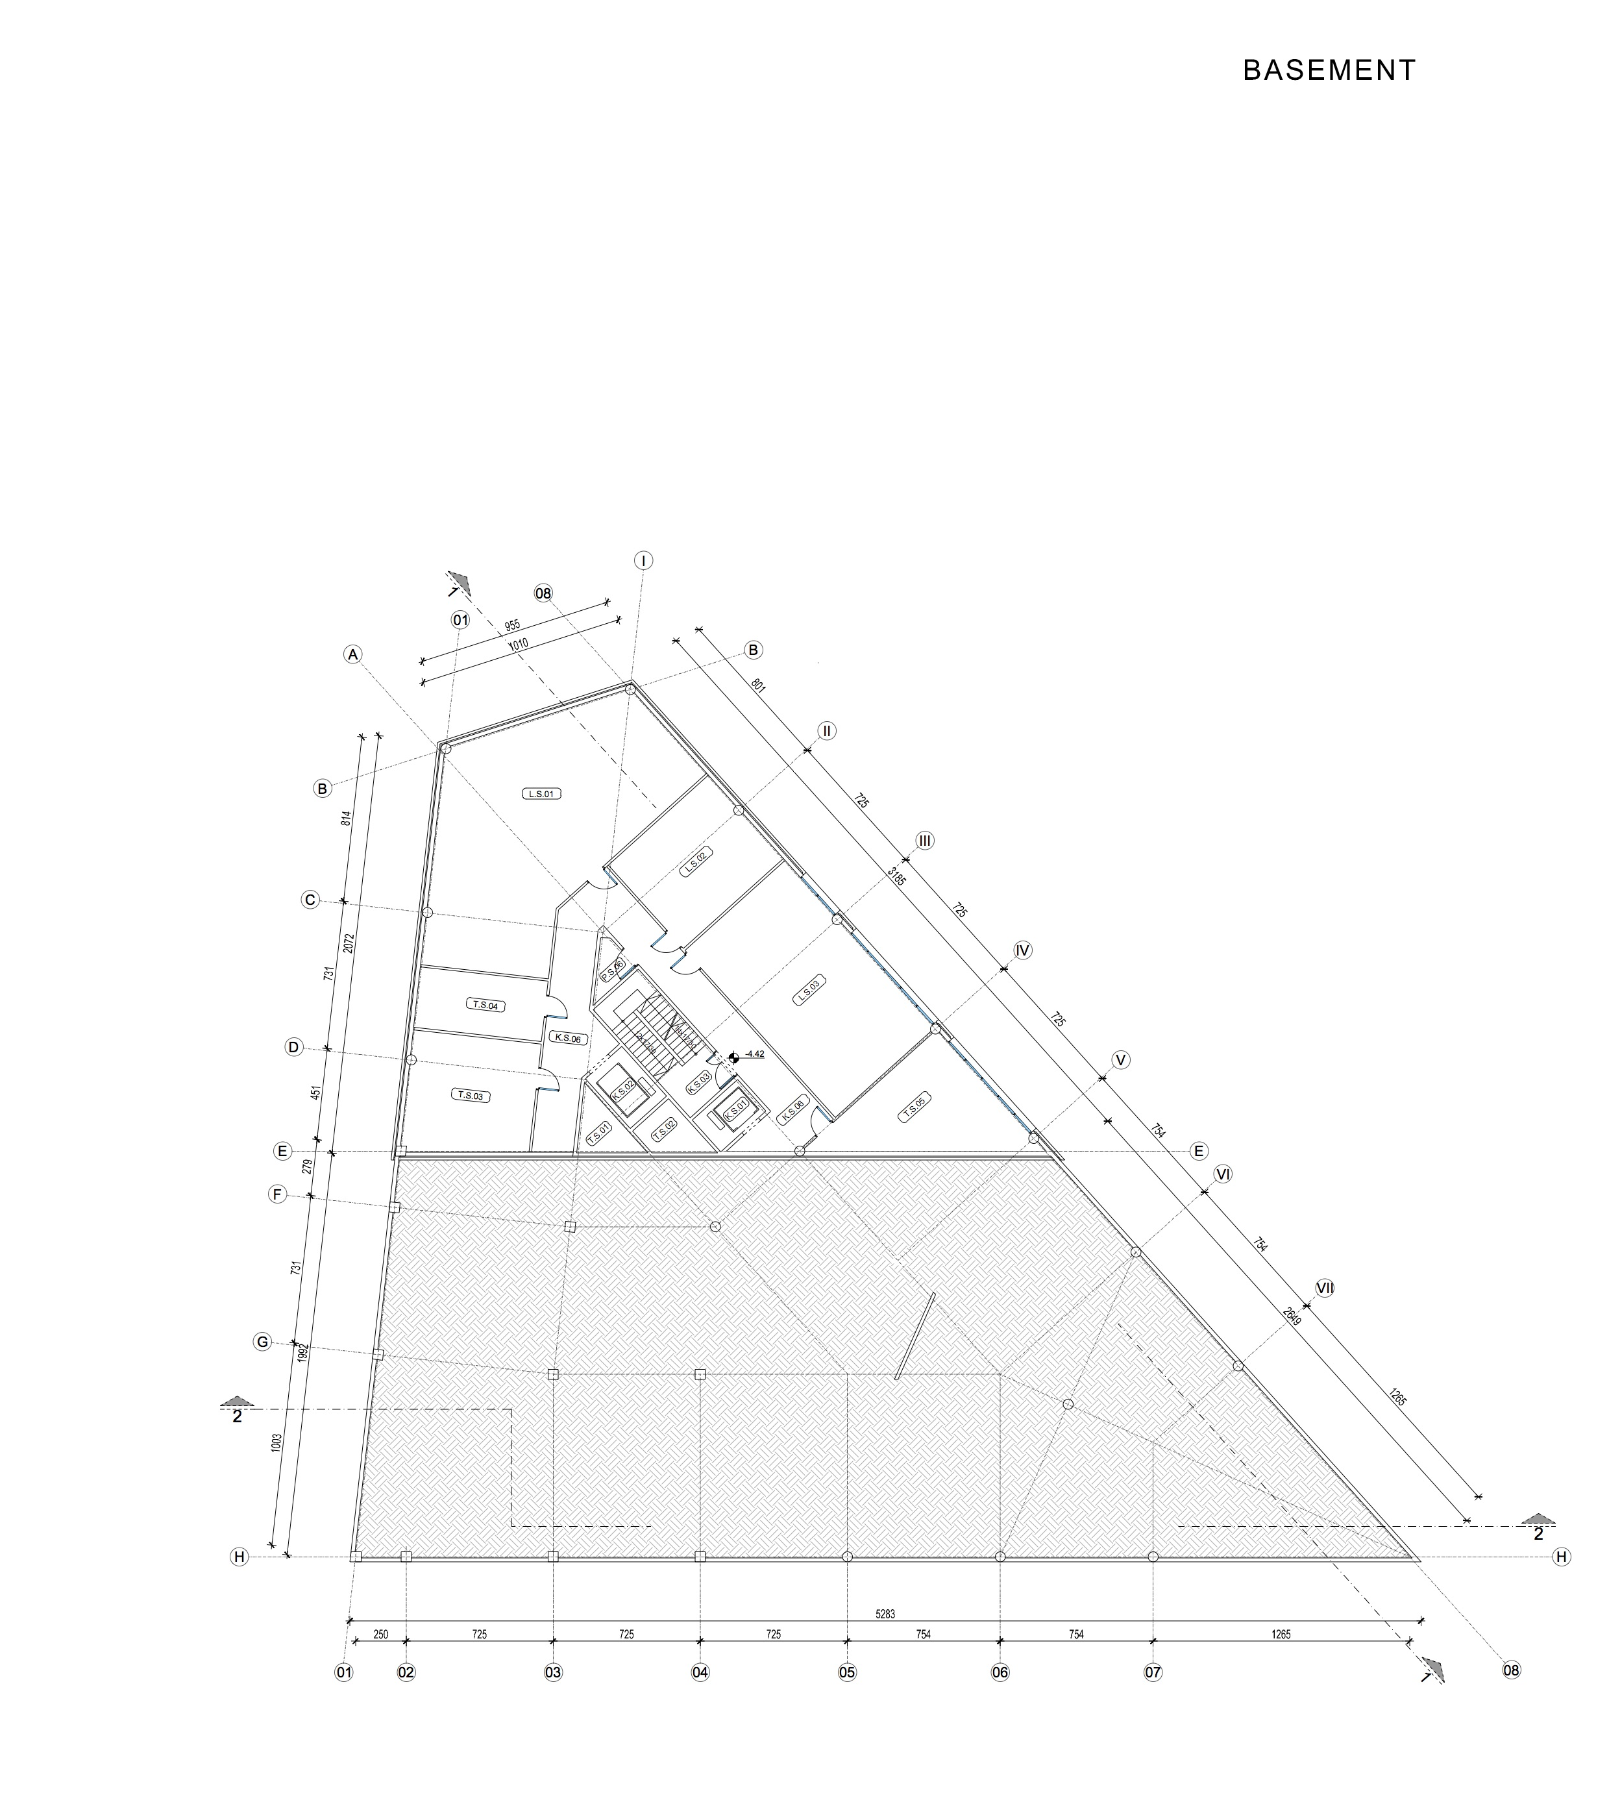
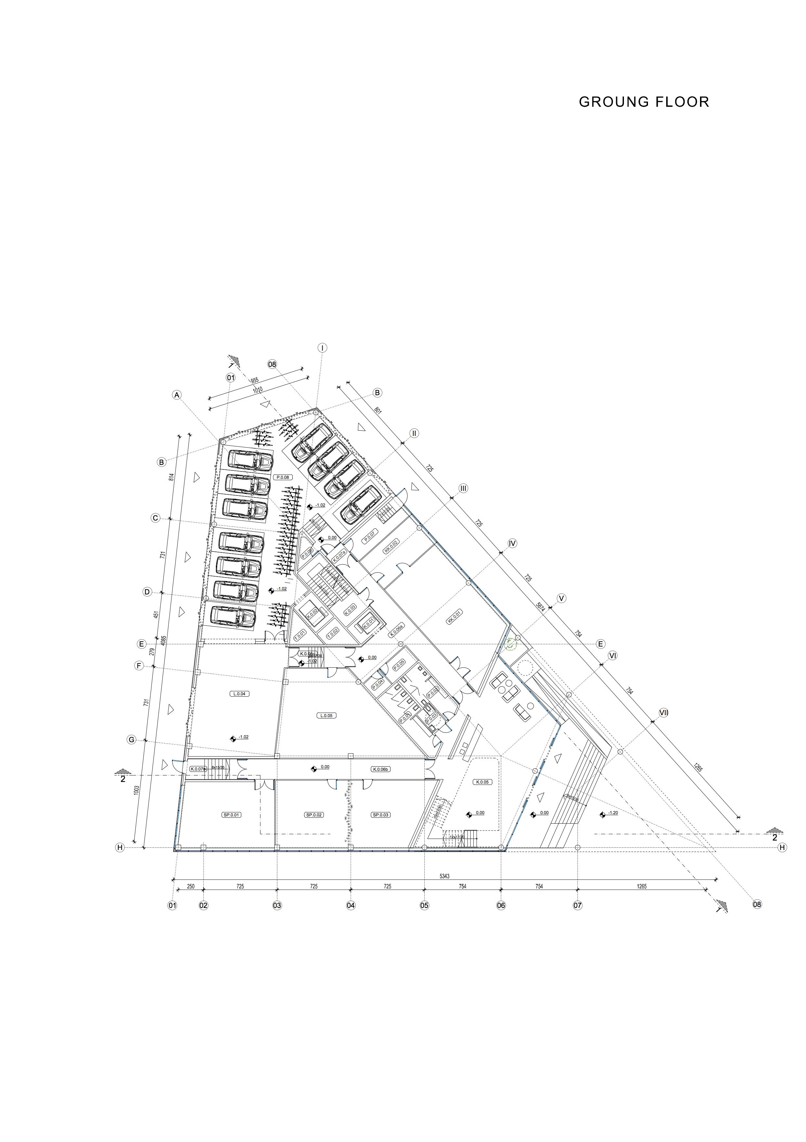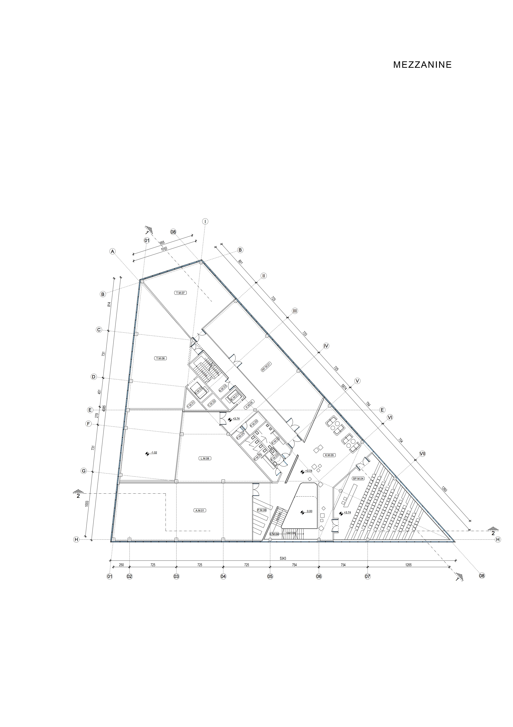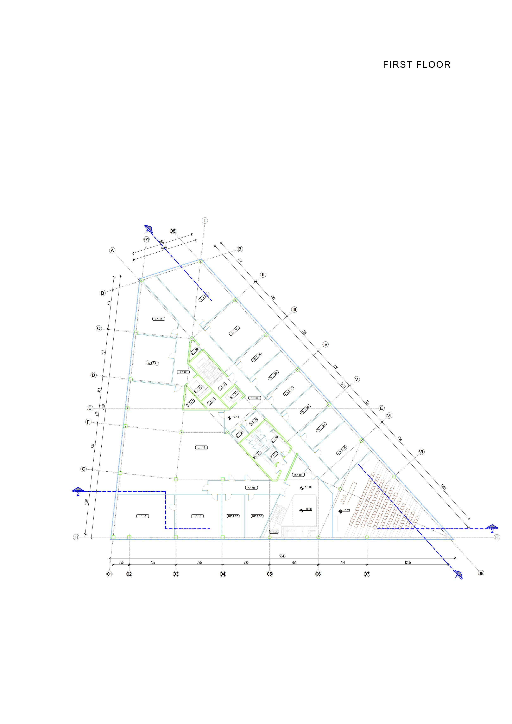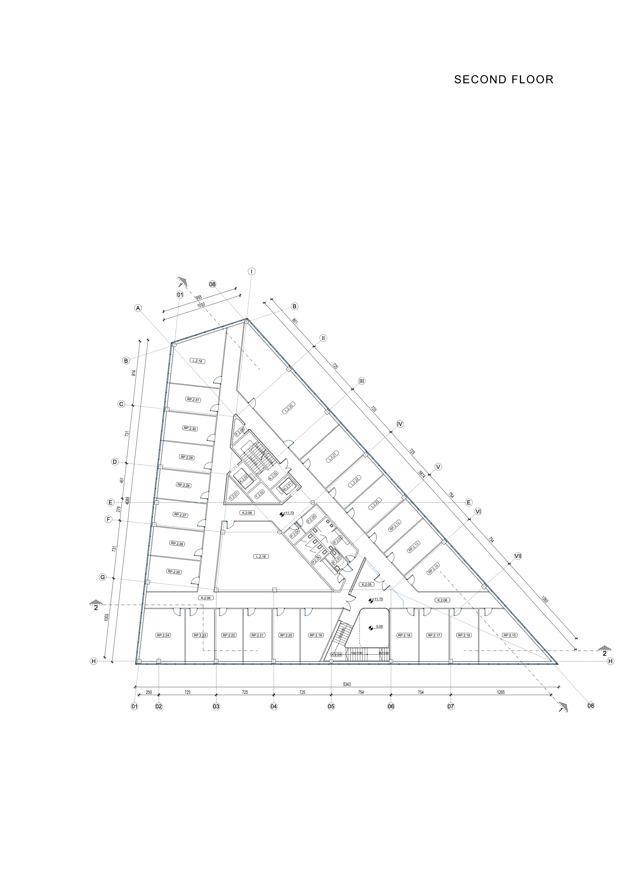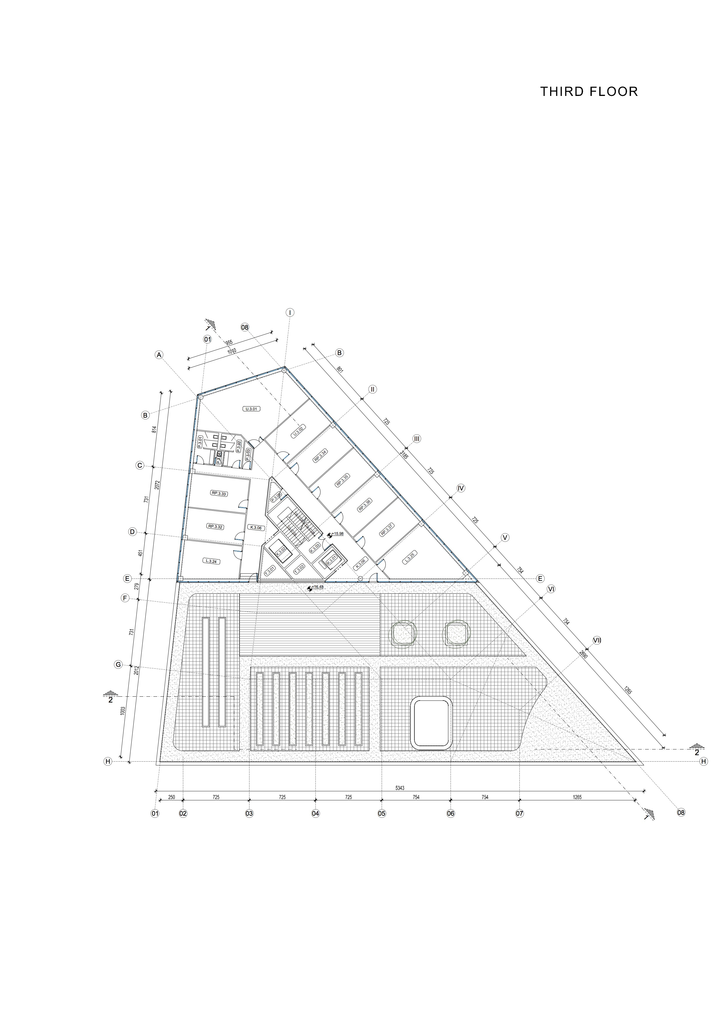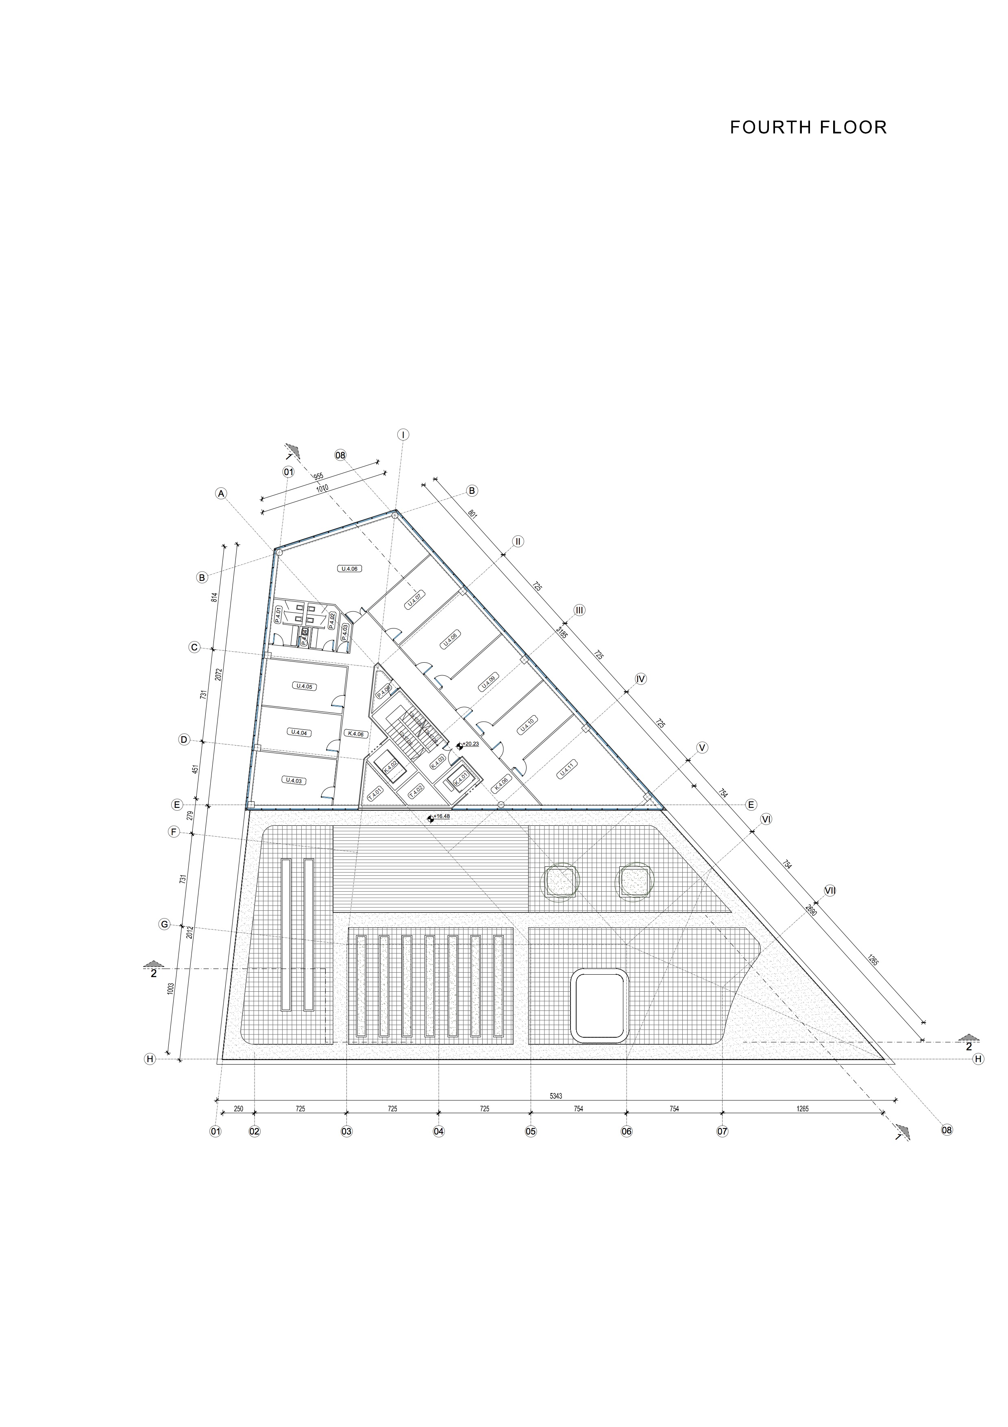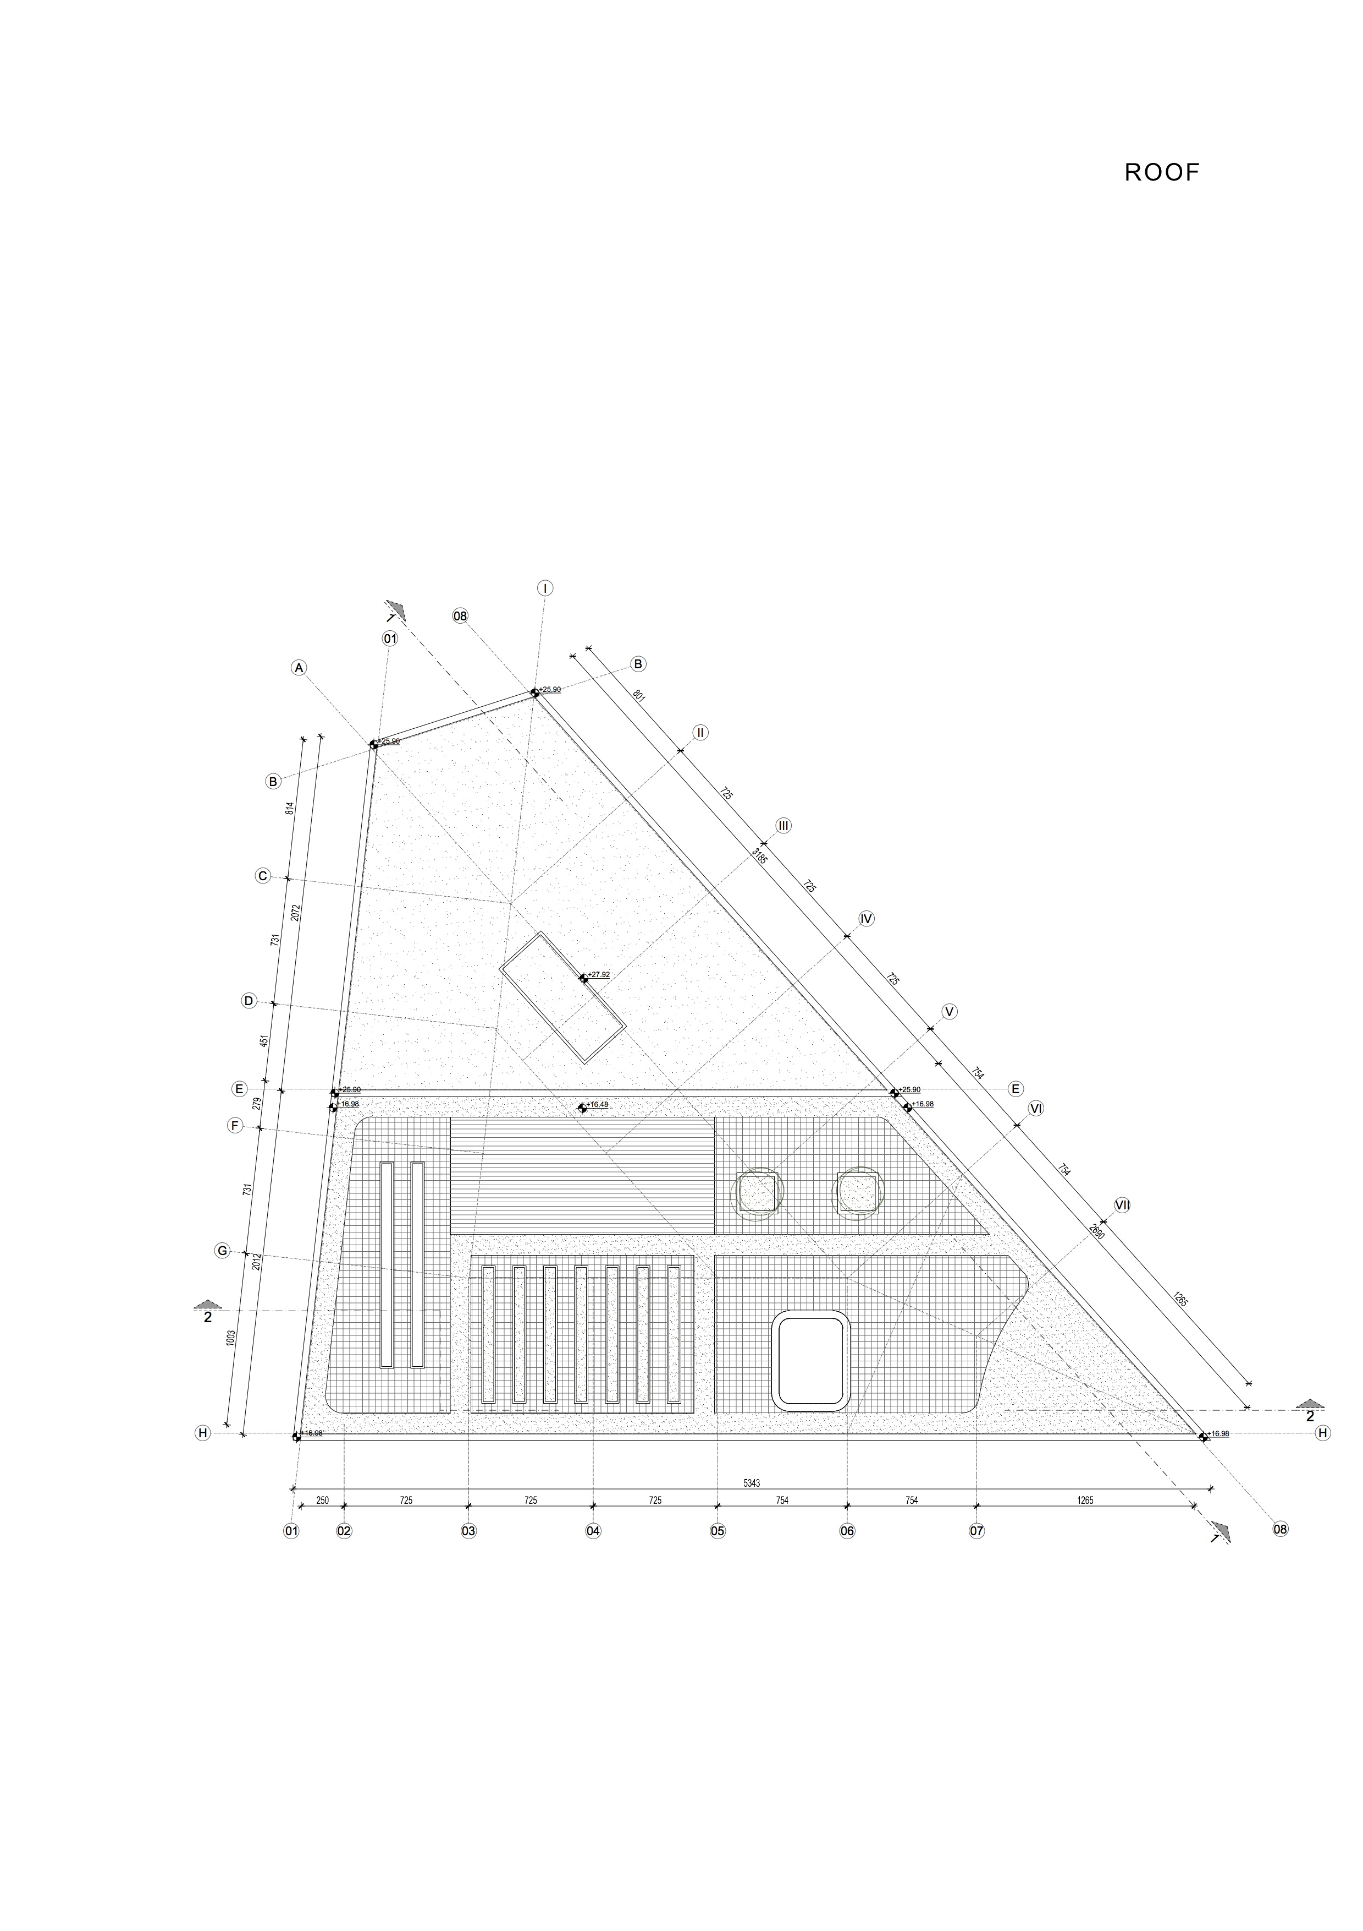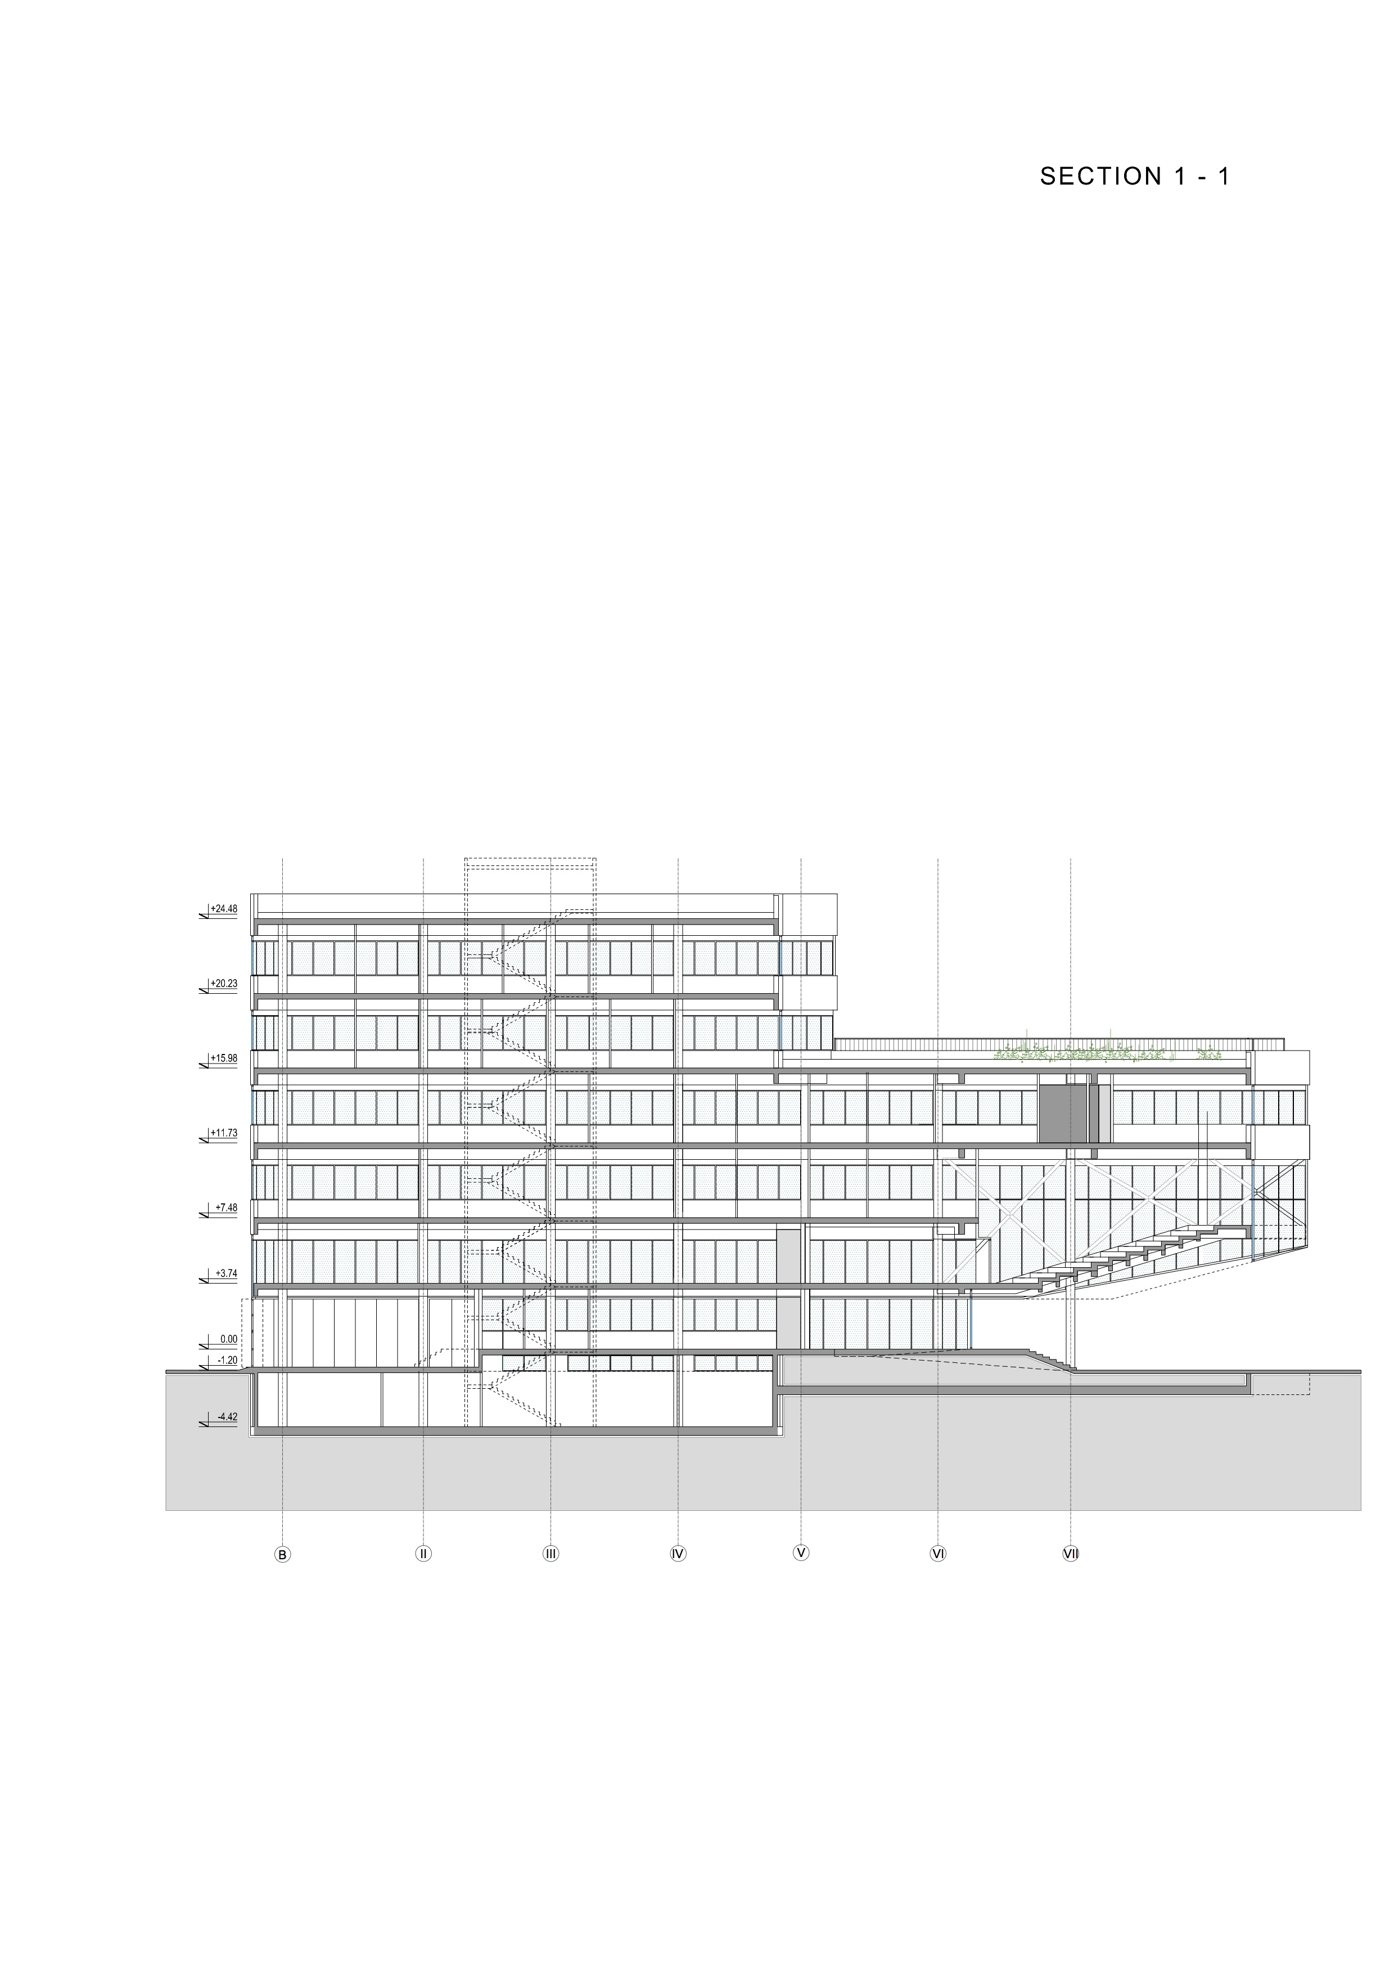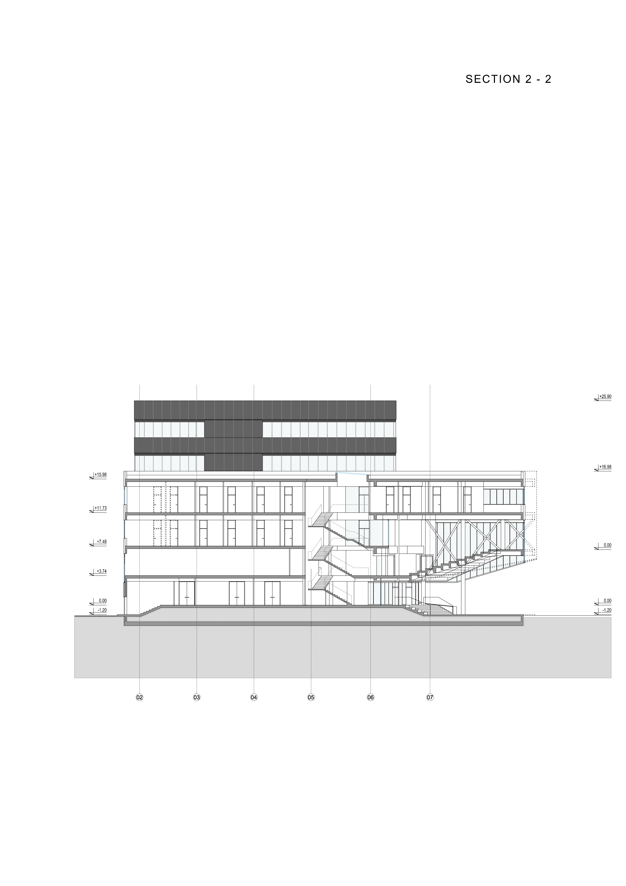
Legend to the floorplans:

BASEMENT
TYPE | INDEX |  |  |  | NAME
LABORATORIES | L.
 | L. | S. | 01 |  | laboratory
 | L. | S. | 02 |  | laboratory
 | L. | S. | 03 |  | laboratory
AUXILIARY ROOMS | P.
 | P. | S. | 06 |  | pantry
TECHNICAL ROOMS | T.
 | T. | S. | 01 |  | installation duct
 | T. | S. | 02 |  | installation duct
 | T. | S. | 03 |  | heat substation
 | T. | S. | 04 |  | space for water gauges and machine for increasing water presssure
 | T. | S. | 05 |  | janitor
COMMUNICATIONS | K.
vertical communications
 | K. | S. | 01 |  | passenger elevator
 | K. | S. | 02 |  | service elevator
 | K. | S. | 03 |  | staircase
horizontal communications
 | K. | S. | 06 |  | corridor

GROUND FLOOR
TYPE | INDEX |  |  |  | NAME
LABORATORIES | L.
 | L. | 0. | 04 |  | prototyping workshop
 | L. | 0. | 05 |  | laboratory
LECTURE AUDITORIUM | SP.
 | SP. | 0. | 01 |  | lecture auditorium 1
 | SP. | 0. | 02 |  | lecture auditorium 2
 | SP. | 0. | 03 |  | lecture auditorium 3
CANTEEN | KK.
 | KK. | 0. | 01 |  | canteen for employees
 | KK. | 0. | 02 |  | kitchen
AUXILIARY ROOMS | P.
 | P. | 0. | 01 |  | toilet W
 | P. | 0. | 02 |  | toilet M
 | P. | 0. | 03 |  | toilet disabled
 | P. | 0. | 04 |  | trocadero
 | P. | 0. | 05 |  | pantry
 | P. | 0. | 06 |  | pantry
 | P. | 0. | 07 |  | recycling
 | P. | 0. | 08 |  | covered parking lot
TECHNICAL ROOMS | T.
 | T. | 0. | 01 |  | installation duct
 | T. | 0. | 02 |  | installation duct
COMMUNICATIONS | K.
vertical communications
 | K. | 0. | 01 |  | passenger elevator
 | K. | 0. | 02 |  | service elevator
 | K. | 0. | 03 |  | staircase
horizontal communications
 | K. | 0. | 05 |  | hall
 | K. | 0. | 06 | a | corridor
 | K. | 0. | 06 | b | corridor
 | K. | 0. | 06 | c | corridor
 | K. | 0. | 07 | a | windshield
 | K. | 0. | 07 | b | windshield

MEZZANINE
TYPE | INDEX |  |  |  | NAME
LABORATORIES | L.
 | L. | M. | 08 |  | laboratory
RESEARCHERS WOORK SPACE | RP.
PhD students
 | RP. | M. | 01 |  | open-space - PhD students
ACCELERATOR | A.
 | A. | M. | 01 |  | open-space - accelerator users
LECTURE AUDITORIUM | SP.
 | SP. | M. | 04 |  | amphitheater
AUXILIARY ROOMS | P.
 | P. | M. | 01 |  | toilet W
 | P. | M. | 02 |  | toilet M
 | P. | M. | 03 |  | toilet disabled
 | P. | M. | 04 |  | trocadero
 | P. | M. | 05 |  | kichenette
 | P. | M. | 06 |  | guest coat room
TECHNICAL ROOMS | T.
 | T. | M. | 01 |  | installation duct
 | T. | M. | 02 |  | installation duct
 | T. | M. | 06 |  | technical room for installation and equipment storage
 | T. | M. | 07 |  | server room
COMMUNICATIONS | K.
vertical communications
 | K. | M. | 01 |  | passenger elevator
 | K. | M. | 02 |  | service elevator
 | K. | M. | 03 |  | staircase
 | K. | M. | 04 |  | staircase
horizontal communications
 | K. | M. | 05 |  | lobby
 | K. | M. | 06 |  | corridor

FIRST FLOOR
TYPE | INDEX |  |  |  | NAME
LABORATORIES | L.
 | L. | 1. | 10 |  | laboratory
 | L. | 1. | 11 |  | laboratory
 | L. | 1. | 12 |  | Clean rooms
 | L. | 1. | 13 |  | laboratory
 | L. | 1. | 14 |  | laboratory
 | L. | 1. | 15 |  | laboratory
 | L. | 1. | 16 |  | laboratory
RESEARCHERS’ WORK SPACE | RP.
 | RP. | 1. | 02 |  | office
 | RP. | 1. | 03 |  | office
 | RP. | 1. | 04 |  | office
 | RP. | 1. | 05 |  | office
 | RP. | 1. | 06 |  | office
 | RP. | 1. | 07 |  | office
 | RP. | 1. | 08 |  | office
 | RP. | 1. | 09 |  | office
AUXILIARY ROOMS | P.
 | P. | 1. | 01 |  | toilet W
 | P. | 1. | 02 |  | toilet M
 | P. | 1. | 03 |  | toilet disabled
 | P. | 1. | 04 |  | trocadero
 | P. | 1. | 05 |  | kichenette
 | P. | 1. | 06 |  | pantry
TECHNICAL ROOMS | T.
 | T. | 1. | 01 |  | installation duct
 | T. | 1. | 02 |  | installation duct
COMMUNICATIONS | K.
vertical communications
 | K. | 1. | 01 |  | passenger elevator
 | K. | 1. | 02 |  | service elevator
 | K. | 1. | 03 |  | staircase
 | K. | 1. | 04 |  | staircase
horizontal communications
 | K. | 1. | 05 |  | lobby
 | K. | 1. | 06 |  | corridor

SECOND FLOOR
TYPE | INDEX |  |  |  | NAME
LABORATORIES | L.
 | L. | 2. | 18 |  | laboratory
 | L. | 2. | 19 |  | laboratory
 | L. | 2. | 20 |  | laboratory
 | L. | 2. | 21 |  | laboratory
 | L. | 2. | 22 |  | laboratory
 | L. | 2. | 23 |  | laboratory
RESEARCHERS' WOORK SPACE | RP.
 | RP. | 2. | 12 |  | office
 | RP. | 2. | 13 |  | office
 | RP. | 2. | 14 |  | office
 | RP. | 2. | 15 |  | office
 | RP. | 2. | 16 |  | office
 | RP. | 2. | 17 |  | office
 | RP. | 2. | 18 |  | office
 | RP. | 2. | 19 |  | office
 | RP. | 2. | 20 |  | office
 | RP. | 2. | 21 |  | office
 | RP. | 2. | 22 |  | office
 | RP. | 2. | 23 |  | office
 | RP. | 2. | 24 |  | office
 | RP. | 2. | 25 |  | office
 | RP. | 2. | 26 |  | office
 | RP. | 2. | 27 |  | office
 | RP. | 2. | 28 |  | office
 | RP. | 2. | 29 |  | office
 | RP. | 2. | 30 |  | office
 | RP. | 2. | 31 |  | office
AUXILIARY ROOMS | P.
 | P. | 2. | 01 |  | toilet W
 | P. | 2. | 02 |  | toilet M
 | P. | 2. | 03 |  | toilet disabled
 | P. | 2. | 04 |  | trocadero
 | P. | 2. | 05 |  | kichenette
 | P. | 2. | 06 |  | pantry
TECHNICAL ROOMS | T.
 | T. | 2. | 01 |  | installation duct
 | T. | 2. | 02 |  | installation duct
COMMUNICATIONS | K.
vertical communications
 | K. | 2. | 01 |  | passenger elevator
 | K. | 2. | 02 |  | service elevator
 | K. | 2. | 03 |  | staircase
 | K. | 2. | 04 |  | staircase
horizontal communications
 | K. | 2. | 05 |  | lobby
 | K. | 2. | 06 |  | corridor

THIRD FLOOR
TYPE | INDEX |  |  |  | NAME
LABORATORIES | L.
 | L. | 3. | 24 |  | laboratory
 | L. | 3. | 25 |  | laboratory
RESEARCHERS WOORK SPACE | RP.
 | RP. | 3. | 32 |  | office
 | RP. | 3. | 33 |  | office
 | RP. | 3. | 34 |  | office
 | RP. | 3. | 35 |  | office
 | RP. | 3. | 36 |  | office
 | RP. | 3. | 37 |  | office
ADMINISTRATION | U.
 | U. | 3. | 01 |  | office
 | U. | 3. | 02 |  | office
AUXILIARY ROOMS | P.
 | P. | 3. | 01 |  | toilet W
 | P. | 3. | 02 |  | toilet M
 | P. | 3. | 03 |  | shower
 | P. | 3. | 04 |  | trocadero
 | P. | 3. | 05 |  | kichenette
TECHNICAL ROOMS | T.
 | T. | 3. | 01 |  | installation duct
 | T. | 3. | 02 |  | installation duct
COMMUNICATIONS
vertical communications
 | K. | 3. | 01 |  | passenger elevator
 | K. | 3. | 02 |  | service elevator
 | K. | 3. | 03 |  | staircase
horizontal communications
 | K. | 3. | 06 |  | corridor

FOURTH FLOOR
TYPE | INDEX |  |  |  | NAME
MANAGMENT | U.
 | U. | 4. | 03 |  | office
 | U. | 4. | 04 |  | office
 | U. | 4. | 05 |  | office
 | U. | 4. | 07 |  | office
 | U. | 4. | 06 |  | meeting room
 | U. | 4. | 08 |  | office
 | U. | 4. | 09 |  | office
 | U. | 4. | 10 |  | office
 | U. | 4. | 11 |  | office
AUXILIARY ROOMS | P.
 | P. | 4. | 01 |  | toilet W
 | P. | 4. | 02 |  | toilet M
 | P. | 4. | 03 |  | shower
 | P. | 4. | 04 |  | trocadero
 | P. | 4. | 05 |  | kichenette
TECHNICAL ROOMS | T.
 | T. | 4. | 01 |  | installation duct
 | T. | 4. | 02 |  | installation duct
COMMUNICATIONS | K
vertical communications
 | K. | 4. | 01 |  | passenger elevator
 | K. | 4. | 02 |  | service elevator
 | K. | 4. | 03 |  | staircase
horizontal communications
 | K. | 4. | 06 |  | corridor

FACADE

The design should envisage a façade combining open, glassed areas and wall sheets – parapets.
Façade walls should combine full façade grouts – parapets, from built light concrete blocks, required fire proof thermo-insulation with a finishing coat from contemporary and aesthetic plate materials, erected onto the substructure in accordance with the execution method and glassed parts of the façade, for the most part in the curtain wall system. Façade walls should fulfil all requirements regarding static stability, weather influence protection, possibility of placing installations with easy maintenance internal coating.
Part of façade walls meant to serve for stiffening, collecting and transferring seismic effects in accordance with the facility design, should be envisaged with an internal structural part from cast reinforced concrete in formwork.
Parapets should be envisaged of regulated height in compliance with the standards and norms.
In accordance with the Study on Energy Efficiency, the external façade hardware should be envisaged from high quality coated or anodized aluminum profiles with interrupted thermal bridge and insulating glass filling.
Special attention to be paid to designing protection from excessive sun radiation in the form of light fixed screens or such.
All hardware should have a good quality, aesthetic and easy used fittings, adjusted to the weight of the wings – glassed, according to wind conditions of the specific location and be fire proof and secure.
All entrance and pendular doors should be designed from reinforced aluminum profiles with glass filling from safety glass with automatic opening sensors and highest quality fittings.
On the part of the façade of the covered parking lot on the ground floor, in the full length of the parking lot façade, between façade pillars, façade dividers should be designed from foldable vertical panels – wings from aluminum profiles e.g. of the same finishing as the façade hardware per floors, with panel – wing filling from the same material the façade of the facility is designed. Opening of the wings should be designed so that they take up as less space as possible when opened, that they can be fixed in the opened position in order to provide easier entrance of vehicles onto the parking lot.
Laboratories, work spaces of the researchers and the management offices along the facade should be designed with parapets to enable rational use of space and flexibility of equipment layout. Parapets should be envisaged in the form of ventilated facades with adequate finishing layers, and all glass sections of the facade to be envisaged as curtain walls. The mezzanine should envisage a glass curtain wall in full height from ceiling to floor, with no parapet.

ROOF

The facility should have flat roofs. The lower roof section should be designed as a walk-on roof accessed from the third floor hallway. The higher roof section should be designed as a non-walk-on roof that should hold the heating and air conditioning equipment. Materials and finishing of the surfaces will be defined in the detailed design stages and must be submitted for approval and written consent of the Employer.

INTERIOR PARTITIONS, CEILINGS, HARDWARE AND WOODWORK / CHOICE OF MATERIAL

The design should envisage interior full partitions from light plaster coats on the substructure from galvanized tin profiles which enable conducting part of the installations through them.
Part of the partitions should be in combination with fixed glassed areas from single glass in aluminum profiles installed on top of the substructures from steel profiles.
All interior doors should be designed from aluminum profiles with aluminum panel or glass filling and according to the size, purpose and significance of the room. Where envisaged by the Fire protection study, full attested fire proof doors complying with fire protection requirements should be designed.

CEILINGS

All usable spaces should envisage suspended ceiling from aesthetic and fire proof safety materials. The ceilings are suspended to the designed height so that they provide unobstructed conducting and distribution of all designed installations and their easy control. In accordance with the interior and lighting designs, part of the ceiling should envisage embedded lights.
The design should envisage a combination of suspended ceiling type – Armstrong, for better accessibility to the installations and monolithic suspended plaster ceilings, in full accordance with the purpose of the rooms and the need for installations accessibility.

INTERIOR WALLS FINISHING

Depending on the interior design, type and purpose of the space, interior surfaces of the walls should be rough cast (concrete and built walls), smooth coated and colored (concrete, built walls as well as dividing plaster walls), plated with good quality ceramics (sanitary spaces), ceramics for use in the laboratories, special panel casings for clean rooms.

FLOORS

In the parts of open/covered space on the ground floor of the facility and in the part of the walk-on flat roof – terrace on the third floor, floors, treads and front covers of exterior staircase and entrance ramps from high quality stone resistant to frost, with anti-slip finishing should be envisaged.
In the part of the covered parking lot, industrial floor such as Ferro concrete floor should be envisaged.
Interior staircases should have treads and fronts from high quality and aesthetic stone with a profiled tread edge with the aim of preventing slipping or to be coated with granite ceramics.
The entrance hall floor should be finished with high class granite ceramics or aesthetic stone.
Antistatic floors to be envisaged in the selected laboratories. Chemical proof floor to be envisaged in the selected laboratory.
All working cabinets (offices) should envisage smooth floors, easy to maintain, such as PVC floors, epoxy floors, etc. All communications should also be floored with high quality smooth material resistant to wearing and envisaged for public spaces.
The management offices and administration offices should have a high quality wooden floor – such as inlaid (parquet with hard surface resistance).
Floors in sanitary spaces and the kitchen should be ceramic.

CONSTRUCTION

Design a stable and rational construction of reinforced concrete or steel, in accordance with the current national regulations.

Take into account the increased live load up to 850 kg/m2 in the special zones defined by function.

The concept of foundations should be adjusted to the conclusions and recommendations of the study on geotechnical research at the site.

Pay special attention to the part of the construction with a large span, in the amphitheater zone.

Special attention should be done on construction in the part of clean rooms since clean rooms area MUST BE secured against vibration. Process Equipment for microelectronic and nano technologies in clean rooms are highly sensitive to vibrations and because of that special design of constructions must be applied to avoid transfer of vibrations from surroundings buildings, from neighboring parts of its own building or various pieces of equipment and installations, as well as to avoid vibrations due to various resonance phenomena. ISO 5 and a portion of ISO 7 parts of the clean room will have to satisfy VC-E vibration criterion curve.

HYDROTECHNICAL INSTALLATIONS

WATER SUPPLY INSTALLATIONS

The facility needs to be supplied with sanitary drinking water and plumbing, as well as a water hydrant internal network.

The quality of the plumbing pipes needs to conform to EN12.201 and JUS ISO 4427:2001 standards. Authorized waterworks public utility company personnel needs to be consulted on any and all water supply issues and details of designs.

Hot water in the facility is envisaged through a boiler.

Internal hydraulic system is to be fitted with an auxiliary pump in case of water pressure dropping.

SEWAGE INSTALLATIONS

Facility sewer water plumbing should be connected to the urban sewer network.

ATMOSPHERIC SEWAGE INSTALLATIONS

Atmospheric sewage from the facility should be connected to the urban atmospheric sewage network. Conditionally, oily atmospheric sewage must be taken out over an adequate oil separator as defined by local regulations and as instructed by authorized public utility company personnel.

FIRE PREVENTION SOLUTIONS
Architectural and structural solutions
FIREFIGHTING VEHICLES’ ACCESS
Urban traffic lines that enable potential firefighting must be available for vehicle access from all four facades of the facility.
EVACUATION
Internal communication of the facility (access ways, hallways, staircases and exit doors) must be designed and dimensioned to enable quick and safe evacuation of the facility.
All staircases that are used for evacuation are to be equipped with windows or eye-lid windows at the highest level and are to be automatically opened by the automated fire protection center in case of fire to allow de-smoking of the staircase.
HIGHER PRESSURE VENTILATION
In all access spaces for staircases, the entrance to the main hall and the amphitheater lobby a system of higher pressure ventilation is to be planned, and is to be controlled from the fire protection signaling system.

ELECTRICAL SOLUTIONS

AUTOMATIC FIRE DETECTION AND ALARM SYSTEM

The whole facility is to be covered by automated fire detection and alarm system.
FIRE PROTECTION SYSTEM CONCEPT
The following equipment and appliances need to stay powered in case of fire, along with those powered from the backup diesel generator:
- Fire protection central unit (0 min – has its own power supply),
- Hydraulic pumps (120 min),
- Ventilation system claps (0 min – in case of fire or short circuit, they automatically close),
- Anti-smoke claps (0 min – lifted as signaled from the fire protection central unit),
- Safety lights (120 min),
- Central de-smoking system (90 min)
- Higher pressure system in areas entering staircases and evacuation routes (90 min),
- Fire protection lights (0 min – have their own power supply),
- De-smoking windows and dampers (0 min – in case of fire, they automatically open),
- Fire doors, normally open (0 min).
BACK UP POWER SUPPLY
As a backup power source, a diesel electrical power generator with an auto start function is envisaged. Plan a diesel electrical power generator for external installation.
UPS
One UPS system is envisaged, with autonomy of at least 15 min. UPS should be located in the server room, and power the installations in the server room by a separate cable system. UPS system covers all vital processes, that require continues power supply.
RESEARCH EQUIPMENT IN THE FACILITY
For selected research equipment, it is necessary to plan isolation transformer as a mean of protection, as well that all installation regarding laboratory area in the facility should be low noise electrical installation.
ELECTRIC POWER IN THE FACILITY
Safety and auxiliary backup lighting installations must be planed for protection of building occupants. In corridors and hallways along evacuation routes, back up lights are envisaged to be supplied by power from the backup generator. The light intensity should be around 30% of regular operational intensity.
SOUND
Equipment and activities that produce a high level of noise must be isolated from the rest of the facility. Visual alarms can be planed as alternatives in certain specific cases.
BMS AND ACCESS CONTROL
The whole building is planned to be energy efficient building. In that sense it is necessary to monitor and control building functions, and manage recourses and usage of energy. Monitoring and control should be from one place, and accessed by computer, or tablet. Administrative accounts must be made for accessing controls, and users must be divided into user groups. All energy going into building must be monitored, by consumption. Lighting, heating and ventilation is preferable to be set to operate by presence of people in the rooms, and laboratories, creating working and nonworking scenarios as a mean of reducing const.

Access control is needed to be planed throughout the building, dividing zones of access to public, and restricted. Service lift is also needed to be used only by authorized personnel. Access control and CCTV must function together, and cover all building area. All of these systems are placed in the control room / reception desk, and their equipment core in the server room. Server room must be covered with all safety systems, and planed with enough space for servers, and other IT equipment.

LIGHTING
As the facility needs to be designed for energy efficiency, the lighting should feature LED Lighting. Plan a smart system for Lighting control and management. Lighting requirements are listed below.

General purpose rooms:
- Hallways – day time 200 lux
- Hallways – night time 50 lux
- Bathrooms and toilets 200 lux

Offices and laboratories:
- Offices and staff rooms 200 lux
- Conference halls 500 lux
- Staff halls 200 lux
- General lights 100 lux
- Reading lights 300 lux
- Research laboratories 300 lux
- Selected research laboratories 1 500 lux
- Selected research laboratories 2 1000 lux

MECHANICAL INSTALATIONS- HVAC

Complete building (except covered parking lot and technical rooms) has to be fully air conditioned.

Design parameters

For the design, take the following outside design conditions:
- temperature/relative humidity of air during winter: -18°C / 90%
- temperature/relative humidity of air during summer: +35°C / 40%

Design parameters of temperature/humidity by rooms:

Clean rooms class ISO5 and ISO7 acc ISO 14644/1:
- temperature/relative humidity of air during winter: +21±2°C / min.20%
- temperature/relative humidity of air during winter: +21±2°C / min.20%
- temperature/relative humidity of air during summer: +24±2°C / max65%
- number of air changes: min.30 ach
- Volume of fresh air: min.3 ach
- overpressure inside the rooms: +30/15Pa

Laboratories:
- temperature/relative humidity of air during winter: +21±2°C / not treated
- temperature/relative humidity of air during summer: +25±2°C / max 65%
- Natural ventilation through windows

Laboratory spaces with no direct daylight (rooms without windows):
- temperature/relative humidity of air during winter: +21±2°C / min.20%
- temperature/relative humidity of air during summer: +24±2°C / max65%
- Volume of fresh air for laboratories according to DIN1946-7
- with constant working hours during shift: 25m³/h/m²
- with constant work during 45min: 9m³/h/m²

Working space of researchers and offices:
- temperature/relative humidity of air during winter: +21±2°C / not treated
- temperature/relative humidity of air during summer: +25±2°C / max.65%
- Natural ventilation through windows

Lecture auditoriums :
- temperature/relative humidity of air during winter: +21±2°C / not treated
- temperature/relative humidity of air during summer: +25±2°C / max 65%
- Natural ventilation through windows

Amphitheater, Amphitheater lobby, Canteen, Hall:
- temperature/relative humidity of air during winter: +21±2°C / not treated
- temperature/relative humidity of air during summer: +25±2°C / max 65%
- Volume of fresh air: 20m³/h per person

Auxiliary and technical rooms:
- temperature/relative humidity of air during winter: min.+15°C / not treated
- temperature/relative humidity of air during summer: not treated
- Volume of fresh air: 3m³/h/m²

Sanitary facilities:
- temperature/relative humidity of air during winter: min.+20°C / not treated
- temperature/relative humidity of air during summer: not treated
- Volume of exhaust air: 75m³/h per bathroom, 50m³/č per urinal

Communications:
- temperature/relative humidity of air during winter: +21±2°C / not treated
- temperature/relative humidity of air during summer: not treated
- volume of fresh air: compensation of the air exhausted from sanitary facilities

Server room:
- temperature/relative humidity of air during winter: +21±2°C / min 20%
- temperature/relative humidity of air during summer: +21±2°C / max 65%
- Volume of fresh air: Supply, +100 m³/h

SUPPLY OF HEATING/COOLING ENERGY

The building is cooled/heated with Air- cooled heat pumps which are located on the roof of the building.
Two working and one spare heat pump has to be designed to ensure constant heat energy supply.
During winter time, if the heat pump as a source of energy is not sufficient supply of the facility with thermal energy is provided through JKP Novosadska toplana.
Heat substation is located in the technical room in the basement of the building.
Space for AHU is proposed to be located on the first floor – the same level where clean room is located.

- Team Composition & Qualification Requirements for the Key Experts (and any other requirements which will be used for evaluating the Key Experts under Data Sheet 21.1 of the ITC)

As stipulated in Qualification Requirements and ITC 21.1. It is paramount to provide information on the soundness of the team composition that will enable a speedy design and issuance of the construction permit and supervision of civil works.

- Reporting Requirements and Time Schedule for Deliverables

The Consultant shall submit to the client a regular monthly report on acitivities in three copies. The monthly report should be formatted as a status report – detailing alignment with the proposed time plan as tendered. The language of the monthly report is English.

Any and all Plans required by local regulations are to be submitted to the Client in three copies as soon as they are to be submitted to the authorities and/or are ready to be reviewed as required by law. The technical and administrative documents that are to be submitted to authorities and local counterparts are to be in Serbian (three copies).

Taking any action under a civil works contract designating the Consultant as “Engineer”, for which action, pursuant to such civil works contract, the written approval of the Client as “Employer” is required, shall be also required accordingly.

- Environmental and Social Policy

- apply good international industry practice to protect and conserve the natural environment and to minimize unavoidable impacts;
- provide and maintain a healthy and safe work environment and safe systems of work;
- protect the health and safety of local communities and users, with particular concern for those who are disabled, elderly, or otherwise vulnerable;
- ensure that terms of employment and working conditions of all workers engaged in the Works meet the requirements of the ILO labor conventions to which the host country is a signatory;
- be intolerant of, and enforce disciplinary measures for illegal activities. To be intolerant of, and enforce disciplinary measures for GBV, child sacrifice, child defilement, and sexual harassment;
- incorporate a gender perspective and provide an enabling environment where women and men have equal opportunity to participate in, and benefit from, planning and development of the Works;
- work co-operatively, including with end users of the Works, relevant authorities, contractors and local communities;
- engage with and listen to affected persons and organizations and be responsive to their concerns, with special regard for vulnerable, disabled, and elderly people;
- provide an environment that fosters the exchange of information, views, and ideas that is free of any fear of retaliation;
- minimize the risk of HIV transmission and to mitigate the effects of HIV/AIDS associated with the execution of the Works;

Requirements and Scope of Services
Key Expert/s: Environment, Social, Health and Safety (ESHS)

Qualification for the ESHS Key Experts:
The Key Expert/s shall have the appropriate level of academic and professional qualifications and experience to recognize and to deliver good international industry practice with respect to Environment, Social, Health and Safety (ESHS).
Scope of ESHS Key Expert Services, tasks and expected deliverables
Ensure the Contractor’s ESHS performance is in accordance with good international industry practice and delivers the Contractor’s ESHS obligations.

This includes, but is not limited to:
- review and approve the Contractor’s Environment and Social Management Plan (C-ESMP), including all updates and revisions (not less than once every 6 monthly);
- review and approve ESHS provisions of method statements plans, proposals, schedules and all relevant Contractor’s documents;
- review and advise the relevant person (of the Engineer) on the ESHS risks and impacts of any design change proposals and the implications for compliance with ESIA, ESMP, consent/permits and other relevant project requirements;
- undertake audits, supervisions and/or inspections of any sites where the Contractor is undertaking activities related to the Works, to verify the Contractor’s compliance with ESHS requirements, with and without contractor and/or client relevant representatives, as necessary, but not less than once per month
- undertake audits and inspections of Contractor’s accident logs, community liaison records, monitoring findings and other ESHS related documentation, as necessary, to confirm the Contractor’s compliance with ESHS requirements;
- agree remedial action/s and their timeframe for implementation in the event of a noncompliance with the Contractor’s ESHS obligations;
- attend meetings including site meetings, progress meetings to discuss and agree appropriate actions to ensure compliance with ESHS obligations;
- check that the Contractor’s actual reporting (content and timeliness) is in accordance with the Contractor’s contractual obligations;
- review and critique, in a timely manner, the Contractor’s ESHS documentation (including regular reports and incident reports) submitted to Key Expert with overall responsibility for the Engineer and to provide advice to ensure the accuracy and efficacy of the documentation
- undertake liaison, from time to time and as necessary, with project stakeholders to identify and discuss any actual or potential ESHS issues, and report to Key Expert with overall responsibility for the Engineer;
- prepare a brief monthly report that describes the work that the Engineer’s ESHS Key Expert/s have undertaken, the issues (including any Contractor’s ESHS noncompliance) identified and the actions taken to address the issues.

Lump-Sum Form of Contract

STANDARD FORM OF CONTRACT

Consultant’s Services
Lump-Sum

Contract for Consultant’s Services

Lump-Sum

Project Name ___________________________

[Loan/Credit/Grant] No.____________________

Contract No. ____________________________
Assignment Title:_____________________________

between

[Name of the Client]

and

[Name of the Consultant]

Dated:

Form of Contract
Lump-Sum

(Text in brackets [ ] is optional; all notes should be deleted in the final text)

This CONTRACT (hereinafter called the “Contract”) is made the [number] day of the month of [month], [year], between, on the one hand, [name of Client or Recipient] (hereinafter called the “Client”) and, on the other hand, [name of Consultant] (hereinafter called the “Consultant”).

[If the Consultant consist of more than one entity, the above should be partially amended to read as follows: “…(hereinafter called the “Client”) and, on the other hand, a Joint Venture (name of the JV) consisting of the following entities, each member of which will be jointly and severally liable to the Client for all the Consultant’s obligations under this Contract, namely, [name of member] and [name of member] (hereinafter called the “Consultant”).]

WHEREAS

(a) the Client has requested the Consultant to provide certain consulting services as defined in this Contract (hereinafter called the “Services”);

(b) the Consultant, having represented to the Client that it has the required professional skills, expertise and technical resources, has agreed to provide the Services on the terms and conditions set forth in this Contract;

(c) the Client has received a loan from the European Investment Bank toward the cost of the Services and intends to apply a portion of the proceeds of loan to eligible payments under this Contract, it being understood that (i) payments by the Bank will be made only at the request of the Client and upon approval by the Bank; (ii) such payments will be subject, in all respects, to the terms and conditions of the loan agreement, including prohibitions of withdrawal from the loan account for the purpose of any payment to persons or entities, or for any import of goods, if such payment or import, to the knowledge of the Bank, is prohibited by the decision of the United Nations Security council taken under Chapter VII of the Charter of the United Nations; and (iii) no party other than the Client shall derive any rights from the loan agreement or have any claim to the loan proceeds;

NOW THEREFORE the parties hereto hereby agree as follows:

1. The following documents attached hereto shall be deemed to form an integral part of this Contract:

(a) The General Conditions of Contract (including Attachment 1 “Fraud and Corruption”);
(b) The Special Conditions of Contract;
(c) Appendices:

Appendix A: Terms of Reference
Appendix B: Key Experts
Appendix C: Breakdown of Contract Price
Appendix D: Forms of Advance Payments Guarantee and Performance Guarantee

In the event of any inconsistency between the documents, the following order of precedence shall prevail: the Special Conditions of Contract; the General Conditions of Contract, including Attachment 1; Appendix A; Appendix B; Appendix C; Appendix D. Any reference to this Contract shall include, where the context permits, a reference to its Appendices.

2. The mutual rights and obligations of the Client and the Consultant shall be as set forth in the Contract, in particular:

(a) the Consultant shall carry out the Services in accordance with the provisions of the Contract; and
(b) the Client shall make payments to the Consultant in accordance with the provisions of the Contract.

IN WITNESS WHEREOF, the Parties hereto have caused this Contract to be signed in their respective names as of the day and year first above written.

For and on behalf of [Name of Client]

[Authorized Representative of the Client – name, title and signature]

For and on behalf of [Name of Consultant or Name of a Joint Venture]

[Authorized Representative of the Consultant – name and signature]

[For a joint venture, either all members shall sign or only the lead member, in which case the power of attorney to sign on behalf of all members shall be attached.

For and on behalf of each of the members of the Consultant [insert the Name of the Joint Venture]

[Name of the lead member]

[Authorized Representative on behalf of a Joint Venture]

[add signature blocks for each member if all are signing]

General Conditions of Contract

A. General Provisions
- Definitions | 1.1 Unless the context otherwise requires, the following terms whenever used in this Contract have the following meanings:  - “Applicable Law” means the laws and any other instruments having the force of law in the Client’s country, or in such other country as may be specified in the Special Conditions of Contract (SCC), as they may be issued and in force from time to time.  - “Applicable Regulations” means Procurement Regulations for IPF Borrowers of date specified in Special Conditions of Contract (SCC).  - “Bank” means European Investment Bank (EIB).  - “Borrower” means the Government, Government agency or other entity that signs the financing agreement with the Bank.  - “Client” means the implementing agency that signs the Contract for the Services with the Selected Consultant.  - “Consultant” means a legally-established professional consulting firm or entity selected by the Client to provide the Services under the signed Contract.  - “Contract” means the legally binding written agreement signed between the Client and the Consultant and which includes all the attached documents listed in its paragraph 1 of the Form of Contract (the General Conditions (GCC), the Special Conditions (SCC), and the Appendices).  - “Day” means a working day unless indicated otherwise.  - “Effective Date” means the date on which this Contract comes into force and effect pursuant to Clause GCC 11.  - “Experts” means, collectively, Key Experts, Non-Key Experts, or any other personnel of the Consultant, Sub-consultant or JV member(s) assigned by the Consultant to perform the Services or any part thereof under the Contract.  - “Foreign Currency” means any currency other than the currency of the Client’s country.  - “GCC” means these General Conditions of Contract.  - “Government” means the government of the Client’s country.  - “Joint Venture (JV)” means an association with or without a legal personality distinct from that of its members, of more than one entity where one member has the authority to conduct all businesses for and on behalf of any and all the members of the JV, and where the members of the JV are jointly and severally liable to the Client for the performance of the Contract.  - “Key Expert(s)” means an individual professional whose skills, qualifications, knowledge and experience are critical to the performance of the Services under the Contract and whose Curricula Vitae (CV) was taken into account in the technical evaluation of the Consultant’s proposal.  - “Local Currency” means the currency of the Client’s country.  - “Non-Key Expert(s)” means an individual professional provided by the Consultant or its Sub-consultant to perform the Services or any part thereof under the Contract.  - “Party” means the Client or the Consultant, as the case may be, and “Parties” means both of them.  - “Procurement Regulations” means Guide to Procurement for Projects Financed by the EIB,  - “SCC” means the Special Conditions of Contract by which the GCC may be amended or supplemented but not over-written.  - “Services” means the work to be performed by the Consultant pursuant to this Contract, as described in Appendix A hereto.  - “Sub-consultants” means an entity to whom/which the Consultant subcontracts any part of the Services while remaining solely liable for the execution of the Contract.  - “Third Party” means any person or entity other than the Government, the Client, the Consultant or a Sub-consultant.
Relationship between the Parties | - Nothing contained herein shall be construed as establishing a relationship of master and servant or of principal and agent as between the Client and the Consultant. The Consultant, subject to this Contract, has complete charge of the Experts and Sub-consultants, if any, performing the Services and shall be fully responsible for the Services performed by them or on their behalf hereunder.
Law Governing Contract | - This Contract, its meaning and interpretation, and the relation between the Parties shall be governed by the Applicable Law.
Language | - This Contract has been executed in the language specified in the SCC, which shall be the binding and controlling language for all matters relating to the meaning or interpretation of this Contract.
Headings | - The headings shall not limit, alter or affect the meaning of this Contract.
Communications | - Any communication required or permitted to be given or made pursuant to this Contract shall be in writing in the language specified in Clause GCC 4. Any such notice, request or consent shall be deemed to have been given or made when delivered in person to an authorized representative of the Party to whom the communication is addressed, or when sent to such Party at the address specified in the SCC.  - A Party may change its address for notice hereunder by giving the other Party any communication of such change to the address specified in the SCC.
Location | - The Services shall be performed at such locations as are specified in Appendix A hereto and, where the location of a particular task is not so specified, at such locations, whether in the Government’s country or elsewhere, as the Client may approve.
Authority of Member in Charge | - In case the Consultant is a Joint Venture, the members hereby authorize the member specified in the SCC to act on their behalf in exercising all the Consultant’s rights and obligations towards the Client under this Contract, including without limitation the receiving of instructions and payments from the Client.
Authorized Representatives | - Any action required or permitted to be taken, and any document required or permitted to be executed under this Contract by the Client or the Consultant may be taken or executed by the officials specified in the SCC.
Fraud and Corruption | 10.1 The Bank requires compliance with the Bank’s Policy on preventing and deterring prohibited conduct.
a. Commissions and Fees | 10.2 The Client requires the Consultant to disclose any commissions, gratuities or fees that may have been paid or are to be paid to agents or any other party with respect to the selection process or execution of the Contract. The information disclosed must include at least the name and address of the agent or other party, the amount and currency, and the purpose of the commission, gratuity or fee. Failure to disclose such commissions, gratuities or fees may result in termination of the Contract and/or sanctions by the Bank.

B. Commencement, Completion, Modification and Termination of Contract
Effectiveness of Contract | - This Contract shall come into force and effect on the date (the “Effective Date”) of the Client’s notice to the Consultant instructing the Consultant to begin carrying out the Services. This notice shall confirm that the effectiveness conditions, if any, listed in the SCC have been met.
Termination of Contract for Failure to Become Effective | - If this Contract has not become effective within such time period after the date of Contract signature as specified in the SCC, either Party may, by not less than twenty two (22) days written notice to the other Party, declare this Contract to be null and void, and in the event of such a declaration by either Party, neither Party shall have any claim against the other Party with respect hereto.
Commencement of Services | - The Consultant shall confirm availability of Key Experts and begin carrying out the Services not later than the number of days after the Effective Date specified in the SCC.
Expiration of Contract | - Unless terminated earlier pursuant to Clause GCC 19 hereof, this Contract shall expire at the end of such time period after the Effective Date as specified in the SCC.
Entire Agreement | - This Contract contains all covenants, stipulations and provisions agreed by the Parties. No agent or representative of either Party has authority to make, and the Parties shall not be bound by or be liable for, any statement, representation, promise or agreement not set forth herein.
Modifications or Variations | - Any modification or variation of the terms and conditions of this Contract, including any modification or variation of the scope of the Services, may only be made by written agreement between the Parties. However, each Party shall give due consideration to any proposals for modification or variation made by the other Party.  - In cases of substantial modifications or variations, the prior written consent of the Bank is required.

Force Majeure
a. Definition | - For the purposes of this Contract, “Force Majeure” means an event which is beyond the reasonable control of a Party, is not foreseeable, is unavoidable, and makes a Party’s performance of its obligations hereunder impossible or so impractical as reasonably to be considered impossible under the circumstances, and subject to those requirements, includes, but is not limited to, war, riots, civil disorder, earthquake, fire, explosion, storm, flood or other adverse weather conditions, strikes, lockouts or other industrial action confiscation or any other action by Government agencies.  - Force Majeure shall not include (i) any event which is caused by the negligence or intentional action of a Party or such Party’s Experts, Sub-consultants or agents or employees, nor (ii) any event which a diligent Party could reasonably have been expected to both take into account at the time of the conclusion of this Contract, and avoid or overcome in the carrying out of its obligations hereunder.  - Force Majeure shall not include insufficiency of funds or failure to make any payment required hereunder.
b. No Breach of Contract | - The failure of a Party to fulfill any of its obligations hereunder shall not be considered to be a breach of, or default under, this Contract insofar as such inability arises from an event of Force Majeure, provided that the Party affected by such an event has taken all reasonable precautions, due care and reasonable alternative measures, all with the objective of carrying out the terms and conditions of this Contract.
c. Measures to be Taken | - A Party affected by an event of Force Majeure shall continue to perform its obligations under the Contract as far as is reasonably practical, and shall take all reasonable measures to minimize the consequences of any event of Force Majeure.  - A Party affected by an event of Force Majeure shall notify the other Party of such event as soon as possible, and in any case not later than fourteen (14) calendar days following the occurrence of such event, providing evidence of the nature and cause of such event, and shall similarly give written notice of the restoration of normal conditions as soon as possible.  - Any period within which a Party shall, pursuant to this Contract, complete any action or task, shall be extended for a period equal to the time during which such Party was unable to perform such action as a result of Force Majeure.  - During the period of their inability to perform the Services as a result of an event of Force Majeure, the Consultant, upon instructions by the Client, shall either:  (a) demobilize, in which case the Consultant shall be reimbursed for additional costs they reasonably and necessarily incurred, and, if required by the Client, in reactivating the Services; or  (b) continue with the Services to the extent reasonably possible, in which case the Consultant shall continue to be paid under the terms of this Contract and be reimbursed for additional costs reasonably and necessarily incurred.  - In the case of disagreement between the Parties as to the existence or extent of Force Majeure, the matter shall be settled according to Clauses GCC 44 & 45.
Suspension | The Client may, by written notice of suspension to the Consultant, suspend part or all payments to the Consultant hereunder if the Consultant fails to perform any of its obligations under this Contract, including the carrying out of the Services, provided that such notice of suspension (i) shall specify the nature of the failure, and (ii) shall request the Consultant to remedy such failure within a period not exceeding thirty (30) calendar days after receipt by the Consultant of such notice of suspension.
Termination | 19.1. This Contract may be terminated by either Party as per provisions set up below:
a. By the Client | 19.1.1. The Client may terminate this Contract in case of the occurrence of any of the events specified in paragraphs (a) through (f) of this Clause. In such an occurrence the Client shall give at least thirty (30) calendar days’ written notice of termination to the Consultant in case of the events referred to in (a) through (d); at least sixty (60) calendar days’ written notice in case of the event referred to in (e); and at least five (5) calendar days’ written notice in case of the event referred to in (f):  (a) If the Consultant fails to remedy a failure in the performance of its obligations hereunder, as specified in a notice of suspension pursuant to Clause GCC 18;  (b) If the Consultant becomes (or, if the Consultant consists of more than one entity, if any of its members becomes) insolvent or bankrupt or enter into any agreements with their creditors for relief of debt or take advantage of any law for the benefit of debtors or go into liquidation or receivership whether compulsory or voluntary;  (c) If the Consultant fails to comply with any final decision reached as a result of arbitration proceedings pursuant to Clause GCC 45.1;  (d) If, as the result of Force Majeure, the Consultant is unable to perform a material portion of the Services for a period of not less than sixty (60) calendar days;  (e) If the Client, in its sole discretion and for any reason whatsoever, decides to terminate this Contract;  (f) If the Consultant fails to confirm availability of Key Experts as required in Clause GCC 13.  19.1.2. Furthermore, if the Client determines that the Consultant has engaged in Fraud and Corruption in competing for or in executing the Contract, then the Client may, after giving fourteen (14) calendar days written notice to the Consultant, terminate the Consultant's employment under the Contract.
b. By the Consultant | 19.1.3. The Consultant may terminate this Contract, by not less than thirty (30) calendar days’ written notice to the Client, in case of the occurrence of any of the events specified in paragraphs (a) through (d) of this Clause.  (a) If the Client fails to pay any money due to the Consultant pursuant to this Contract and not subject to dispute pursuant to Clause GCC 45.1 within forty-five (45) calendar days after receiving written notice from the Consultant that such payment is overdue.  (b) If, as the result of Force Majeure, the Consultant is unable to perform a material portion of the Services for a period of not less than sixty (60) calendar days.  (c) If the Client fails to comply with any final decision reached as a result of arbitration pursuant to Clause GCC 45.1.  (d) If the Client is in material breach of its obligations pursuant to this Contract and has not remedied the same within forty-five (45) days (or such longer period as the Consultant may have subsequently approved in writing) following the receipt by the Client of the Consultant’s notice specifying such breach.
c. Cessation of Rights and Obligations | 19.1.4. Upon termination of this Contract pursuant to Clauses GCC 12 or GCC 19 hereof, or upon expiration of this Contract pursuant to Clause GCC 14, all rights and obligations of the Parties hereunder shall cease, except (i) such rights and obligations as may have accrued on the date of termination or expiration, (ii) the obligation of confidentiality set forth in Clause GCC 22, (iii) the Consultant’s obligation to permit inspection, copying and auditing of their accounts and records set forth in Clause GCC 25 and to cooperate and assist in any inspection or investigation, and (iv) any right which a Party may have under the Applicable Law.
d. Cessation of Services | 19.1.5. Upon termination of this Contract by notice of either Party to the other pursuant to Clauses GCC 19a or GCC 19b, the Consultant shall, immediately upon dispatch or receipt of such notice, take all necessary steps to bring the Services to a close in a prompt and orderly manner and shall make every reasonable effort to keep expenditures for this purpose to a minimum. With respect to documents prepared by the Consultant and equipment and materials furnished by the Client, the Consultant shall proceed as provided, respectively, by Clauses GCC 27 or GCC 28.
e. Payment upon Termination | 19.1.6. Upon termination of this Contract, the Client shall make the following payments to the Consultant:  (a) payment for Services satisfactorily performed prior to the effective date of termination; and  (b) in the case of termination pursuant to paragraphs (d) and (e) of Clause GCC 19.1.1, reimbursement of any reasonable cost incidental to the prompt and orderly termination of this Contract, including the cost of the return travel of the Experts.

C. Obligations of the Consultant

General
a. Standard of Performance | 20.1 The Consultant shall perform the Services and carry out the Services with all due diligence, efficiency and economy, in accordance with generally accepted professional standards and practices, and shall observe sound management practices, and employ appropriate technology and safe and effective equipment, machinery, materials and methods. The Consultant shall always act, in respect of any matter relating to this Contract or to the Services, as a faithful adviser to the Client, and shall at all times support and safeguard the Client’s legitimate interests in any dealings with the third parties.  20.2. The Consultant shall employ and provide such qualified and experienced Experts and Sub-consultants as are required to carry out the Services.  20.3. The Consultant may subcontract part of the Services to an extent and with such Key Experts and Sub-consultants as may be approved in advance by the Client. Notwithstanding such approval, the Consultant shall retain full responsibility for the Services.
b. Law Applicable to Services | 20.4. The Consultant shall perform the Services in accordance with the Contract and the Applicable Law and shall take all practicable steps to ensure that any of its Experts and Sub-consultants, comply with the Applicable Law.  20.5. Throughout the execution of the Contract, the Consultant shall comply with the import of goods and services prohibitions in the Client’s country when  (a) as a matter of law or official regulations, the Borrower’s country prohibits commercial relations with that country; or  (b) by an act of compliance with a decision of the United Nations Security Council taken under Chapter VII of the Charter of the United Nations, the Borrower’s Country prohibits any import of goods from that country or any payments to any country, person, or entity in that country.  20.6. The Client shall notify the Consultant in writing of relevant local customs, and the Consultant shall, after such notification, respect such customs.
Conflict of Interest | 21.1. The Consultant shall hold the Client’s interests paramount, without any consideration for future work, and strictly avoid conflict with other assignments or their own corporate interests.
a. Consultant Not to Benefit from Commissions, Discounts, etc. | 21.1.1 The payment of the Consultant pursuant to GCC F (Clauses GCC 38 through 42) shall constitute the Consultant’s only payment in connection with this Contract and, subject to Clause GCC 21.1.3, the Consultant shall not accept for its own benefit any trade commission, discount or similar payment in connection with activities pursuant to this Contract or in the discharge of its obligations hereunder, and the Consultant shall use its best efforts to ensure that any Sub-consultants, as well as the Experts and agents of either of them, similarly shall not receive any such additional payment.  21.1.2 Furthermore, if the Consultant, as part of the Services, has the responsibility of advising the Client on the procurement of goods, works or services, the Consultant shall comply with the Bank’s Applicable Regulations, and shall at all times exercise such responsibility in the best interest of the Client. Any discounts or commissions obtained by the Consultant in the exercise of such procurement responsibility shall be for the account of the Client.
b. Consultant and Affiliates Not to Engage in Certain Activities | 21.1.3 The Consultant agrees that, during the term of this Contract and after its termination, the Consultant and any entity affiliated with the Consultant, as well as any Sub-consultants and any entity affiliated with such Sub-consultants, shall be disqualified from providing goods, works or non-consulting services resulting from or directly related to the Consultant’s Services for the preparation or implementation of the project.
c. Prohibition of Conflicting Activities | 21.1.4 The Consultant shall not engage, and shall cause its Experts as well as its Sub-consultants not to engage, either directly or indirectly, in any business or professional activities that would conflict with the activities assigned to them under this Contract.
d. Strict Duty to Disclose Conflicting Activities | 21.1.5 The Consultant has an obligation and shall ensure that its Experts and Sub-consultants shall have an obligation to disclose any situation of actual or potential conflict that impacts their capacity to serve the best interest of their Client, or that may reasonably be perceived as having this effect. Failure to disclose said situations may lead to the disqualification of the Consultant or the termination of its Contract.
Confidentiality | 22.1 Except with the prior written consent of the Client, the Consultant and the Experts shall not at any time communicate to any person or entity any confidential information acquired in the course of the Services, nor shall the Consultant and the Experts make public the recommendations formulated in the course of, or as a result of, the Services.
Liability of the Consultant | 23.1 Subject to additional provisions, if any, set forth in the SCC, the Consultant’s liability under this Contract shall be provided by the Applicable Law.
Insurance to be taken out by the Consultant | 24.1 The Consultant (i) shall take out and maintain, and shall cause any Sub-consultants to take out and maintain, at its (or the Sub-consultants’, as the case may be) own cost but on terms and conditions approved by the Client, insurance against the risks, and for the coverage specified in the SCC, and (ii) at the Client’s request, shall provide evidence to the Client showing that such insurance has been taken out and maintained and that the current premiums therefore have been paid. The Consultant shall ensure that such insurance is in place prior to commencing the Services as stated in Clause GCC 13.
Accounting, Inspection and Auditing | 25.1 The Consultant shall keep, and shall make all reasonable efforts to cause its Sub-consultants to keep, accurate and systematic accounts and records in respect of the Services and in such form and detail as will clearly identify relevant time changes and costs.  25.2 Pursuant to paragraph 2.2 e. of Appendix to the General Conditions the Consultant shall permit and shall cause its subcontractors and subconsultants to permit, the Bank and/or persons appointed by the Bank to inspect the Site and/or the accounts and records relating to the performance of the Contract and the submission of the proposal, and to have such accounts and records audited by auditors appointed by the Bank if requested by the Bank. The Consultant’s and its Subcontractors’ and subconsultants’ attention is drawn to Sub-Clause 10.1 which provides, inter alia, that acts intended to materially impede the exercise of the Bank’s inspection and audit rights constitute a prohibited practice subject to contract termination (as well as to a determination of ineligibility pursuant to the Bank’s prevailing sanctions procedures).
Reporting Obligations | 26.1 The Consultant shall submit to the Client the reports and documents specified in Appendix A, in the form, in the numbers and within the time periods set forth in the said Appendix.
Proprietary Rights of the Client in Reports and Records | 27.1 Unless otherwise indicated in the SCC, all reports and relevant data and information such as maps, diagrams, plans, databases, other documents and software, supporting records or material compiled or prepared by the Consultant for the Client in the course of the Services shall be confidential and become and remain the absolute property of the Client. The Consultant shall, not later than upon termination or expiration of this Contract, deliver all such documents to the Client, together with a detailed inventory thereof. The Consultant may retain a copy of such documents, data and/or software but shall not use the same for purposes unrelated to this Contract without prior written approval of the Client.  27.2 If license agreements are necessary or appropriate between the Consultant and third parties for purposes of development of the plans, drawings, specifications, designs, databases, other documents and software, the Consultant shall obtain the Client’s prior written approval to such agreements, and the Client shall be entitled at its discretion to require recovering the expenses related to the development of the program(s) concerned. Other restrictions about the future use of these documents and software, if any, shall be specified in the SCC.
Equipment, Vehicles and Materials | 28.1 Equipment, vehicles and materials made available to the Consultant by the Client, or purchased by the Consultant wholly or partly with funds provided by the Client, shall be the property of the Client and shall be marked accordingly. Upon termination or expiration of this Contract, the Consultant shall make available to the Client an inventory of such equipment, vehicles and materials and shall dispose of such equipment, vehicles and materials in accordance with the Client’s instructions. While in possession of such equipment, vehicles and materials, the Consultant, unless otherwise instructed by the Client in writing, shall insure them at the expense of the Client in an amount equal to their full replacement value.  28.2 Any equipment or materials brought by the Consultant or its Experts into the Client’s country for the use either for the project or personal use shall remain the property of the Consultant or the Experts concerned, as applicable.

D. Consultant’s Experts and Sub-Consultants
Description of Key Experts | 29.1 The title, agreed job description, minimum qualification and estimated period of engagement to carry out the Services of each of the Consultant’s Key Experts are described in Appendix B.
Replacement of Key Experts | 30.1 Except as the Client may otherwise agree in writing, no changes shall be made in the Key Experts.  30.2 Notwithstanding the above, the substitution of Key Experts during Contract execution may be considered only based on the Consultant’s written request and due to circumstances outside the reasonable control of the Consultant, including but not limited to death or medical incapacity. In such case, the Consultant shall forthwith provide as a replacement, a person of equivalent or better qualifications and experience, and at the same rate of remuneration.
Removal of Experts or Sub-consultants | 31.1 If the Client finds that any of the Experts or Sub-consultant has committed serious misconduct or has been charged with having committed a criminal action, or if the Client determines that a Consultant’s Expert or Sub-consultant has engaged in Fraud and Corruption while performing the Services, the Consultant shall, at the Client’s written request, provide a replacement.  31.2 In the event that any of Key Experts, Non-Key Experts or Sub-consultants is found by the Client to be incompetent or incapable in discharging assigned duties, the Client, specifying the grounds therefore, may request the Consultant to provide a replacement.  31.3 Any replacement of the removed Experts or Sub-consultants shall possess better qualifications and experience and shall be acceptable to the Client.  31.4 The Consultant shall bear all costs arising out of or incidental to any removal and/or replacement of such Experts.

E. Obligations of the Client
Assistance and Exemptions | 32.1 Unless otherwise specified in the SCC, the Client shall use its best efforts to:  (a) Assist the Consultant with obtaining work permits and such other documents as shall be necessary to enable the Consultant to perform the Services.  (b) Assist the Consultant with promptly obtaining, for the Experts and, if appropriate, their eligible dependents, all necessary entry and exit visas, residence permits, exchange permits and any other documents required for their stay in the Client’s country while carrying out the Services under the Contract.  (c) Facilitate prompt clearance through customs of any property required for the Services and of the personal effects of the Experts and their eligible dependents.  (c) Issue to officials, agents and representatives of the Government all such instructions and information as may be necessary or appropriate for the prompt and effective implementation of the Services.  (d) Assist the Consultant and the Experts and any Sub-consultants employed by the Consultant for the Services with obtaining exemption from any requirement to register or obtain any permit to practice their profession or to establish themselves either individually or as a corporate entity in the Client’s country according to the applicable law in the Client’s country.  (e) Assist the Consultant, any Sub-consultants and the Experts of either of them with obtaining the privilege, pursuant to the applicable law in the Client’s country, of bringing into the Client’s country reasonable amounts of foreign currency for the purposes of the Services or for the personal use of the Experts and of withdrawing any such amounts as may be earned therein by the Experts in the execution of the Services.  (f) Provide to the Consultant any such other assistance as may be specified in the SCC.
Access to Project Site | 33.1 The Client warrants that the Consultant shall have, free of charge, unimpeded access to the project site in respect of which access is required for the performance of the Services. The Client will be responsible for any damage to the project site or any property thereon resulting from such access and will indemnify the Consultant and each of the experts in respect of liability for any such damage, unless such damage is caused by the willful default or negligence of the Consultant or any Sub-consultants or the Experts of either of them.
Change in the Applicable Law Related to Taxes and Duties | 34.1 If, after the date of this Contract, there is any change in the applicable law in the Client’s country with respect to taxes and duties which increases or decreases the cost incurred by the Consultant in performing the Services, then the remuneration and reimbursable expenses otherwise payable to the Consultant under this Contract shall be increased or decreased accordingly by agreement between the Parties hereto, and corresponding adjustments shall be made to the Contract price amount specified in Clause GCC 38.1
Services, Facilities and Property of the Client | 35.1 The Client shall make available to the Consultant and the Experts, for the purposes of the Services and free of any charge, the services, facilities and property described in the Terms of Reference (Appendix A) at the times and in the manner specified in said Appendix A.
Counterpart Personnel | 36.1 The Client shall make available to the Consultant free of charge such professional and support counterpart personnel, to be nominated by the Client with the Consultant’s advice, if specified in Appendix A.  36.2 Professional and support counterpart personnel, excluding Client’s liaison personnel, shall work under the exclusive direction of the Consultant. If any member of the counterpart personnel fails to perform adequately any work assigned to such member by the Consultant that is consistent with the position occupied by such member, the Consultant may request the replacement of such member, and the Client shall not unreasonably refuse to act upon such request.
Payment Obligation | 37.1 In consideration of the Services performed by the Consultant under this Contract, the Client shall make such payments to the Consultant for the deliverables specified in Appendix A and in such manner as is provided by GCC F below.

F. Payments to the Consultant
Contract Price | 38.1 The Contract price is fixed and is set forth in the SCC. The Contract price breakdown is provided in Appendix C.  38.2 Any change to the Contract price specified in Clause GCC 38.1 can be made only if the Parties have agreed to the revised scope of Services pursuant to Clause GCC 16 and have amended in writing the Terms of Reference in Appendix A.
Taxes and Duties | 39.1 The Consultant, Sub-consultants and Experts are responsible for meeting any and all tax liabilities arising out of the Contract unless it is stated otherwise in the SCC.  39.2 As an exception to the above and as stated in the SCC, all local identifiable indirect taxes (itemized and finalized at Contract negotiations) are reimbursed to the Consultant or are paid by the Client on behalf of the Consultant.
Currency of Payment | 40.1 Any payment under this Contract shall be made in the currency (ies) of the Contract.
Mode of Billing and Payment | 41.1 The total payments under this Contract shall not exceed the Contract price set forth in Clause GCC 38.1.  41.2 The payments under this Contract shall be made in lump-sum installments against deliverables specified in Appendix A. The payments will be made according to the payment schedule stated in the SCC.  41.2.1 Advance payment: Unless otherwise indicated in the SCC, an advance payment shall be made against an advance payment bank guarantee acceptable to the Client in an amount (or amounts) and in a currency (or currencies) specified in the SCC. Such guarantee (i) is to remain effective until the advance payment has been fully set off, and (ii) is to be in the form set forth in Appendix D, or in such other form as the Client shall have approved in writing. The advance payments will be set off by the Client in equal portions against the lump-sum installments specified in the SCC until said advance payments have been fully set off.  41.2.2 The Lump-Sum Installment Payments. The Client shall pay the Consultant within sixty (60) days after the receipt by the Client of the deliverable(s) and the cover invoice for the related lump-sum installment payment. The payment can be withheld if the Client does not approve the submitted deliverable(s) as satisfactory in which case the Client shall provide comments to the Consultant within the same sixty (60) days period. The Consultant shall thereupon promptly make any necessary corrections, and thereafter the foregoing process shall be repeated.  41.2.3 The Final Payment .The final payment under this Clause shall be made only after the final report have been submitted by the Consultant and approved as satisfactory by the Client. The Services shall then be deemed completed and finally accepted by the Client. The last lump-sum installment shall be deemed approved for payment by the Client within ninety (90) calendar days after receipt of the final report by the Client unless the Client, within such ninety (90) calendar day period, gives written notice to the Consultant specifying in detail deficiencies in the Services, the final report. The Consultant shall thereupon promptly make any necessary corrections, and thereafter the foregoing process shall be repeated. 41.2.4 All payments under this Contract shall be made to the accounts of the Consultant specified in the SCC.  41.2.4 With the exception of the final payment under 41.2.3 above, payments do not constitute acceptance of the whole Services nor relieve the Consultant of any obligations hereunder.
Interest on Delayed Payments | 42.1 If the Client had delayed payments beyond fifteen (15) days after the due date stated in Clause GCC 41.2.2 , interest shall be paid to the Consultant on any amount due by, not paid on, such due date for each day of delay at the annual rate stated in the SCC.

G. Fairness and Good Faith
Good Faith | 43.1 The Parties undertake to act in good faith with respect to each other’s rights under this Contract and to adopt all reasonable measures to ensure the realization of the objectives of this Contract.

H. Settlement of Disputes
Amicable Settlement | 44.1 The Parties shall seek to resolve any dispute amicably by mutual consultation.  44.2 If either Party objects to any action or inaction of the other Party, the objecting Party may file a written Notice of Dispute to the other Party providing in detail the basis of the dispute. The Party receiving the Notice of Dispute will consider it and respond in writing within fourteen (14) days after receipt. If that Party fails to respond within fourteen (14) days, or the dispute cannot be amicably settled within fourteen (14) days following the response of that Party, Clause GCC 45.1 shall apply.
Dispute Resolution | 45.1 Any dispute between the Parties arising under or related to this Contract that cannot be settled amicably may be referred to by either Party to the adjudication/arbitration in accordance with the provisions specified in the SCC.

Special Conditions of Contract
[Notes in brackets are for guidance purposes only and should be deleted in the final text of the signed contract]

Number of GC Clause | Amendments of, and Supplements to, Clauses in the General Conditions of Contract
1.1(a) | The Contract shall be construed in accordance with the law of the Republic of Serbia.
1.1 (b) | The date of the “Applicable Regulations” is: July 1, 2016, revised May 2017
4.1 | The language is English
6.1 and 6.2 | The addresses are [fill in at negotiations with the selected firm]:  Client :  Attention :  Facsimile :  E-mail (where permitted):  Consultant :  Attention :  Facsimile :  E-mail (where permitted) :
8.1 | [If the Consultant consists only of one entity, state “N/A”;  OR  If the Consultant is a Joint Venture consisting of more than one entity, the name of the JV member whose address is specified in Clause SCC6.1 should be inserted here. ]  The Lead Member on behalf of the JV is ___________ ______________________________ [insert name of the member]
9.1 | The Authorized Representatives are:  For the Client: [name, title]  For the Consultant: [name, title]
11.1 | The effectiveness conditions are the following:  The Consultant shall provide the Performance Security to the Employer no later than the date specified in the Letter of acceptance. The Performance Security shall be issued in an amount and form and by a bank or surety acceptable to the Employer, and denominated in the types and proportions of the currencies in which the Contract Price is payable. The performance Security shall be valid until a date 28 days from the Completion Date of the Contract.
12.1 | Termination of Contract for Failure to Become Effective:  The time period shall be 28 days.
13.1 | Commencement of Services:  The number of days shall be ten.  Confirmation of Key Experts’ availability to start the Assignment shall be submitted to the Client in writing as a written statement signed by each Key Expert.
14.1 | Expiration of Contract:  The time period shall be 48 months.
18.1 | If the Consultant fails to remedy the failure after the period stated in GCC 18.1, the Client may, as liquidated damages, withhold due payments in the amount of 0.1% of the lump sum instalment due, for each day the Consultant is still in breach of its obligations. The total suspended payments as liquidated damages shall not exceed 10% of the Contract Price.  Withholding any payments as liquidated damages shall in no way limit the Client’s right to also request payment by liquidating the Performance Security indicated in SCC clause 11.1.
21 b. | The Client reserves the right to determine on a case-by-case basis whether the Consultant should be disqualified from providing goods, works or non-consulting services due to a conflict of a nature described in Clause GCC 21.1.3  Yes

23.1 | No additional provisions.
24.1 | The insurance coverage against the risks shall be as follows:  (a) Professional liability insurance, with a minimum coverage of 500.000,00 EUR  (b) Third Party motor vehicle liability insurance in respect of motor vehicles operated in the Client’s country by the Consultant or its Experts or Sub-consultants, with a minimum coverage in accordance with the applicable law in the Client’s country;  (c) Third Party liability insurance, with a minimum coverage of in accordance with the applicable law in the Client’s country;  (d) employer’s liability and workers’ compensation insurance in respect of the experts and Sub-consultants in accordance with the relevant provisions of the applicable law in the Client’s country, as well as, with respect to such Experts, any such life, health, accident, travel or other insurance as may be appropriate; and  (e) insurance against loss of or damage to (i) equipment purchased in whole or in part with funds provided under this Contract, (ii) the Consultant’s property used in the performance of the Services, and (iii) any documents prepared by the Consultant in the performance of the Services.
27.2 | Neither Party shall use these documents and software created in the process of Contract performance for purposes unrelated to this Contract without the prior written approval of the other Party, apart form the Bills of Quantities required for tendering civil works as designed as a result of this Contract being performed.
38.1 | The Contract price is: ____________________ [insert amount and currency for each currency as applicable] exclusive of local indirect taxes.  Any indirect local taxes chargeable in respect of this Contract for the Services provided by the Consultant shall be reimbursed by the Client to the Consultant.  The amount of such taxes is ____________________ [insert the amount as finalized at the Contract’s negotiations on the basis of the estimates provided by the Consultant in Form FIN-2 of the Consultant’s Financial Proposal.
39.1 and 39.2 | The Client warrants that [choose one applicable option consistent with the ITC 16.3 and the outcome of the Contract’s negotiations (Form FIN-2, part B “Indirect Local Tax – Estimates”):  If ITC16.3 indicates a tax exemption status, include the following: “the Consultant, the Sub-consultants and the Experts shall be exempt from”  OR  If ITC16.3 does not indicate the exemption and, depending on whether the Client shall pay the withholding tax or the Consultant has to pay, include the following:  “the Client shall pay on behalf of the Consultant, the Sub-consultants and the Experts,” OR “the Client shall reimburse the Consultant, the Sub-consultants and the Experts”]  any indirect taxes, duties, fees, levies and other impositions imposed, under the applicable law in the Client’s country, on the Consultant, the Sub-consultants and the Experts in respect of:  (a) any payments whatsoever made to the Consultant, Sub-consultants and the Experts (other than nationals or permanent residents of the Client’s country), in connection with the carrying out of the Services;  (b) any equipment, materials and supplies brought into the Client’s country by the Consultant or Sub-consultants for the purpose of carrying out the Services and which, after having been brought into such territories, will be subsequently withdrawn by them;  (c) any equipment imported for the purpose of carrying out the Services and paid for out of funds provided by the Client and which is treated as property of the Client;  (d) any property brought into the Client’s country by the Consultant, any Sub-consultants or the Experts (other than nationals or permanent residents of the Client’s country), or the eligible dependents of such experts for their personal use and which will subsequently be withdrawn by them upon their respective departure from the Client’s country, provided that:  (i) the Consultant, Sub-consultants and experts shall follow the usual customs procedures of the Client’s country in importing property into the Client’s country; and  (ii) if the Consultant, Sub-consultants or Experts do not withdraw but dispose of any property in the Client’s country upon which customs duties and taxes have been exempted, the Consultant, Sub-consultants or Experts, as the case may be, (a) shall bear such customs duties and taxes in conformity with the regulations of the Client’s country, or (b) shall reimburse them to the Client if they were paid by the Client at the time the property in question was brought into the Client’s country.
41.2 | The payment schedule:  [Payment of installments shall be linked to the deliverables specified in the Terms of Reference in Appendix A]  1st payment: [insert the amount of the installment, percentage of the total Contract price, and the currency. If the first payment is an advance payment, it shall be made against the bank guarantee for the same amount as per GCC 41.2.1]  2nd payment: ________________  ……………:__________________  Final payment: ________________  [Total sum of all installments shall not exceed the Contract price set up in SCC38.1.]
41.2.1 | [The advance payment could be in either the foreign currency, or the local currency, or both; select the correct wording in the Clause here below. The advance bank payment guarantee should be in the same currency(ies)]  The following provisions shall apply to the advance payment and the advance bank payment guarantee:  (1) An advance payment [of [insert amount] in foreign currency] [and of [insert amount] in local currency] shall be made within [insert number] days after the receipt of an advance bank payment guarantee by the Client. The advance payment will be set off by the Client in equal portions against [list the payments against which the advance is offset].  (2) The advance bank payment guarantee shall be in the amount and in the currency of the currency(ies) of the advance payment.  (3) The bank guarantee will be released when the advance payment has been fully set off.
41.2.4 | The accounts are:  for foreign currency: [insert account].  for local currency: [insert account].
42.1 | The interest rate is: [insert rate].
45.1 | [In contracts with foreign consultants, the Bank requires that the international commercial arbitration in a neutral venue is used.]  Disputes shall be settled by arbitration in accordance with the following provisions:  1. Selection of Arbitrators. Each dispute submitted by a Party to arbitration shall be heard by a sole arbitrator or an arbitration panel composed of three (3) arbitrators, in accordance with the following provisions:  (a) Where the Parties agree that the dispute concerns a technical matter, they may agree to appoint a sole arbitrator or, failing agreement on the identity of such sole arbitrator within thirty (30) days after receipt by the other Party of the proposal of a name for such an appointment by the Party who initiated the proceedings, either Party may apply to [name an appropriate international professional body, e.g., the Federation Internationale des Ingenieurs-Conseil (FIDIC) of Lausanne, Switzerland] for a list of not fewer than five (5) nominees and, on receipt of such list, the Parties shall alternately strike names therefrom, and the last remaining nominee on the list shall be the sole arbitrator for the matter in dispute. If the last remaining nominee has not been determined in this manner within sixty (60) days of the date of the list, [insert the name of the same professional body as above] shall appoint, upon the request of either Party and from such list or otherwise, a sole arbitrator for the matter in dispute.  (b) Where the Parties do not agree that the dispute concerns a technical matter, the Client and the Consultant shall each appoint one (1) arbitrator, and these two arbitrators shall jointly appoint a third arbitrator, who shall chair the arbitration panel. If the arbitrators named by the Parties do not succeed in appointing a third arbitrator within thirty (30) days after the latter of the two (2) arbitrators named by the Parties has been appointed, the third arbitrator shall, at the request of either Party, be appointed by [name an appropriate international appointing authority, e.g., the Secretary General of the Permanent Court of Arbitration, The Hague; the Secretary General of the International Centre for Settlement of Investment Disputes, Washington, D.C.; the International Chamber of Commerce, Paris; etc.].  (c) If, in a dispute subject to paragraph (b) above, one Party fails to appoint its arbitrator within thirty (30) days after the other Party has appointed its arbitrator, the Party which has named an arbitrator may apply to the [name the same appointing authority as in said paragraph (b)] to appoint a sole arbitrator for the matter in dispute, and the arbitrator appointed pursuant to such application shall be the sole arbitrator for that dispute.
2. Rules of Procedure. Except as otherwise stated herein, arbitration proceedings shall be conducted in accordance with the rules of procedure for arbitration of the United Nations Commission on International Trade Law (UNCITRAL) as in force on the date of this Contract.

3. Substitute Arbitrators. If for any reason an arbitrator is unable to perform his/her function, a substitute shall be appointed in the same manner as the original arbitrator.

4. Nationality and Qualifications of Arbitrators. The sole arbitrator or the third arbitrator appointed pursuant to paragraphs 1(a) through 1(c) above shall be an internationally recognized legal or technical expert with extensive experience in relation to the matter in dispute and shall not be a national of the Consultant’s home country [If the Consultant consists of more than one entity, add: or of the home country of any of their members or Parties] or of the Government’s country. For the purposes of this Clause, “home country” means any of:

(a) the country of incorporation of the Consultant [If the Consultant consists of more than one entity, add: or of any of their members or Parties]; or

(b) the country in which the Consultant’s [or any of their members’ or Parties’] principal place of business is located; or

(c) the country of nationality of a majority of the Consultant’s [or of any members’ or Parties’] shareholders; or

(d) the country of nationality of the Sub-consultants concerned, where the dispute involves a subcontract.
5. Miscellaneous. In any arbitration proceeding hereunder:

(a) proceedings shall, unless otherwise agreed by the Parties, be held in [select a country which is neither the Client’s country nor the Consultant’s country];

(b) the English language shall be the official language for all purposes; and

(c) the decision of the sole arbitrator or of a majority of the arbitrators (or of the third arbitrator if there is no such majority) shall be final and binding and shall be enforceable in any court of competent jurisdiction, and the Parties hereby waive any objections to or claims of immunity in respect of such enforcement.

Appendices

Appendix A – Terms of Reference

[This Appendix shall include the final Terms of Reference (TORs) worked out by the Client and the Consultant during the negotiations; dates for completion of various tasks; location of performance for different tasks; detailed reporting requirements and list of deliverables against which the payments to the Consultant will be made; Client’s input, including counterpart personnel assigned by the Client to work on the Consultant’s team; specific tasks or actions that require prior approval by the Client.

Insert the text based on the Section 7 (Terms of Reference) of the ITC in the RFP and modified based on the Forms TECH-1 through TECH-5 of the Consultant’s Proposal. Highlight the changes to Section 7 of the RFP]

………………………………………………………………………………………………

Appendix B - Key Experts

[Insert a table based on Form TECH-6 of the Consultant’s Technical Proposal and finalized at the Contract’s negotiations. Attach the CVs (updated and signed by the respective Key Experts) demonstrating the qualifications of Key Experts.]

……………………………………………………………………………………………………

Appendix C – Breakdown of Contract Price

[Insert the table with the unit rates to arrive at the breakdown of the lump-sum price. The table shall be based on [Form FIN-3] of the Consultant’s Proposal and reflect any changes agreed at the Contract negotiations, if any. The footnote shall list such changes made to [Form FIN-3] at the negotiations or state that none has been made.]

[See Clause GCC 41.2.1 and SCC 41.2.1]

{Guarantor letterhead or SWIFT identifier code}

Bank Guarantee for Advance Payment

Guarantor: ___________________ [insert commercial Bank’s Name, and Address of Issuing Branch or Office]
Beneficiary: _________________ [insert Name and Address of Client]
Date: ____________[insert date]____
ADVANCE PAYMENT GUARANTEE No.: ___________[insert number]______
We have been informed that ____________ [name of Consultant or a name of the Joint Venture, same as appears on the signed Contract] (hereinafter called "the Consultant") has entered into Contract No. _____________ [reference number of the contract] dated ___[insert date]_________ with the Beneficiary, for the provision of __________________ [brief description of Services] (hereinafter called "the Contract").
Furthermore, we understand that, according to the conditions of the Contract, an advance payment in the sum of ___________ [insert amount in figures] ( ) [amount in words] is to be made against an advance payment guarantee.
At the request of the Consultant, we, as Guarantor, hereby irrevocably undertake to pay the Beneficiary any sum or sums not exceeding in total an amount of ___________ [amount in figures] ( ) [amount in words]1 upon receipt by us of the Beneficiary’s complying demand supported by the Beneficiary’s a written statement, whether in the demand itself or in a separate signed document accompanying or identifying the demand, stating that the Consultant is in breach of its obligation under the Contract because the Consultant:

(a) has failed to repay the advance payment in accordance with the Contract conditions, specifying the amount which the Consultant has failed to repay;
(b) has used the advance payment for purposes other than toward providing the Services under the Contract.
It is a condition for any claim and payment under this guarantee to be made that the advance payment referred to above must have been received by the Consultant on their account number ___________ at _________________ [name and address of bank].
The maximum amount of this guarantee shall be progressively reduced by the amount of the advance payment repaid by the Consultant as indicated in certified statements or invoices marked as “paid” by the Client which shall be presented to us. This guarantee shall expire, at the latest, upon our receipt of the payment certificate or paid invoice indicating that the Consultant has made full repayment of the amount of the advance payment, or on the __ day of _[month]__________, [year]__,2 whichever is earlier. Consequently, any demand for payment under this guarantee must be received by us at this office on or before that date.

This guarantee is subject to the Uniform Rules for Demand Guarantees (URDG) 2010 revision, ICC Publication No. 758.

_____________________
[signature(s)]

{Note: All italicized text is for indicative purposes only to assist in preparing this form and shall be deleted from the final product.}

Performance Security
Bank Guarantee
[The bank, as requested by the successful Consultant, shall fill in this form in accordance with the instructions indicated]

[Guarantor letterhead or SWIFT identifier code]
Beneficiary: [insert name and Address of Employer]
Date: _ [Insert date of issue]
PERFORMANCE GUARANTEE No.: [Insert guarantee reference number]
Guarantor: [Insert name and address of place of issue, unless indicated in the letterhead]
We have been informed that _ [insert name of Concultant which in the case of a joint venture shall be the name of the joint venture] (hereinafter called "the Consultant") has entered into Contract No. [insert reference number of the contract] dated [insert date] with the Beneficiary, for the Consulting Services of _ [insert name of contract and brief description of the Consulting Services] (hereinafter called "the Contract").
Furthermore, we understand that, according to the conditions of the Contract, a performance guarantee is required.
At the request of the Consultant, we as Guarantor, hereby irrevocably undertake to pay the Beneficiary any sum or sums not exceeding 10% of the Contract Price, which in total amounts to [insert amount in figures]
( ) [insert amount in words],1 such sum being payable in the types and proportions of currencies in which the Contract Price is payable, upon receipt by us of the Beneficiary’s complying demand supported by the Beneficiary’s statement, whether in the demand itself or in a separate signed document accompanying or identifying the demand, stating that the Consultant is in breach of its obligation(s) under the Contract, without the Beneficiary needing to prove or to show grounds for your demand or the sum specified therein.
This guarantee shall expire, no later than the …. Day of ……, 2…2, and any demand for payment under it must be received by us at this office indicated above on or before that date.
This guarantee is subject to the Uniform Rules for Demand Guarantees (URDG) 2010 Revision, ICC Publication No. 758, except that the supporting statement under Article 15(a) is hereby excluded.

_____________________
[signature(s)]

Note: All italicized text (including footnotes) is for use in preparing this form and shall be deleted from the final product.

1 The Guarantor shall insert an amount representing the amount of the advance payment and denominated either in the currency(ies) of the advance payment as specified in the Contract, or in a freely convertible currency acceptable to the Client.
2 Insert the expected expiration date. In the event of an extension of the time for completion of the Contract, the Client would need to request an extension of this guarantee from the Guarantor. Such request must be in writing and must be made prior to the expiration date established in the guarantee. In preparing this guarantee, the Client might consider adding the following text to the form, at the end of the penultimate paragraph: “The Guarantor agrees to a one-time extension of this guarantee for a period not to exceed [six months][one year], in response to the Client’s written request for such extension, such request to be presented to the Guarantor before the expiry of the guarantee.”
1 The Guarantor shall insert an amount representing the percentage of the Accepted Contract Amount specified in the Letter of Acceptance, and denominated either in the currency (ies) of the Contract or a freely convertible currency acceptable to the Beneficiary.
2 Insert the date twenty-eight days after the expected completion date as described in GCC. The Service Provider should note that in the event of an extension of this date for completion of the Contract, the Service Consultant would need to request an extension of this guarantee from the Guarantor. Such request must be in writing and must be made prior to the expiration date established in the guarantee. In preparing this guarantee, the Consultant might consider adding the following text to the form, at the end of the penultimate paragraph: “The Guarantor agrees to a one-time extension of this guarantee for a period not to exceed [six months] [one year], in response to the Beneficiary’s written request for such extension, such request to be presented to the Guarantor before the expiry of the guarantee.”

